**Ghulam Ishaq Khan Institute of Engineering Sciences and Technology**



**Semester Project Report**

**Group 1**

**Module 2 & 3: Footprinting & Reconnaissance, Scanning Networks**

***Certified Ethical Hacking labs by EC-Council***

**Group members:**

Mahad Aqeel 2023286

Muhammad Daniyal 2023406

Muhammad Bin Waseem 2023403

**Course:CY201: Cyber Security Ethics and Principles**

**Instructor : Sir Abdullah Bin Zarshaid (ABZ)**

**Date of submission:** May18th, 2025

Objective of the modules:

## Module 2: Footprinting and Reconnaissance

## This module teaches gathering publicly available target information using passive and active reconnaissance. Tools like theHarvester, Photon, and Sherlock collect emails, usernames, and host data from open sources and social media. Website crawlers such as Web Data Extractor and CeWL extract metadata and create custom wordlists. Network tools like CentralOps.net, WHOIS, and Netcraft analyze domain records, traceroutes, and DNS details. Shodan and Censys.io identify exposed ports and devices, while EmailTrackerPro examines email headers. The goal is to understand attacker intelligence-gathering and implement defensive countermeasures

## Module 3: Scanning Networks

This module focuses on actively scanning networks to identify live hosts, open ports, services, and vulnerabilities. Tools like Nmap, Unicornscan, and Angry IP Scanner map network topology and fingerprint operating systems. Wireshark captures and analyzes live packet data to uncover hidden communications. Shodan and Censys.io confirm exposed services and validate scan results. Various scanning methods (TCP, UDP, stealth) are explored= used to perform structured scans. The objective is to master scanning techniques and recognize countermeasures to mitigate them.

**Total 4 Labs Performed by Muhammad Bin Waseem 2023403**

1. Module 2: Lab 1
2. Module 2: Lab 3
3. Module 2: Lab 4
4. Module 3: Lab 3

* Environment Setup
* **Attacker OS**: ParrotSec OS (Running in VirtualBox)
* **Target OS**:
* Windows 11
* Windows Server 2019
* **Virtualization Tool**: Oracle VirtualBox **v7.1.8**
* **Network Settings**: **Bridged Adapter**  
  (Allows full interaction between VMs and real network)

|  |  |  |
| --- | --- | --- |
| **Tool** | **Version** | **Purpose** |
| theHarvester | v4.4.3 | Collect emails, subdomains, hosts from public sources |
| Photon | v1.3.2 | Crawl websites to extract emails, links, and files |
| Sherlock | v0.14.3 | Find social media usernames across platforms |
| Wireshark | v4.4.6 | Network packet capture,  OS Discovery and analysis |
| Nmap | v7.94 SVN | Port scanning and OS discovery |
| Web Data Extractor | v1.8 | Extract emails, phone numbers, and links from webpages |
| CeWL | v5.5.2 | Generate custom wordlist from webpage content |
| Unicornscan | v1.10.3 | OS discovery and Port Scanning |
| CentralOps.net | Web-based | WHOIS, DNS lookup, traceroute, and email header analysis |
| Shodan | Web-based | Find open ports, services, and vulnerable devices |
| YouTube Metadata Tool | Web-based | Extract video metadata like upload time, GPS, etc. |
| FTP Search Engine | Web-based | Locate and browse files and directories stored on FTP servers |

Module 2: Lab 1 Perform Footprinting Through Search Engines

Objective of Task 1: Gather Information using Advanced Google Hacking Techniques

Target Organization : EC-Council

* Command or Procedure Used:
  + - 1. Used Windows 11 OS .
      2. Using edge went to <https://google.com> .
      3. Typed intitle:login site:eccouncil.org and pressed Enter.
      4. Then Typed EC-Council filetype:pdf and pressed Enter.
      5. Then typed [cache:www.eccouncil.org] and pressed Enter.
      6. Then typed [allinurl:EC-Council career] and pressed Enter.
      7. Got their Results.
* Screenshot:

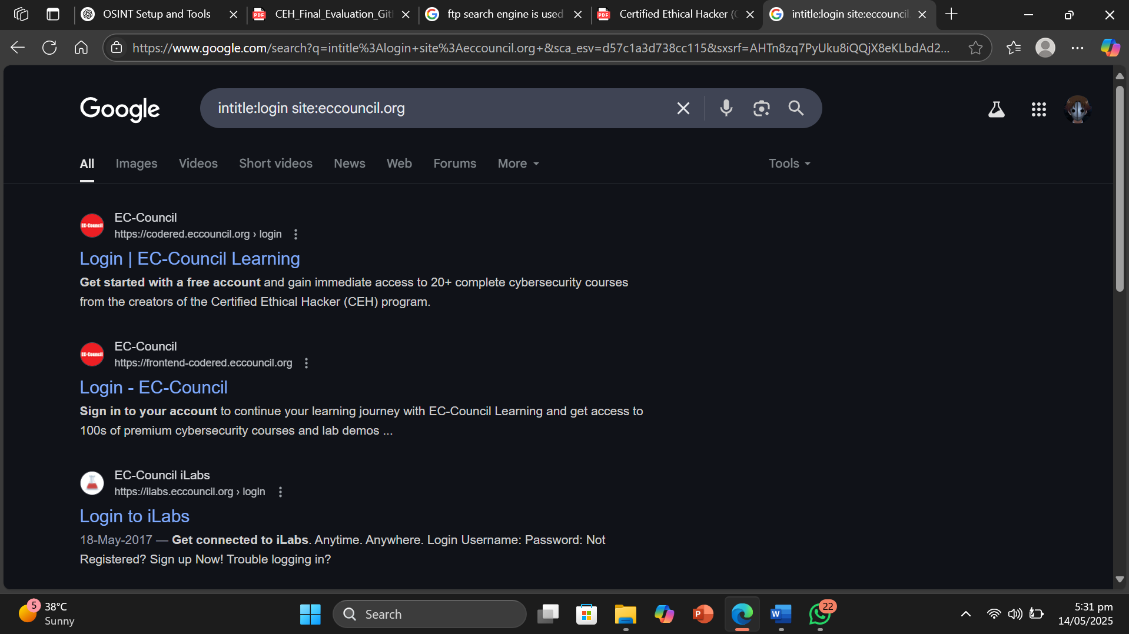

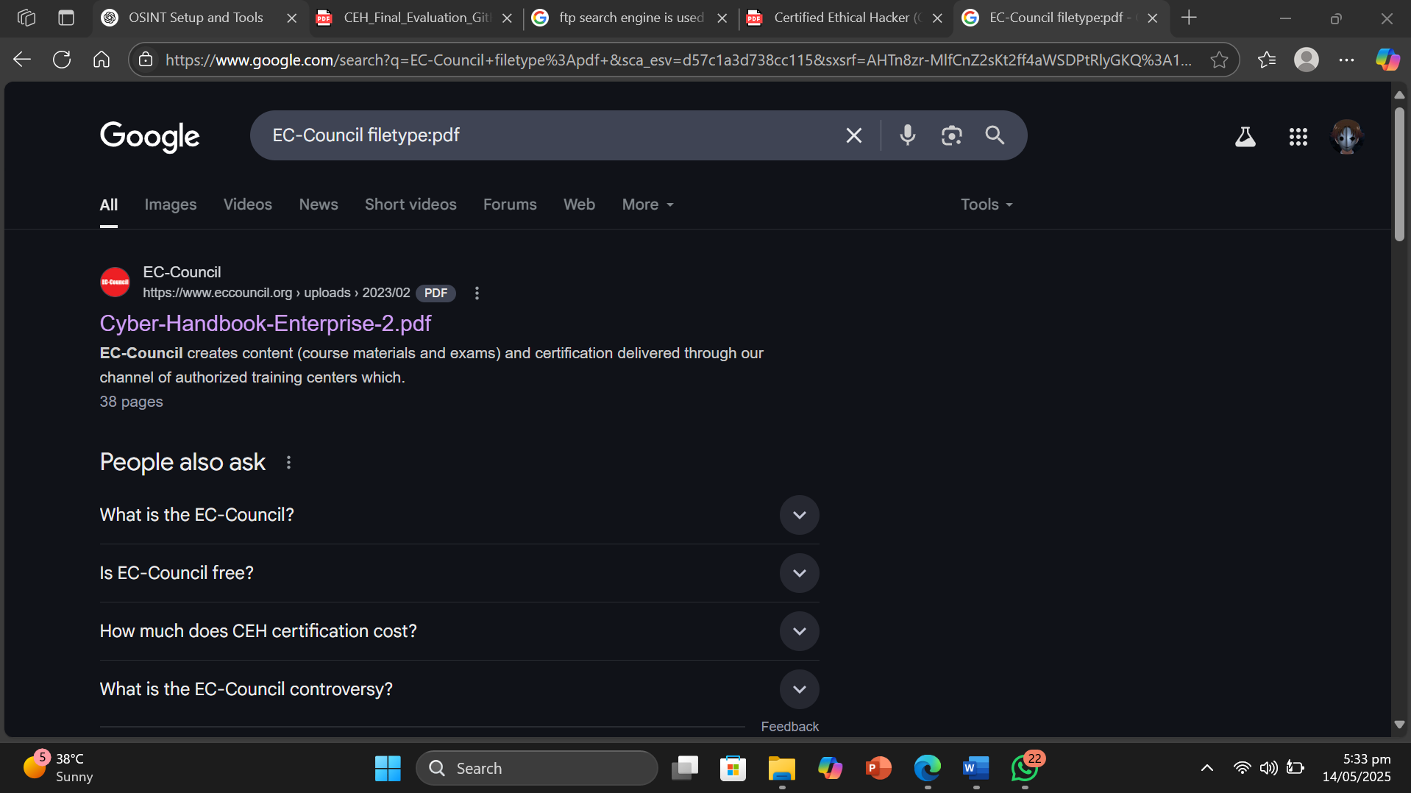

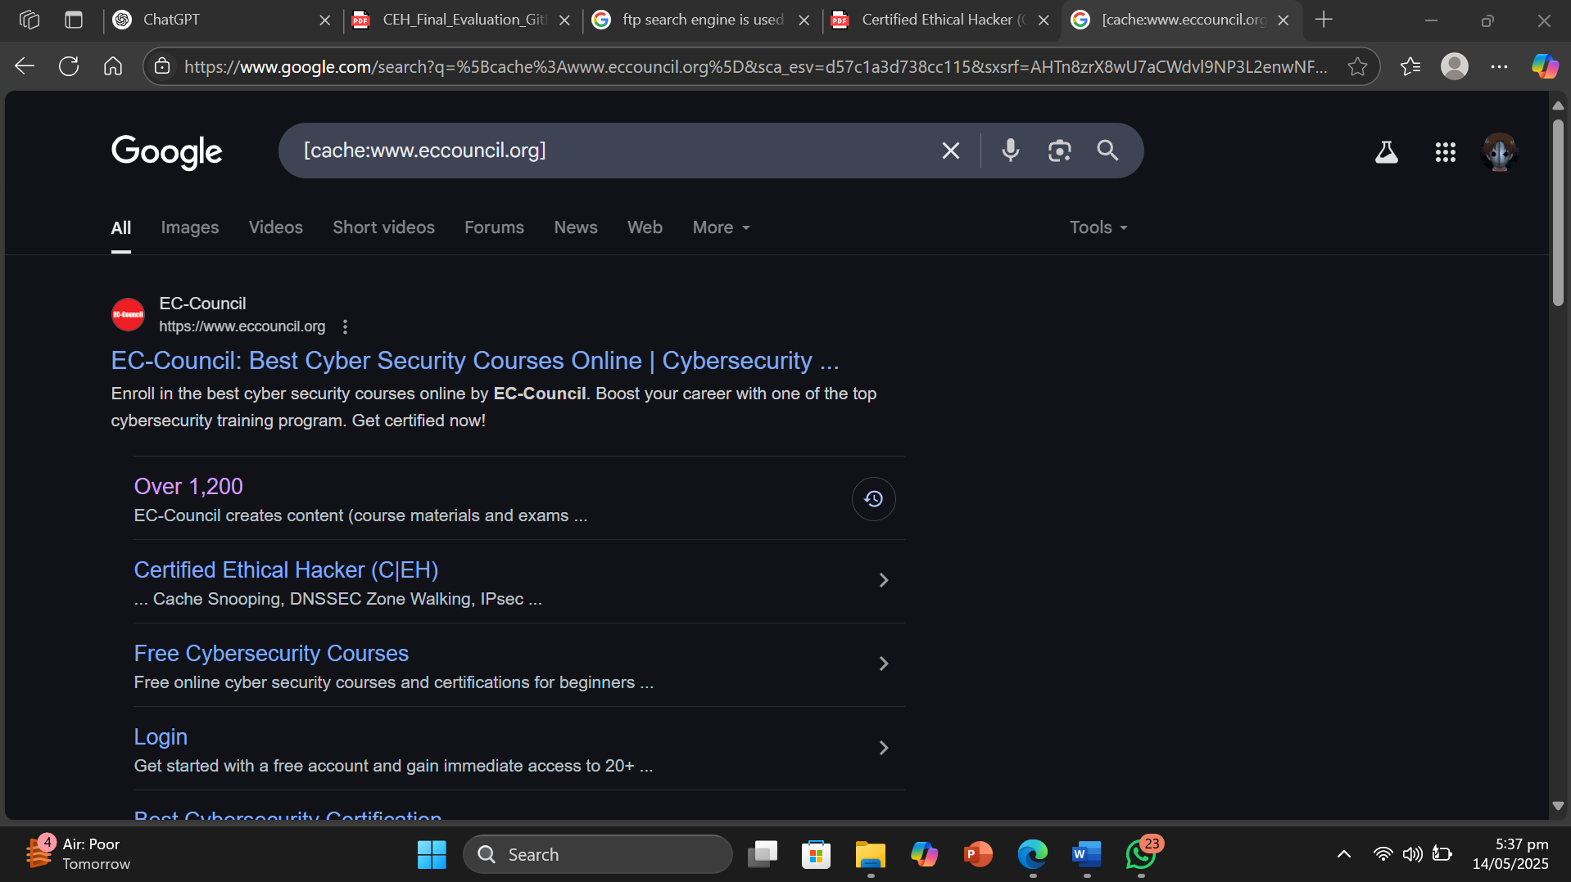

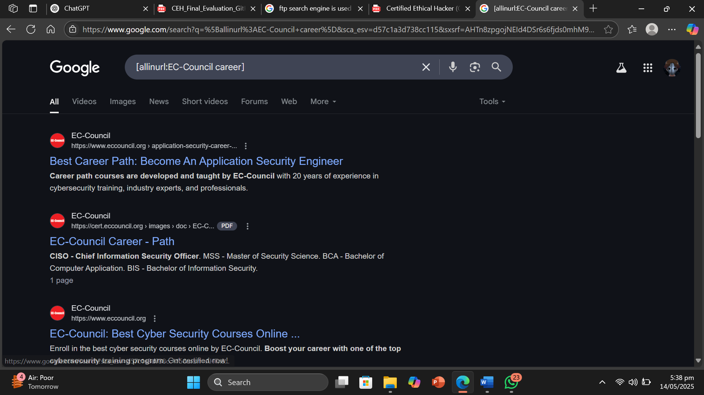

* Result or Output: The commands actually gave the result according to the operaters that were used such as pdf gave the target site links that contained PDFs .The login gave the links of target site that contained login pages and etc .
* Interpretation: I understood that footprinting can be done using search engines just by formatting our commands . We can use advanced Google operators to look up for information which is required.

Objective of Task 2: Gather Information from Video Search Engines

Target Organization : EC-Council

Command or Procedure Used:

Used Windows 11 OS .

Using edge went to https://www.youtube.com .

Searched Target Organization

Copied link of yt video <https://youtu.be/maO8_0cA7W8?si=U-XmykHoSatWwhfi>.

Went to <https://mattw.io/youtube-metadata/>

Pasted the yt link there and submitted.

Got the Result .

* Screenshot :

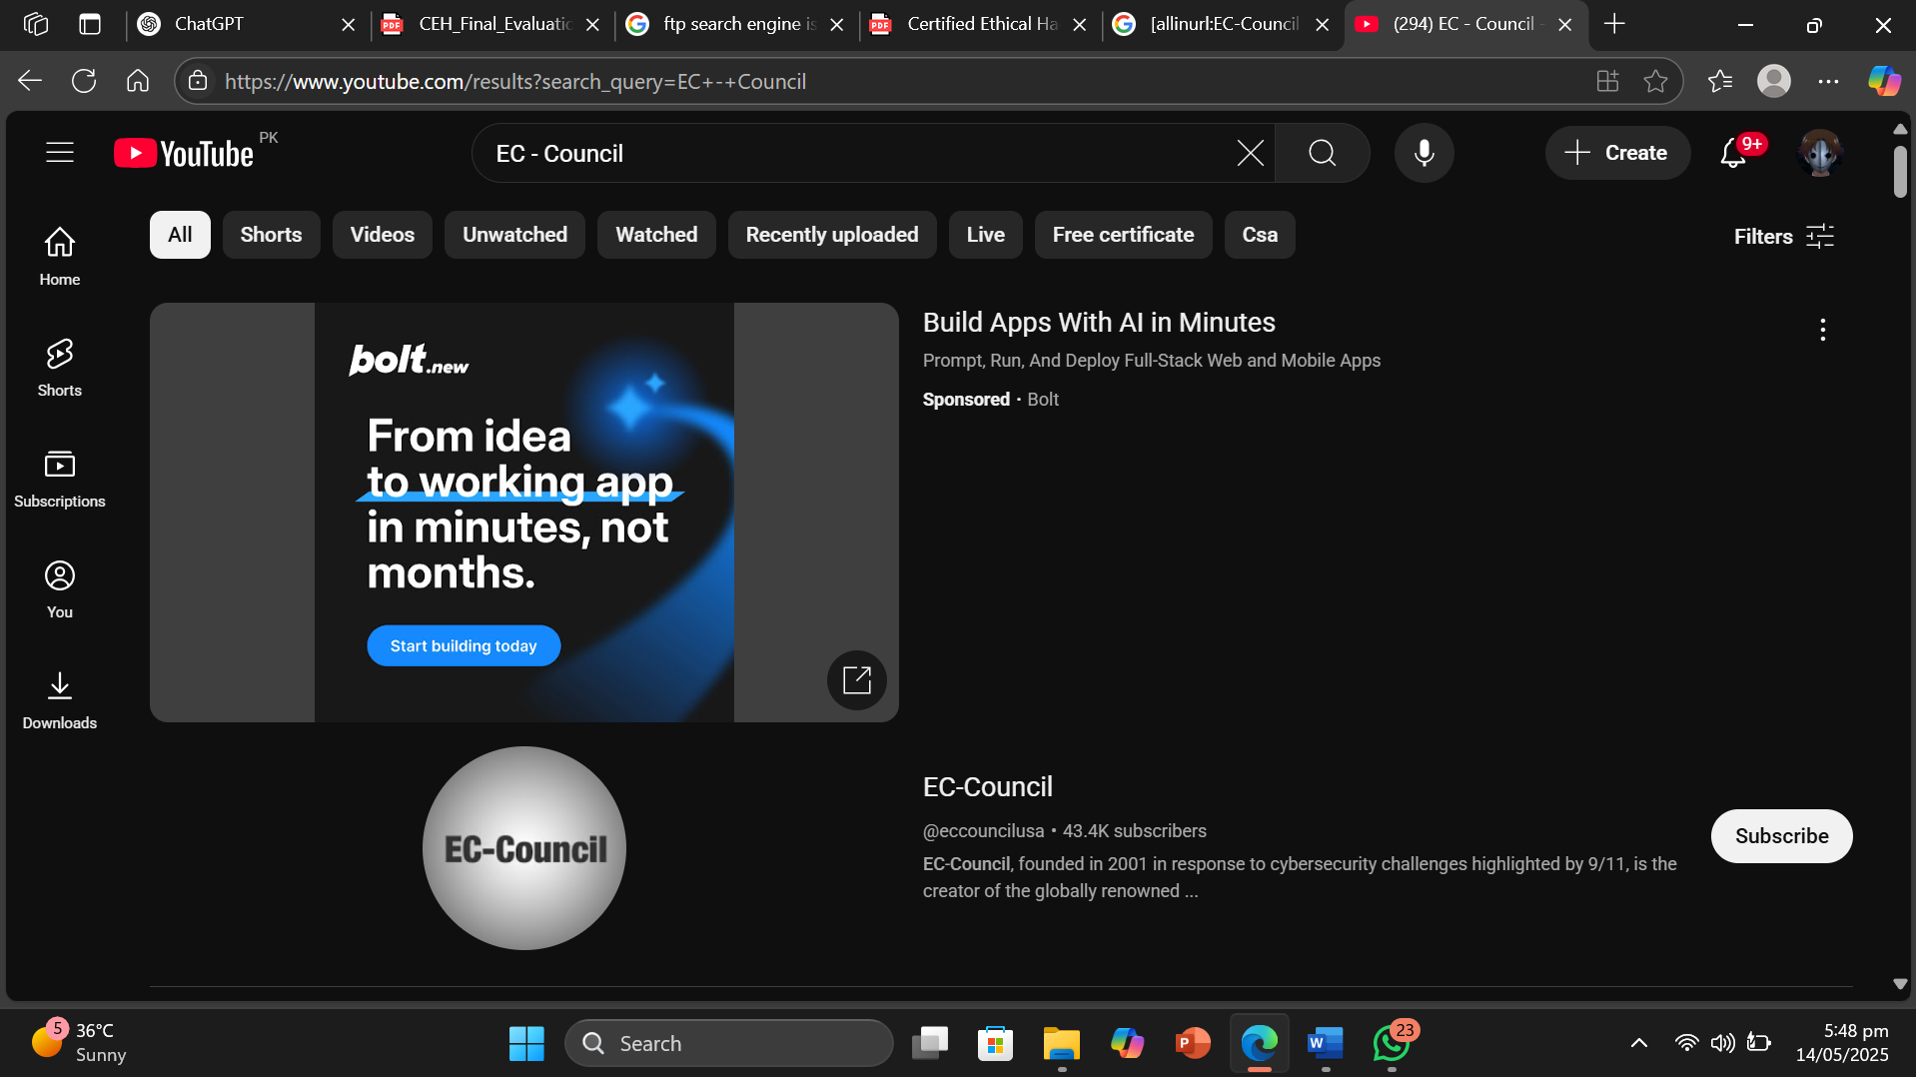

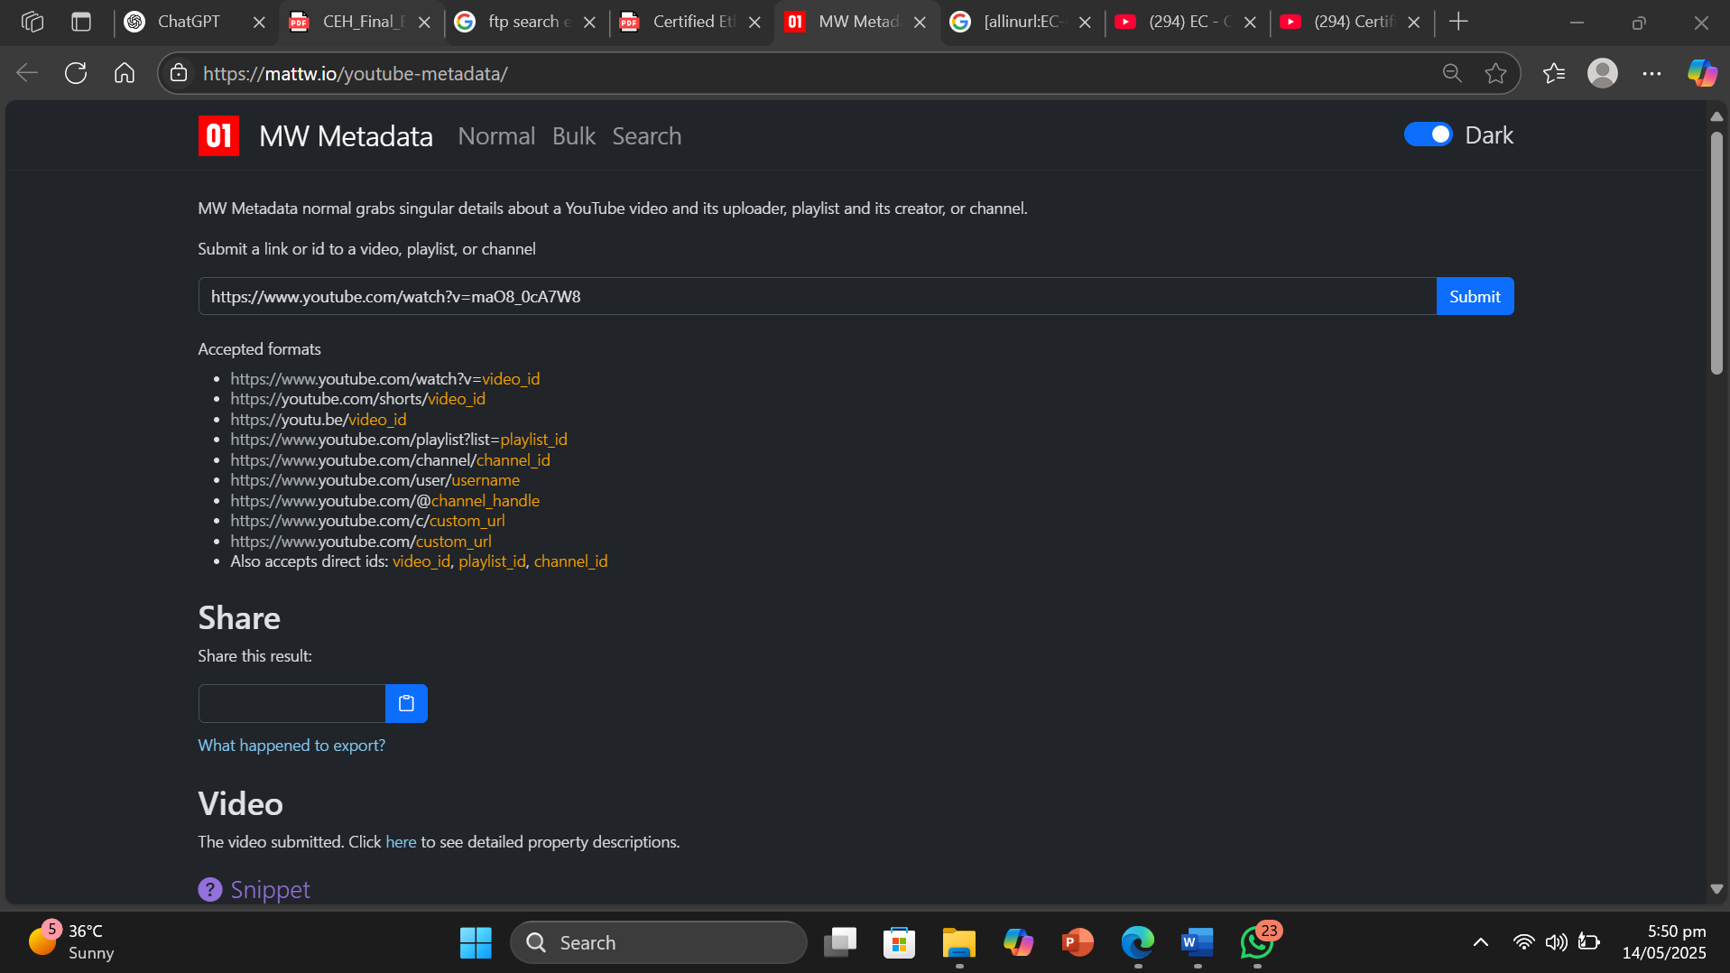

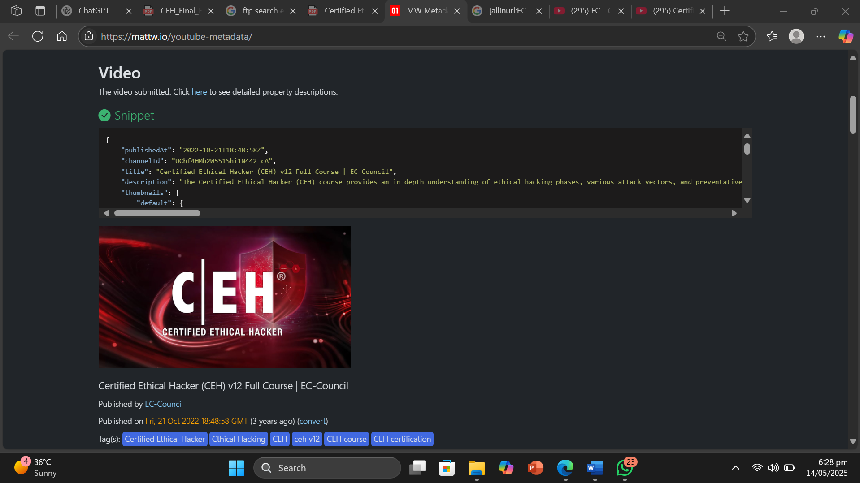

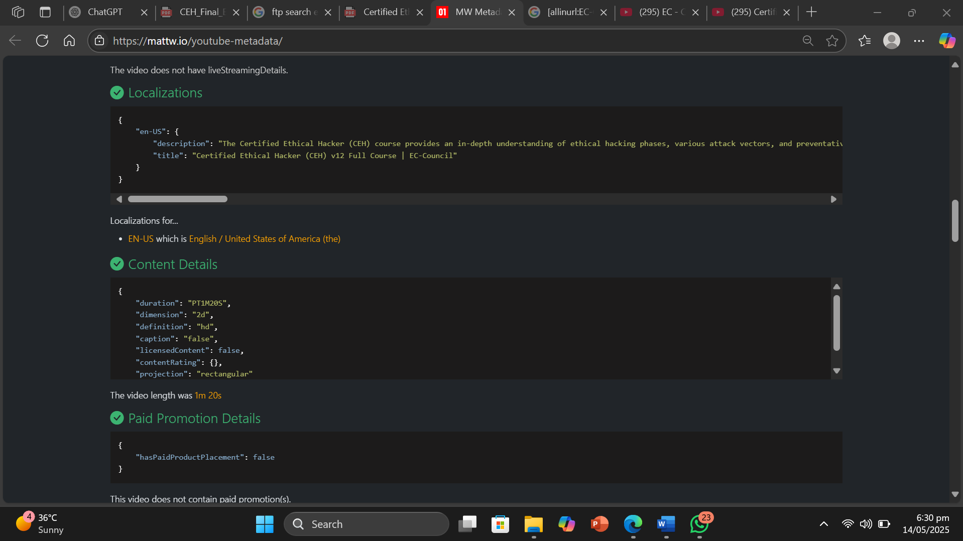

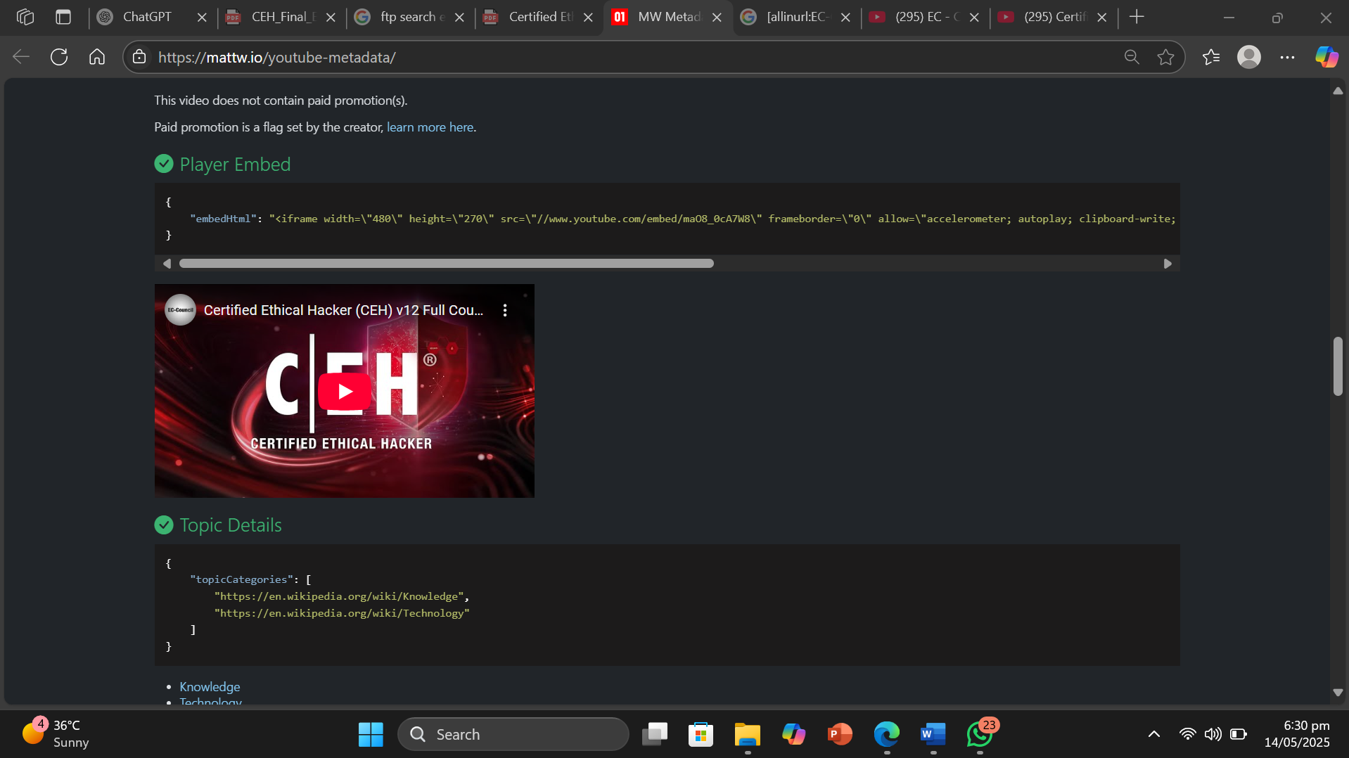

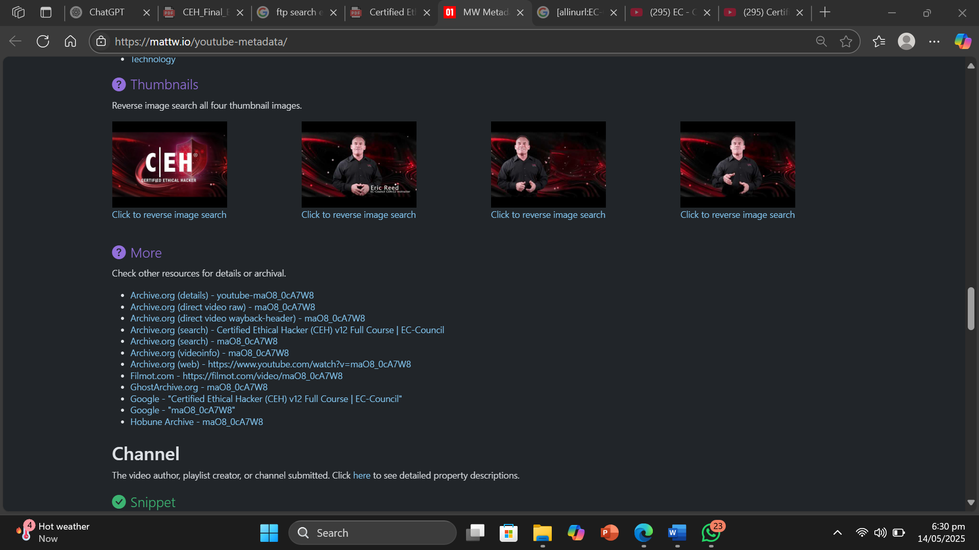

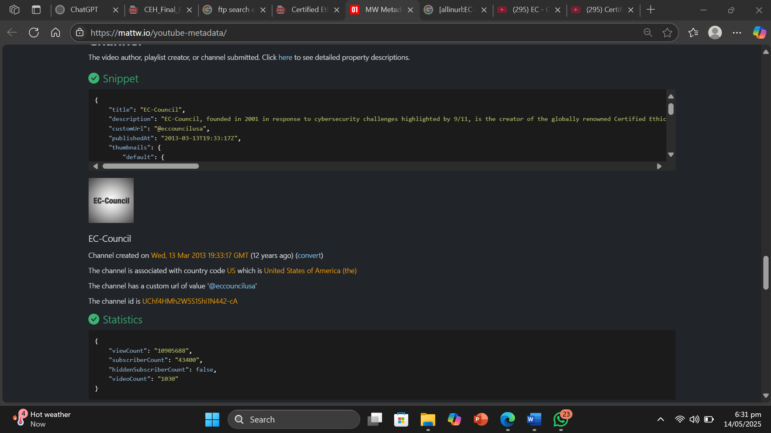

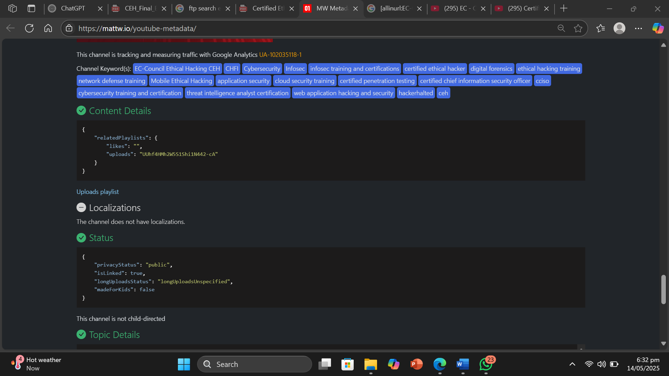

* Result or Output: The youtube metadata tool gave me a lot of details of the video and from the video . It gave me status , topic details , content details , localizations , channel details and etc.
* Interpretation: I understood that footprinting can be done by extracting data from a youtube video using YouTube Metadata Tool . It gives us a lot of details about the target organization .

Objective of Task 3: Gather Information from FTP Search Engines

Target Organization : Microsoft

* Command or Procedure Used:

1. Used Windows 11 OS.
2. Opened Browser and Visited <https://www.searchftps.net/> .
3. Searched our target organization .
4. Got the Result .

* 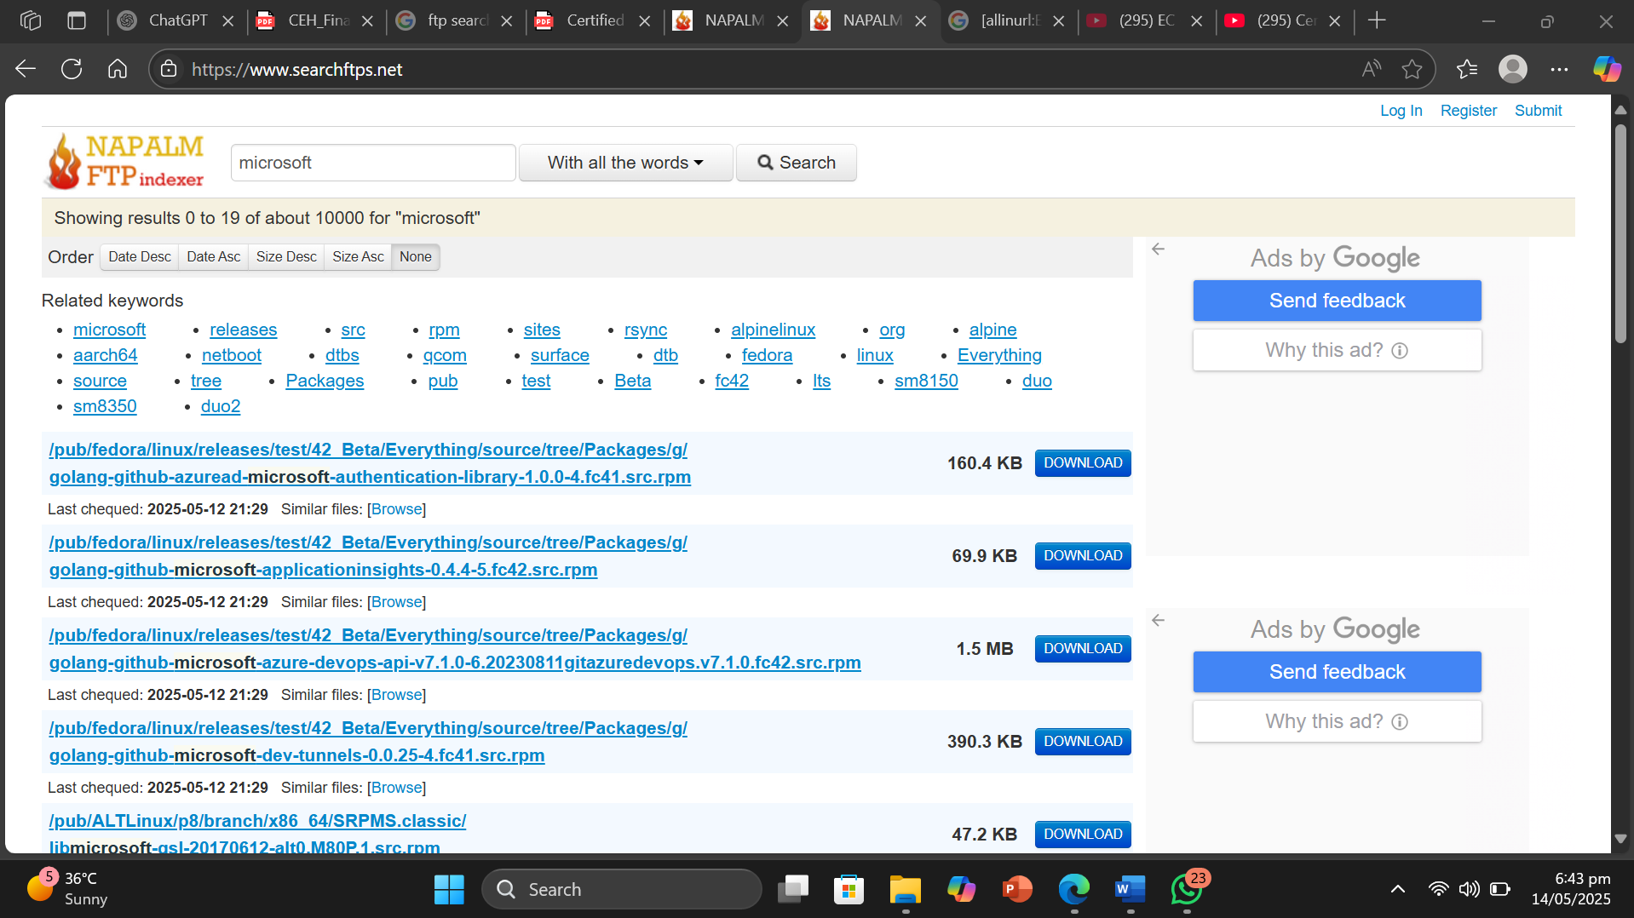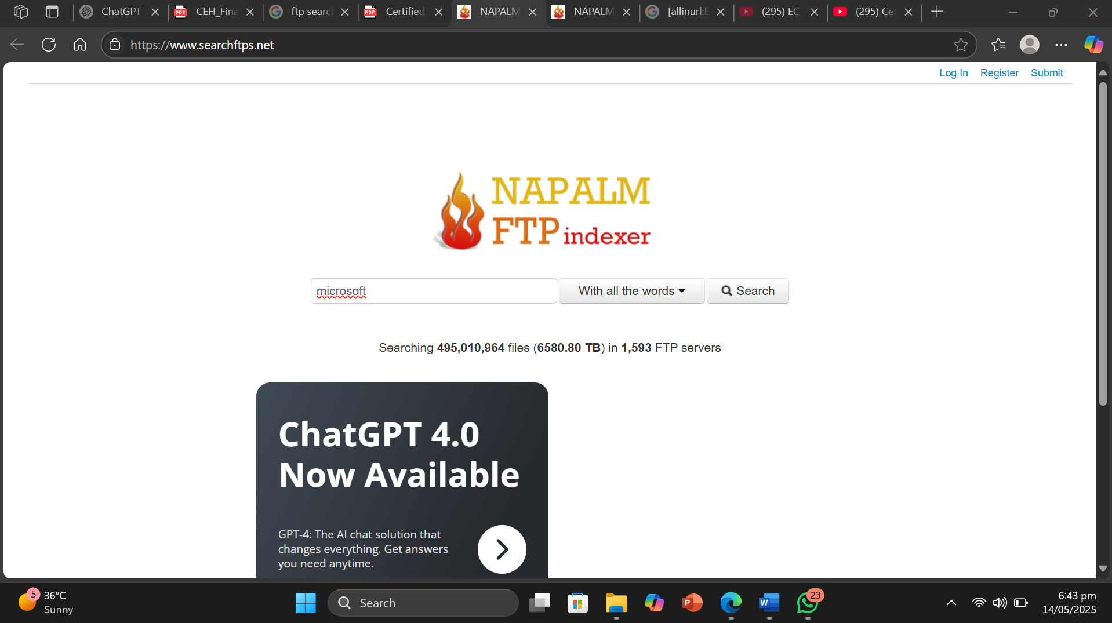Screnshot :
* Result or Output: The FTP search engine gave us the critical files and documents related to our target organization.
* Interpretation: I understood that footprinting can be done by using FTP search engines . These engines give us the critical files and documents uploaded on FTP server.

Objective of Task 4: Gather Information from IoT Search Engines

Target Organization : Amazon

* Command or Procedure Used:

1. Used Windows 11 OS
2. Opened browser and visited <https://www.shodan.io/>.
3. Typed target organization and searched.
4. Got the result.

* Screnshot :

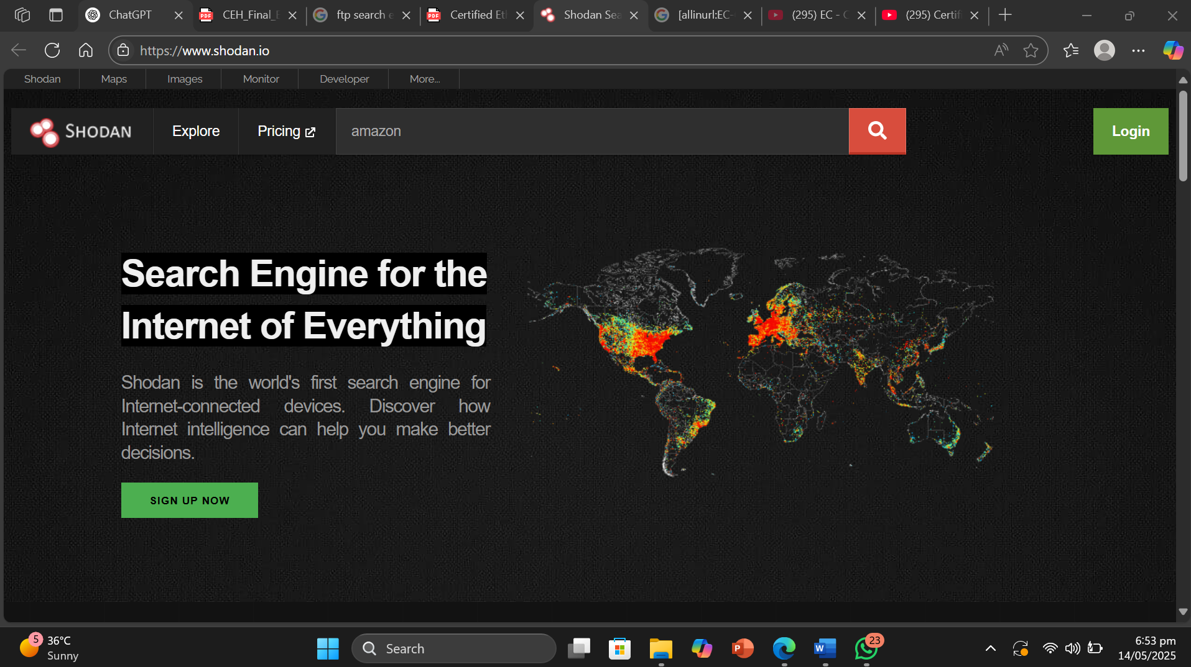

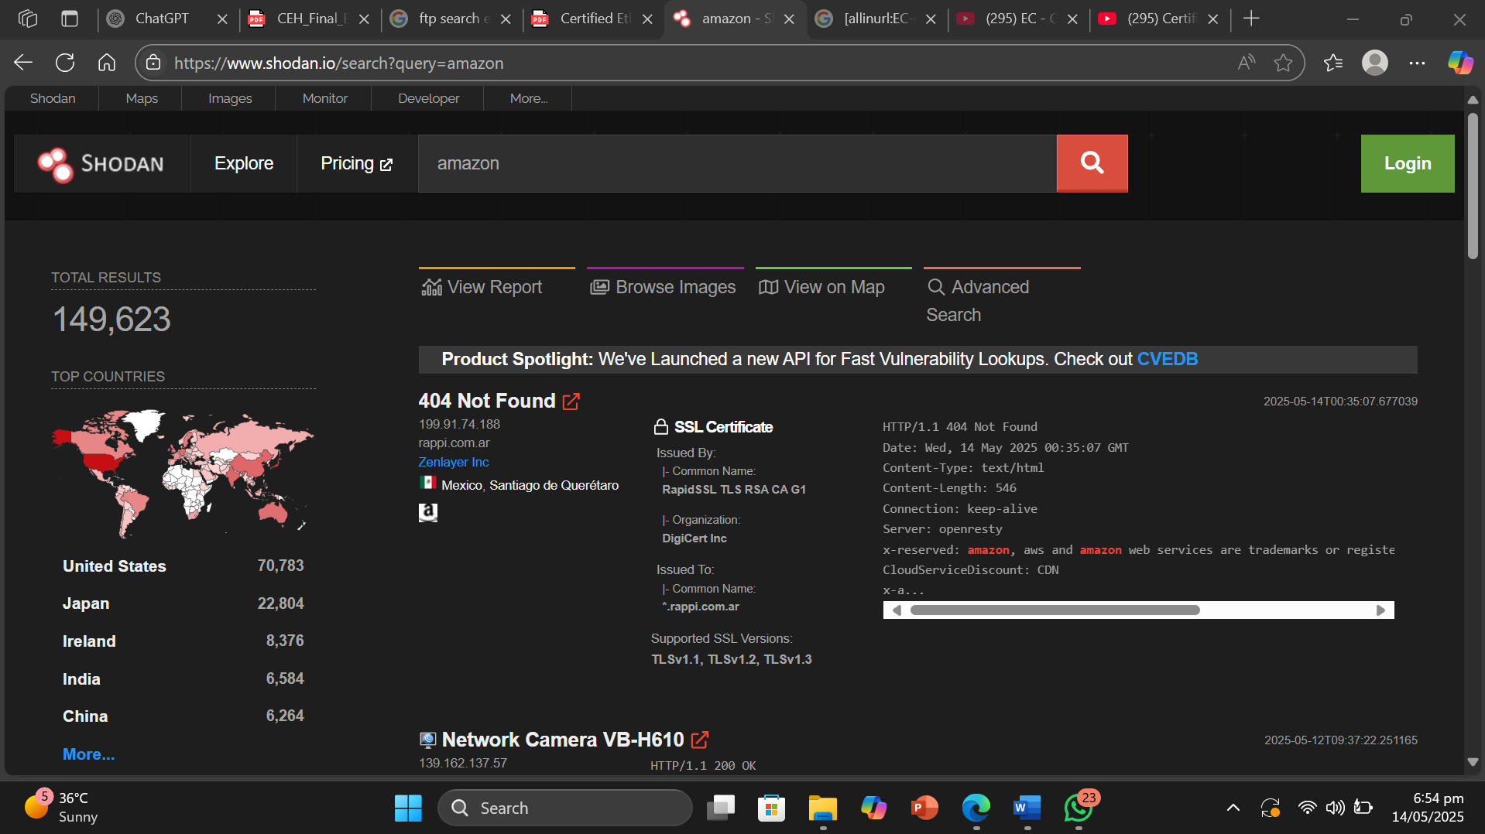

* Result or Output: The Shodan IoT search engine gave us the vulnerable loT devices related to amazon in various countries .
* Interpretation: I understood that footprinting can be done by using IoT search engines . It gives us details such as vulnerable IoT devices related to target organization around the globe.

Module 2: Lab 3 Perform Footprinting Through Social Networking Sites

Objective of Task 1: Gather Employees’ Information from LinkedIn using theHarvester

Target Organization : EC-Council

Error : LinkedIn **strictly prohibits** scraping or automating interactions on its platform due to which its not possible nowadays to use theHarvester on Linkedin .Allowed sites are found by using command :

* theHarvester -h

So for this purpose , we are using a Semi-Relevant site i.e . bing as other allowed sites require API keys .

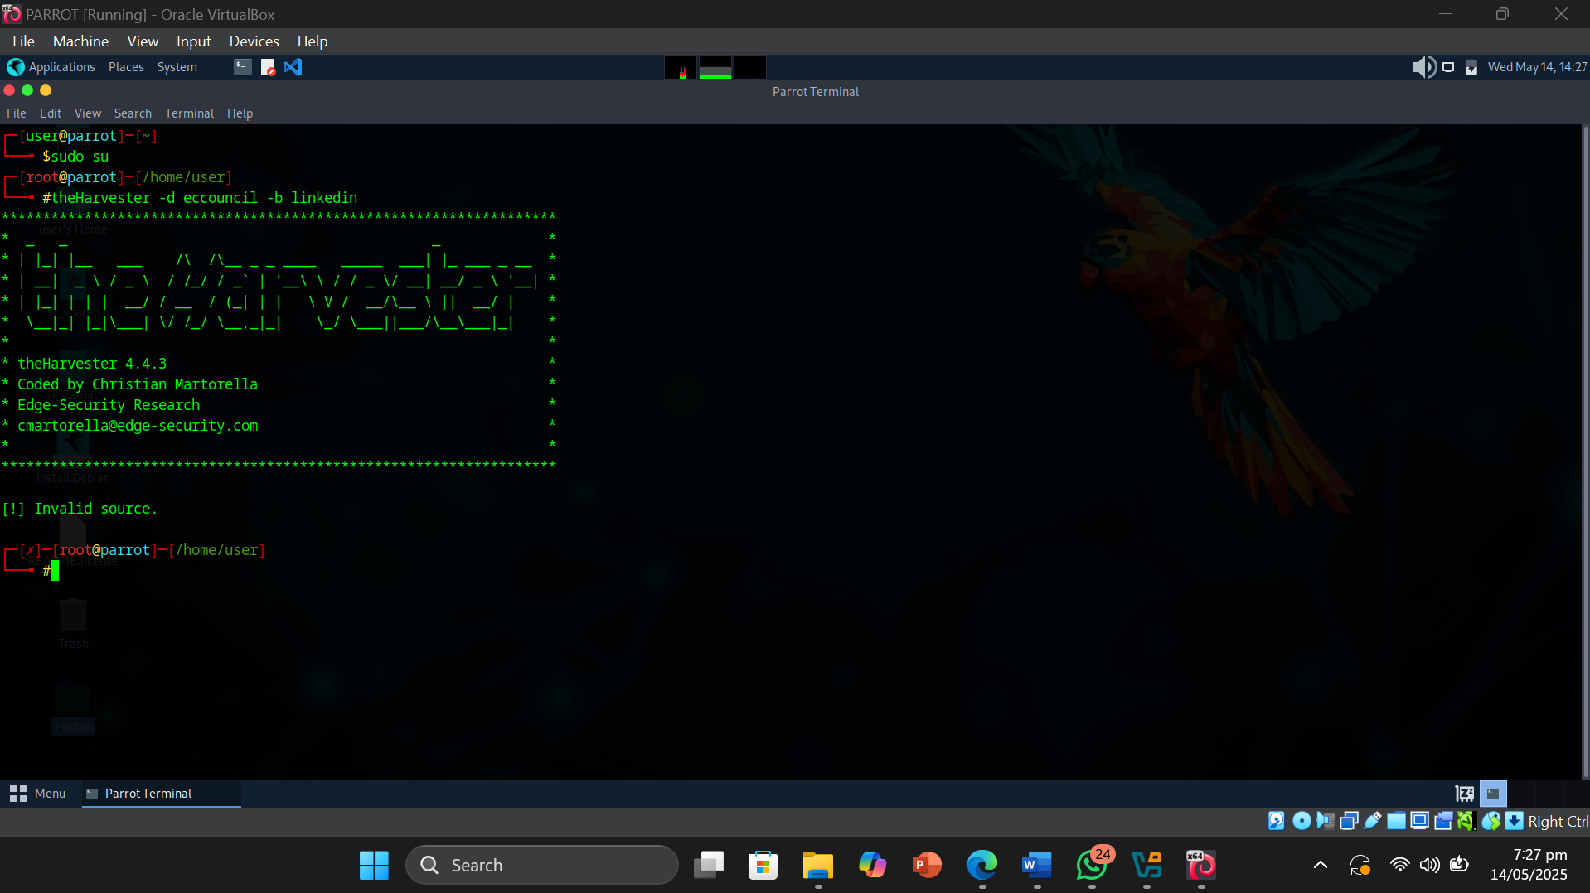Error Proof :

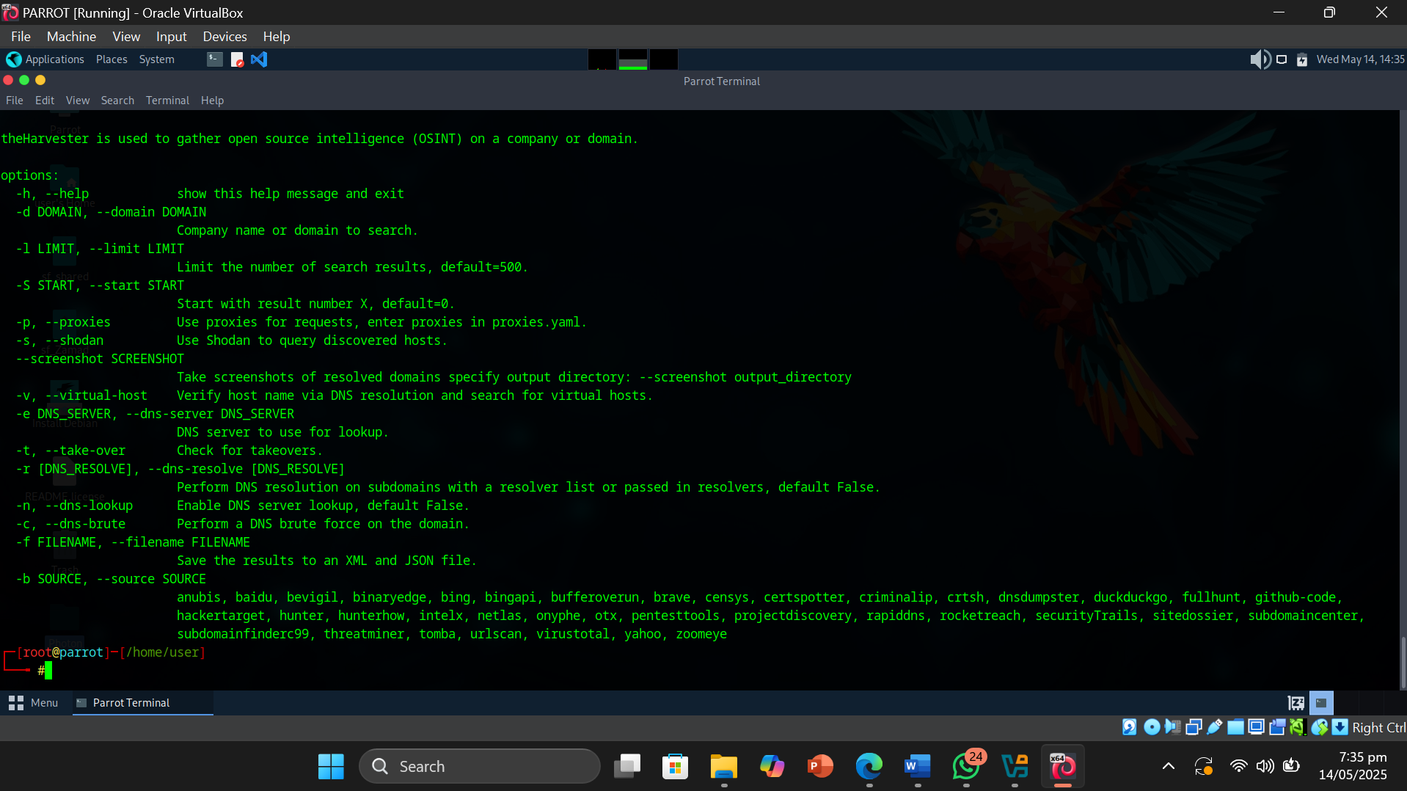

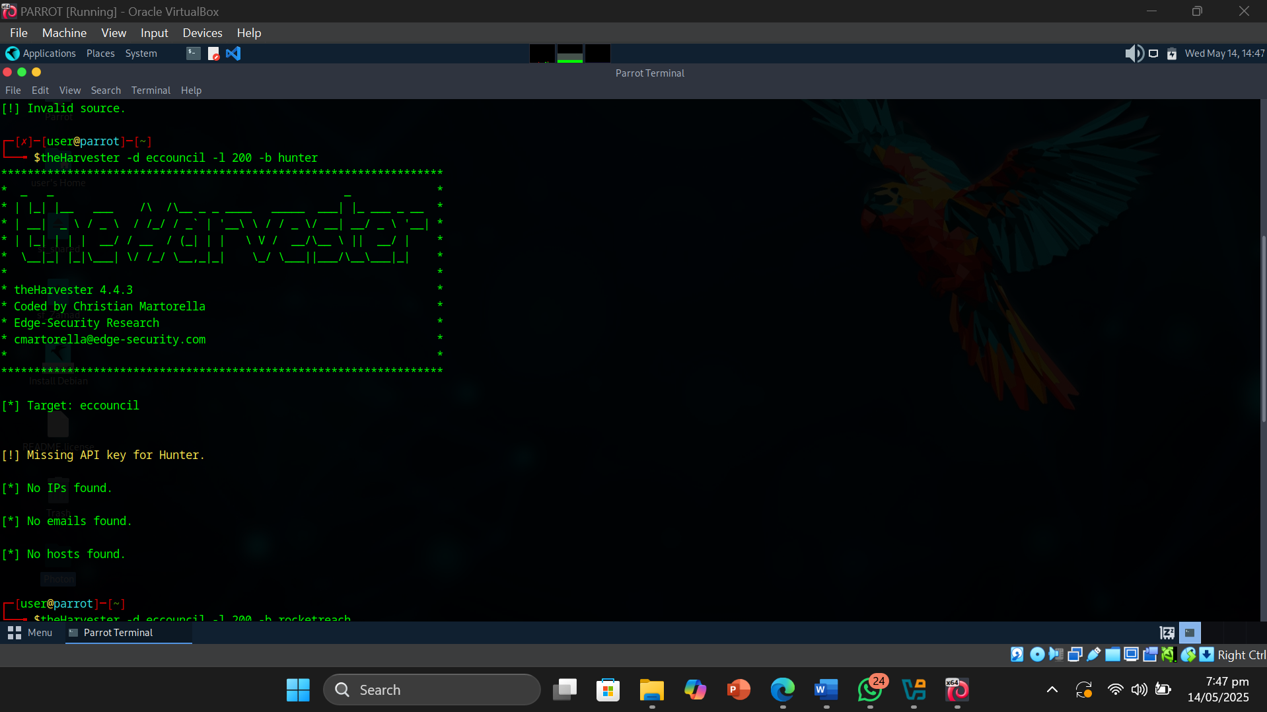

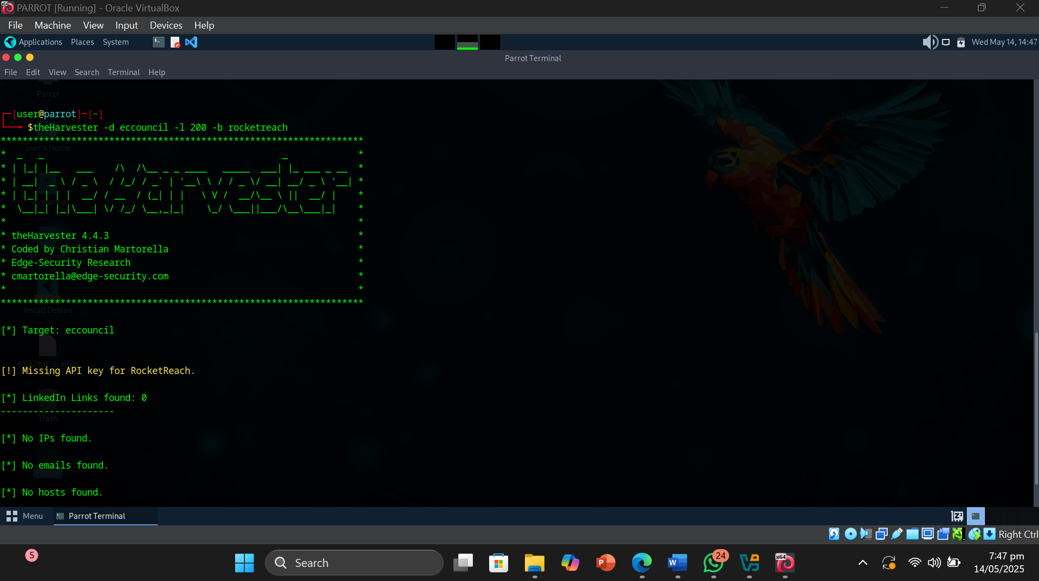

* Command or Procedure Used:

1. Opened Parrot OS VM.
2. Opened Terminal and entered sudo su.
3. Entered theHarvester -d eccouncil -l 200 -b bing.
4. Got Result.
5. Entered theHarvester -d eccouncil -l 200 -b yahoo.
6. Got Result.

* 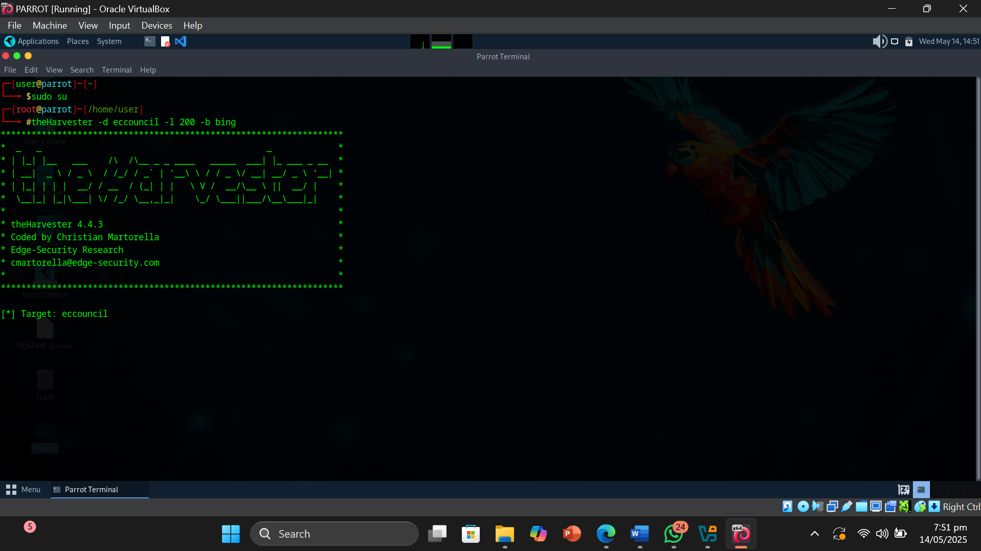Screenshot:

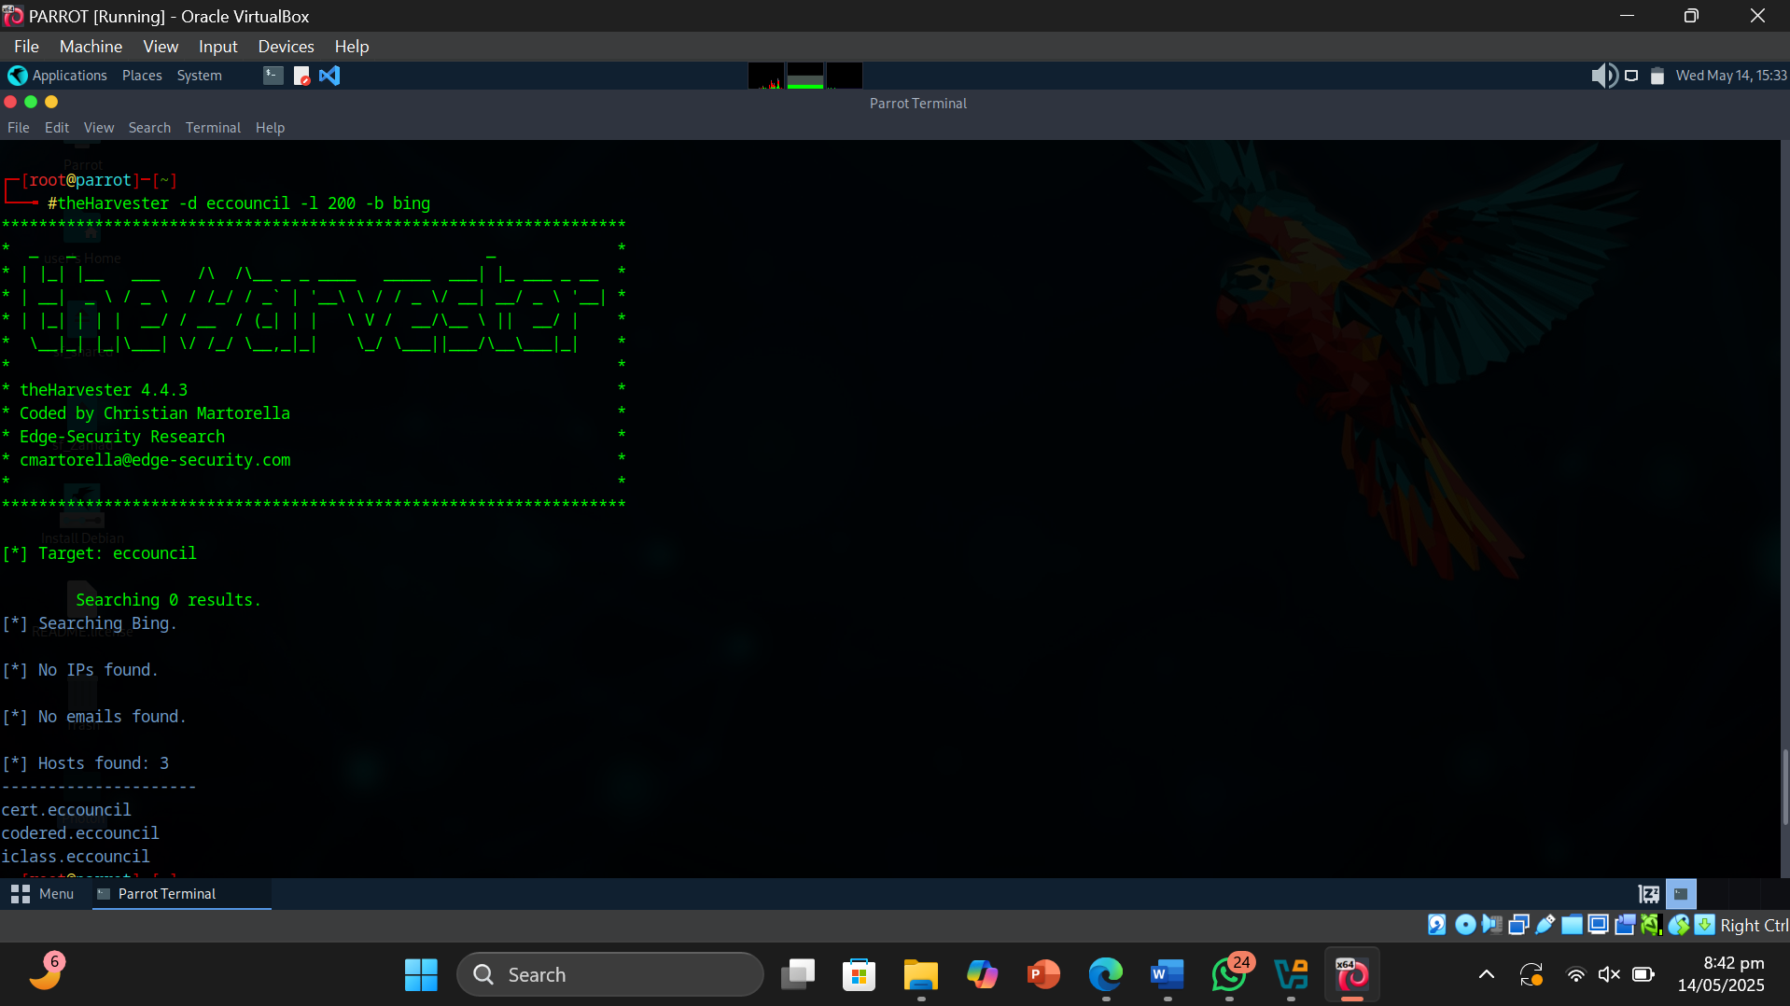

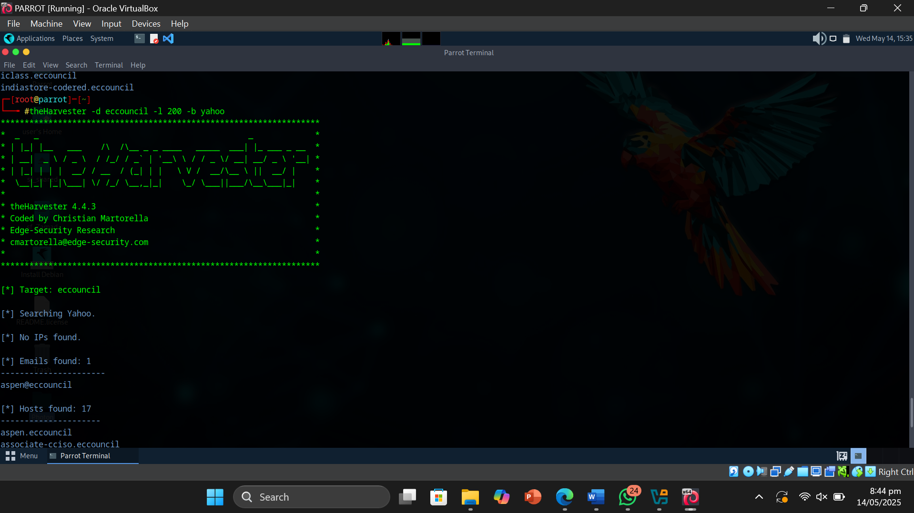

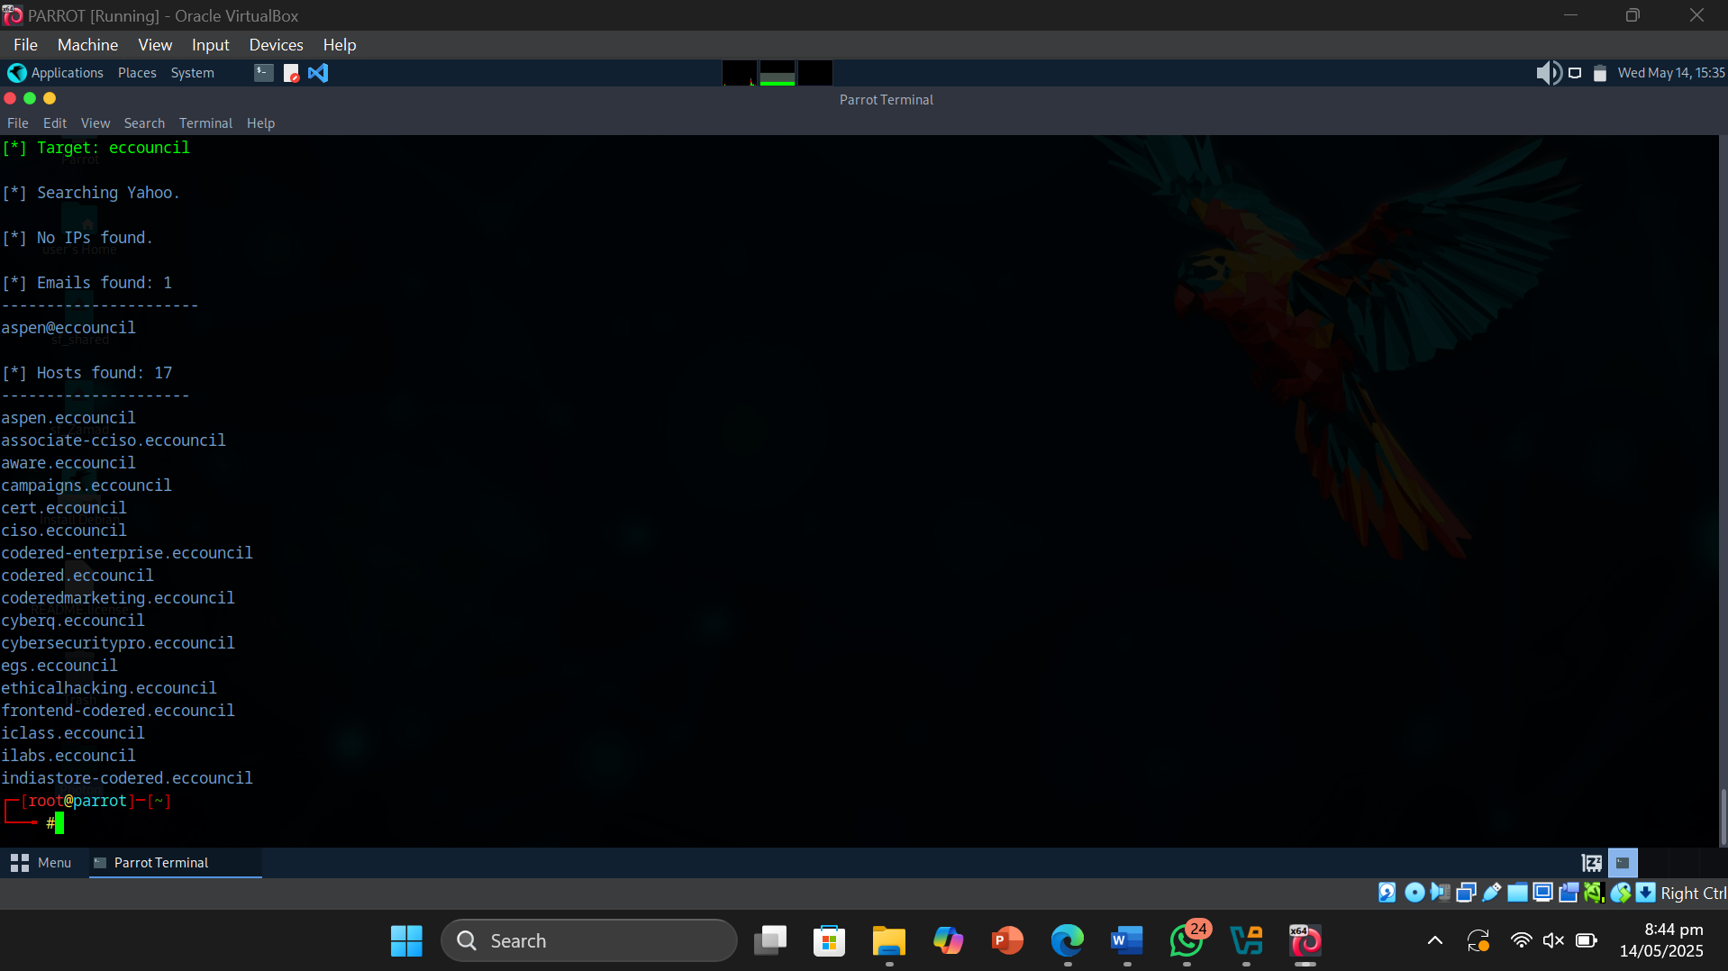

* Result or Output: The Harvester Tool gave us the emails , Hosts and Ip’s of our target organization .
* Interpretation: I understood that footprinting can be done by using theHarvester which extracts emails , hosts and ip addresses of our target organization. It can be used to conduct footprinting through social networking sites.

Objective of Task 2: Gather Personal Information from Various Social Networking Sites using Sherlock

Target Person : Satya Nadella

* Command or Procedure Used:

1. Used Parrot OS VM.
2. Opened Parrot Terminal and typed sudo su.
3. Went to the directory where sherlock was kept using cd .
4. Cloned the repository of github [https://github.com/sherlock-project /sherlock.git](https://github.com/sherlock-project%20/sherlock.git) in~Desktop/sherlock using git clone.
5. Installed python3 venv and ran the virtual environment using following commands:-

* sudo apt install python3-venv
* python3 -m venv sherlock-venv
* source sherlock-venv/bin/activate
* pip install sherlock-project

1. Ran sherlock on target person through command :- sherlock satya Nadella .

* Screnshot :

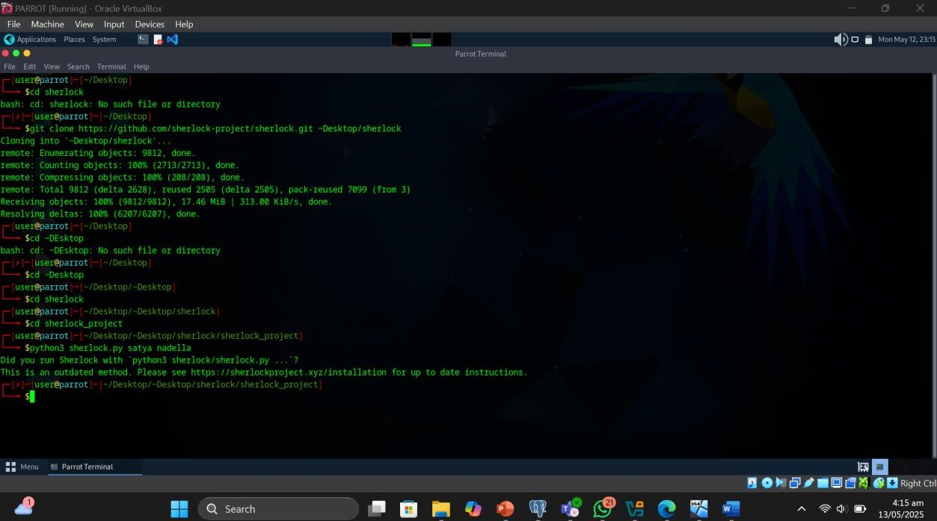

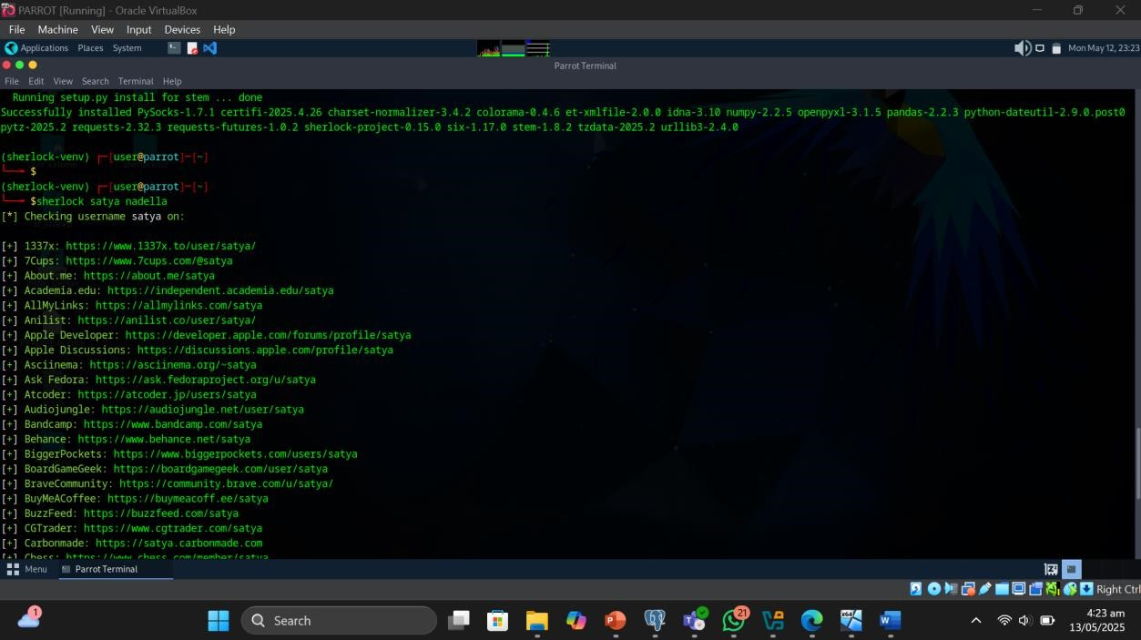

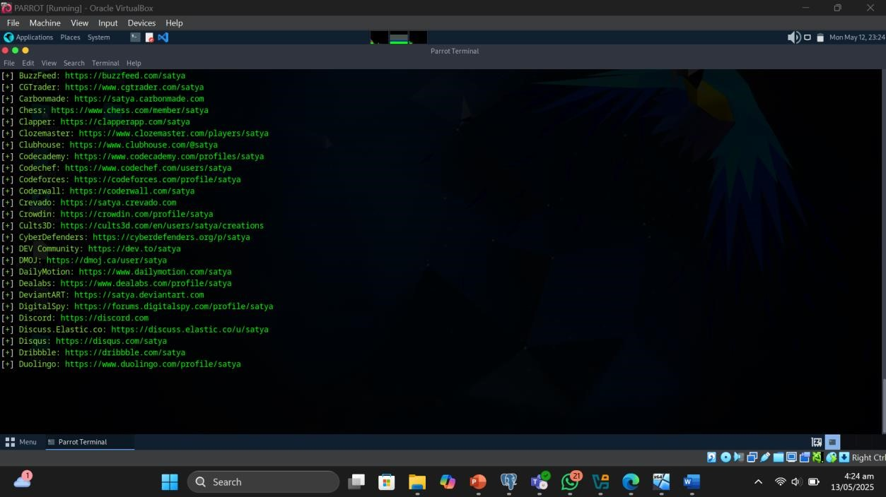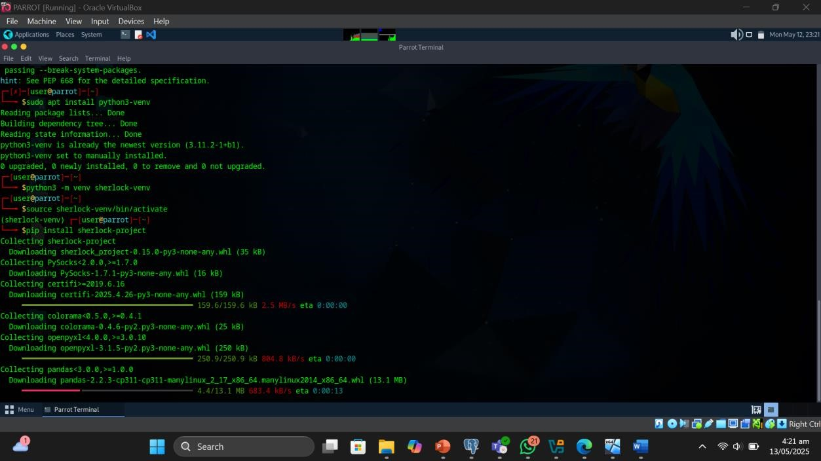

* Result or Output: The Sherlock tool gave us all the domains of social networking at which the person has his/her profile registered .
* Interpretation: I understood that footprinting can be done by using Sherlock tool which extracts all the social networking domains links on which the person profile can be viewed .

Objective of Task 3: Gather Information using Followerwonk

Target Person : Donald Trump

Error : This tool is a paid version . It can’t be used freely . I created an account on this site and also created a twitter account using vpn . But it’s a paid tool .

Error Proof :

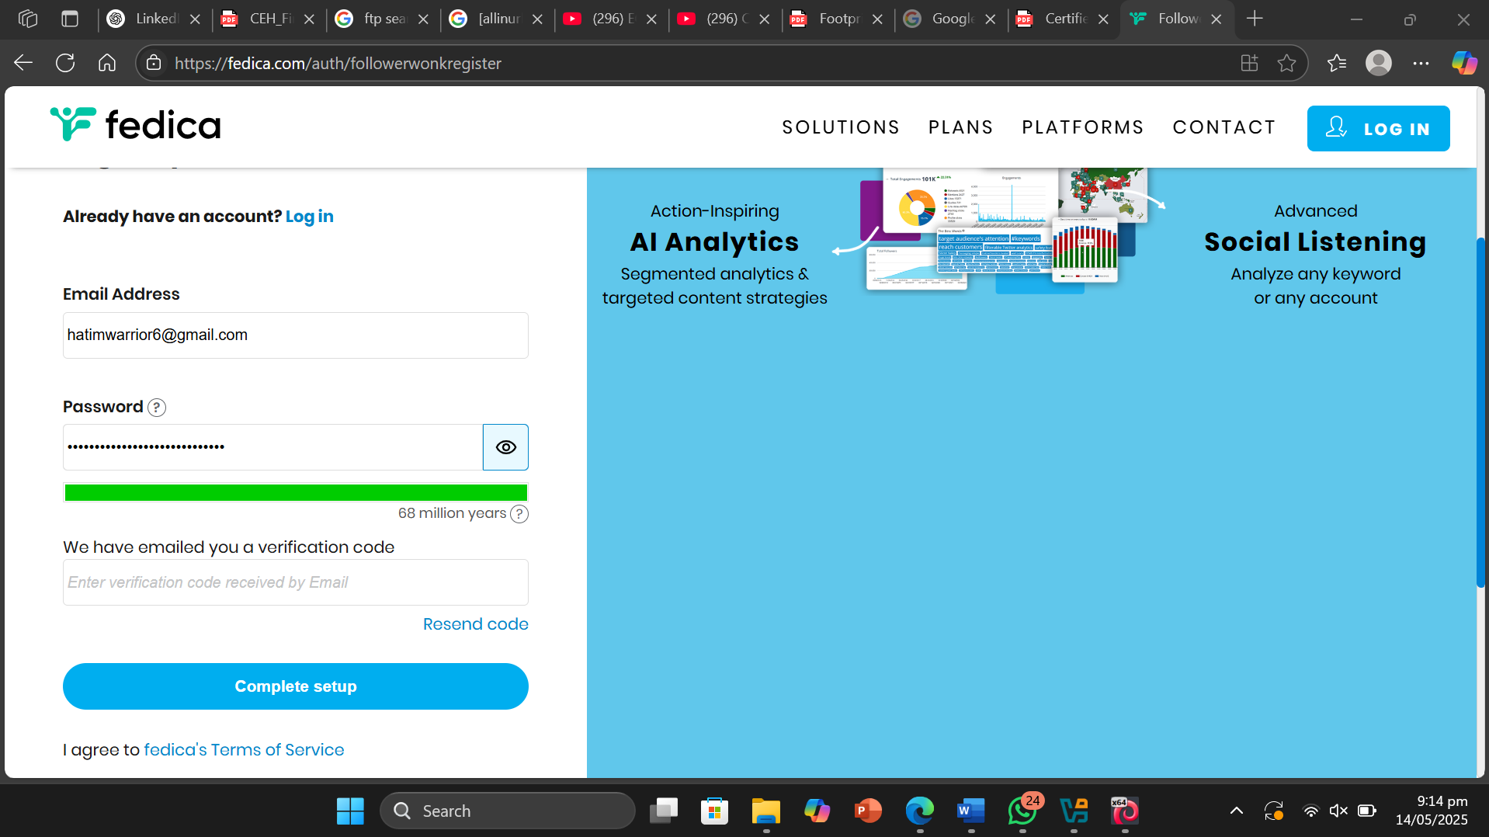

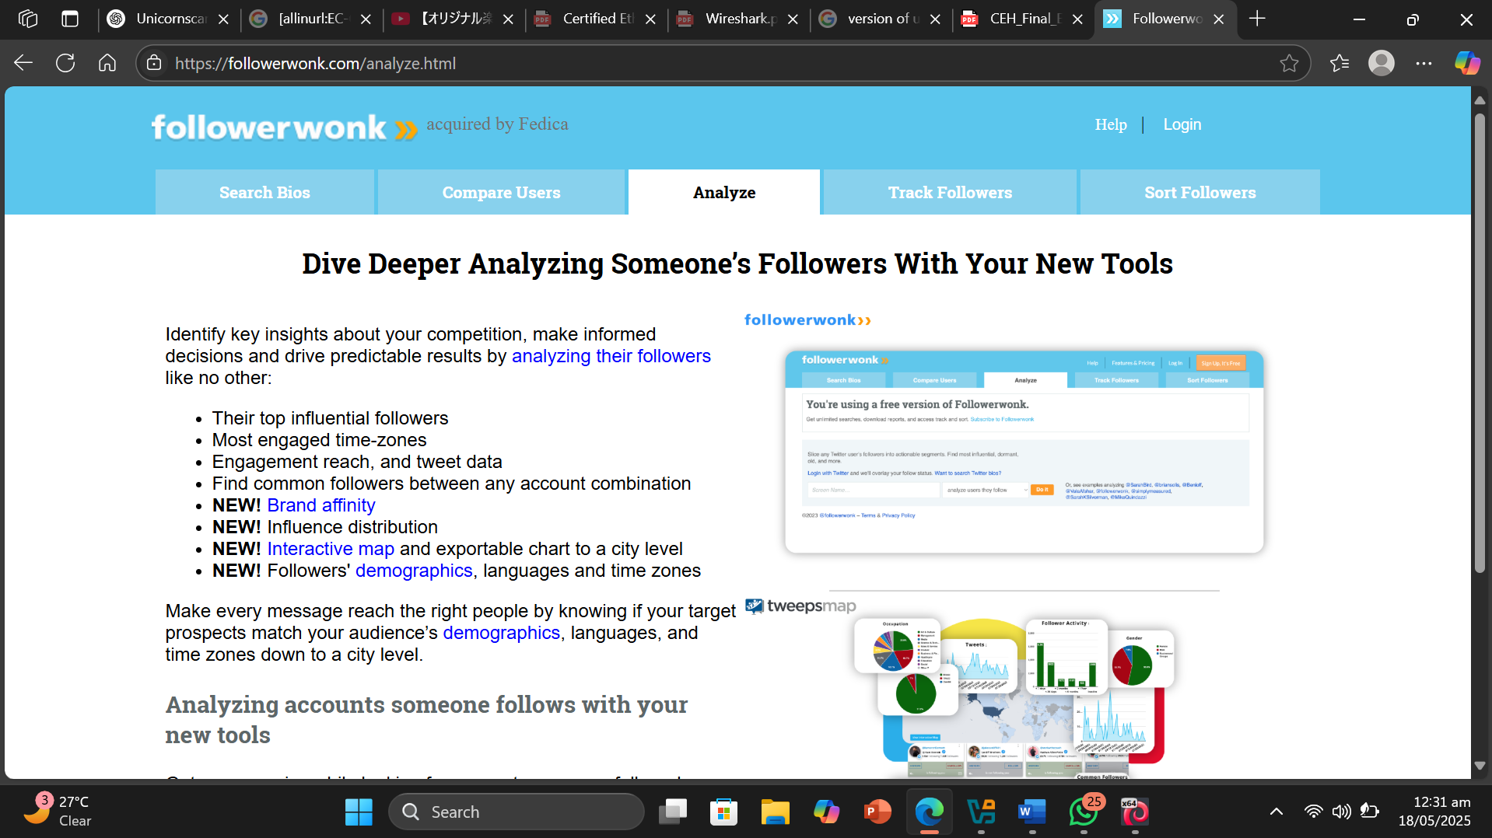

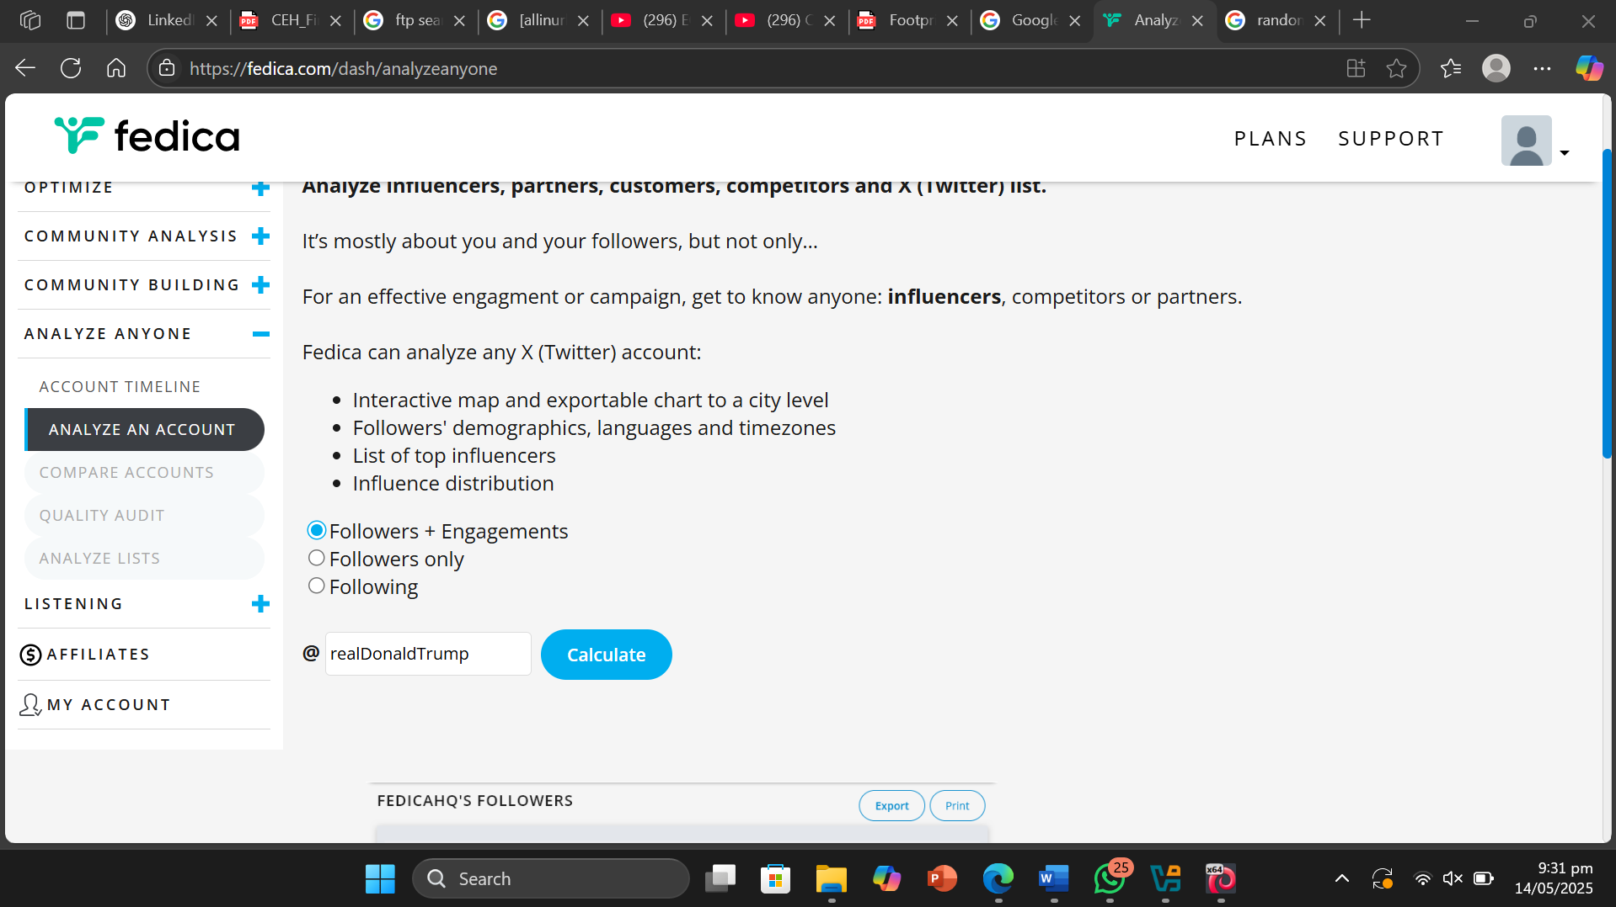

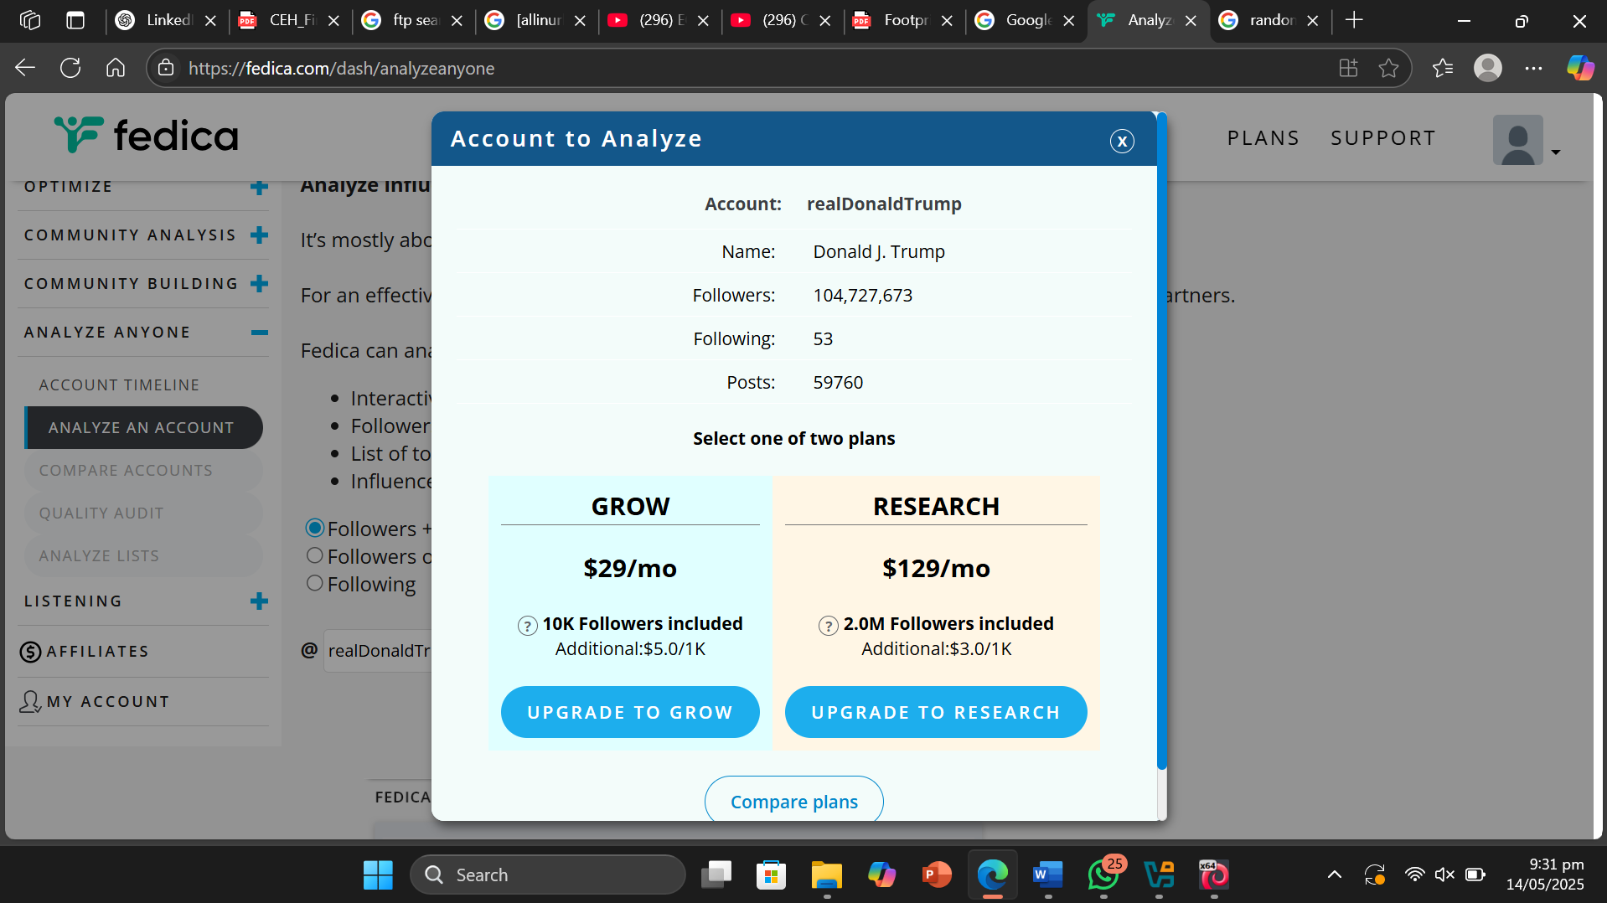

Followerwonk is a paid tool because it offers **specialized analytics capabilities** that go beyond what public Twitter data alone provides.

Module 2: Lab 4 Perform Website Footprinting

Objective of Task 1: Gather Information About a Target Website using Ping Command Line Utility

Target Website : [www.certifiedhacker.com](http://www.certifiedhacker.com)

* Command or Procedure Used:

1. Used Windows 11 OS .
2. Opened cmd.
3. Typed ping [www.certifiedhacker.com](http://www.certifiedhacker.com).
4. Typed ping www.certifiedhacker.com -f -l 1500
5. Typed ping www.certifiedhacker.com -f -l 1300
6. Typed ping www.certifiedhacker.com -f -l 1473
7. Typed ping www.certifiedhacker.com -i 2 -n 1
8. Typed ping www.certifiedhacker.com -i 4 -n 1
9. Typed ping www.certifiedhacker.com -i 26 -n 1
10. Got Result .

* Screenshot :

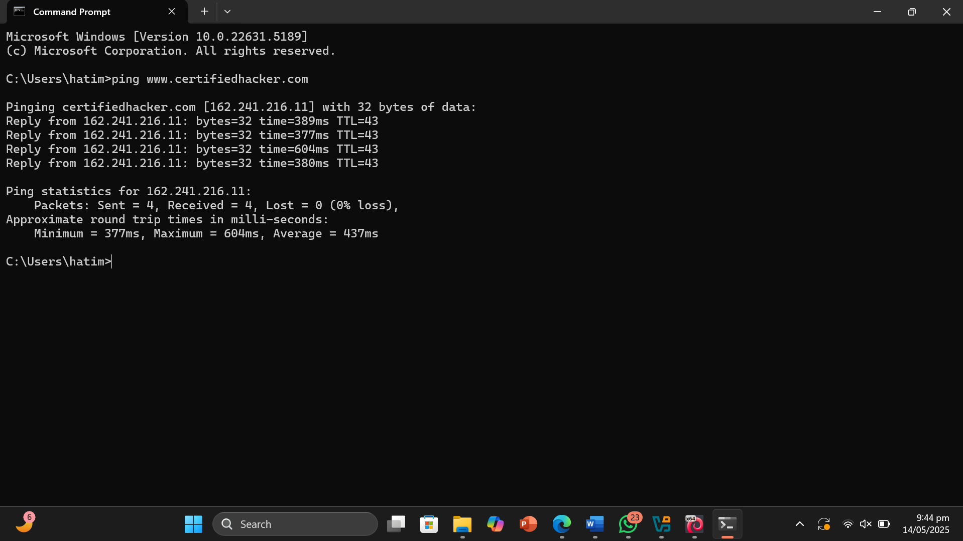

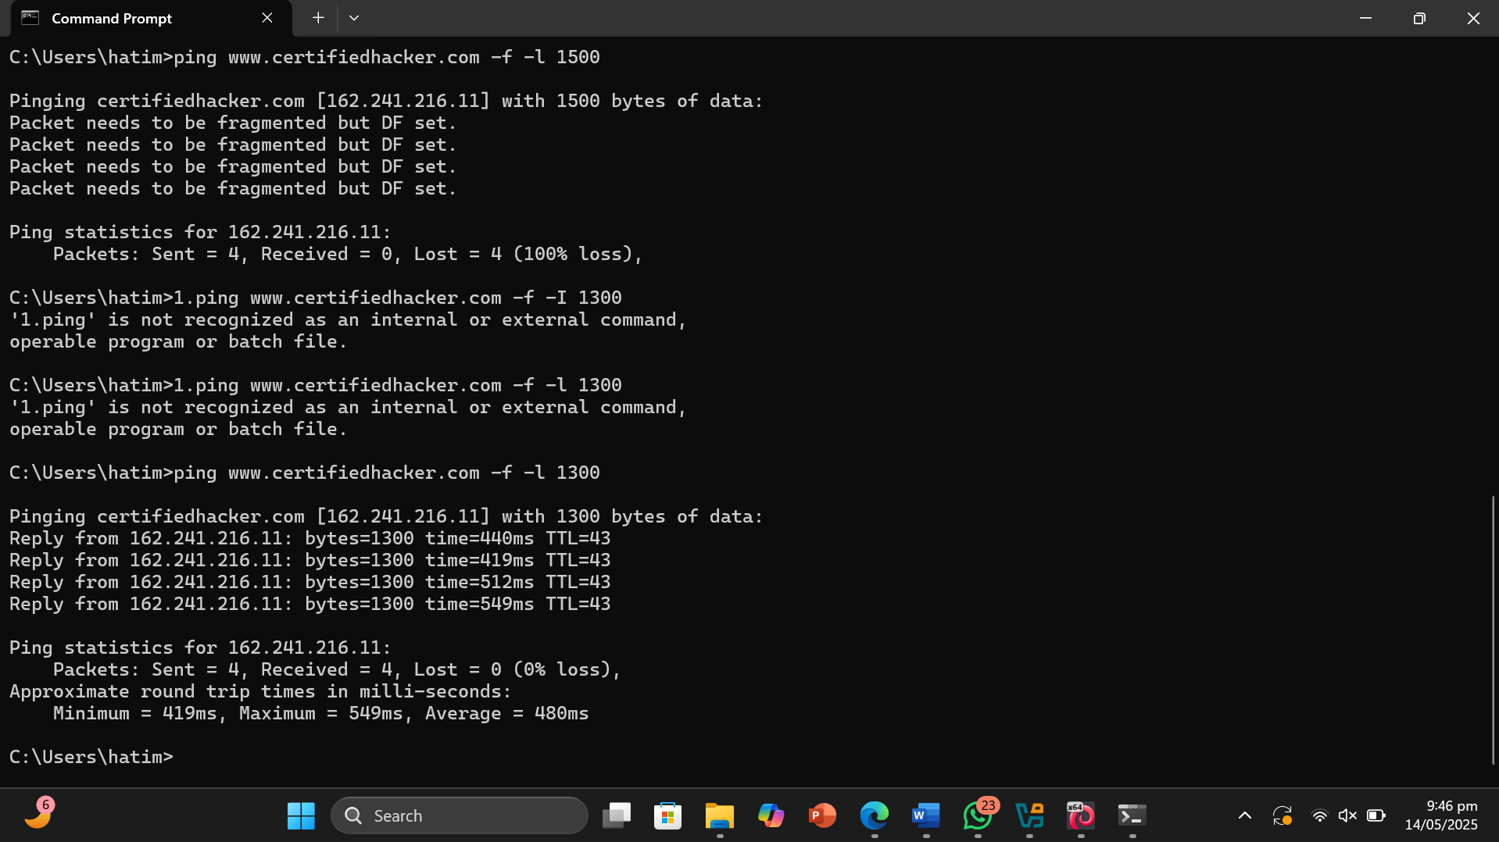

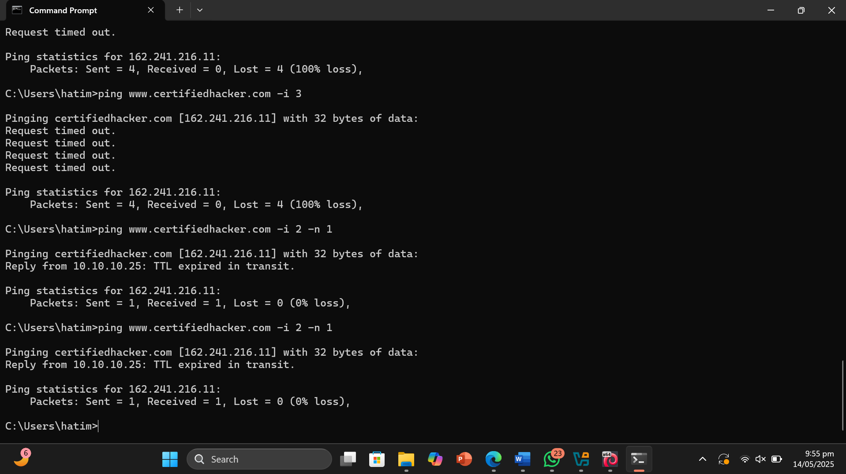

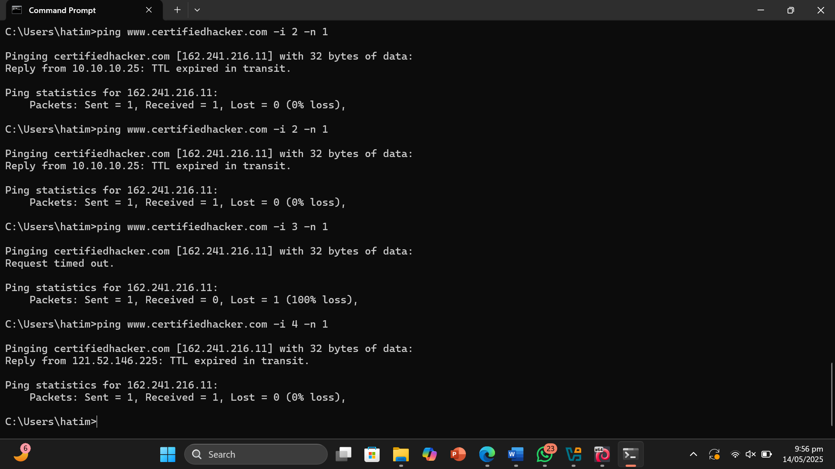

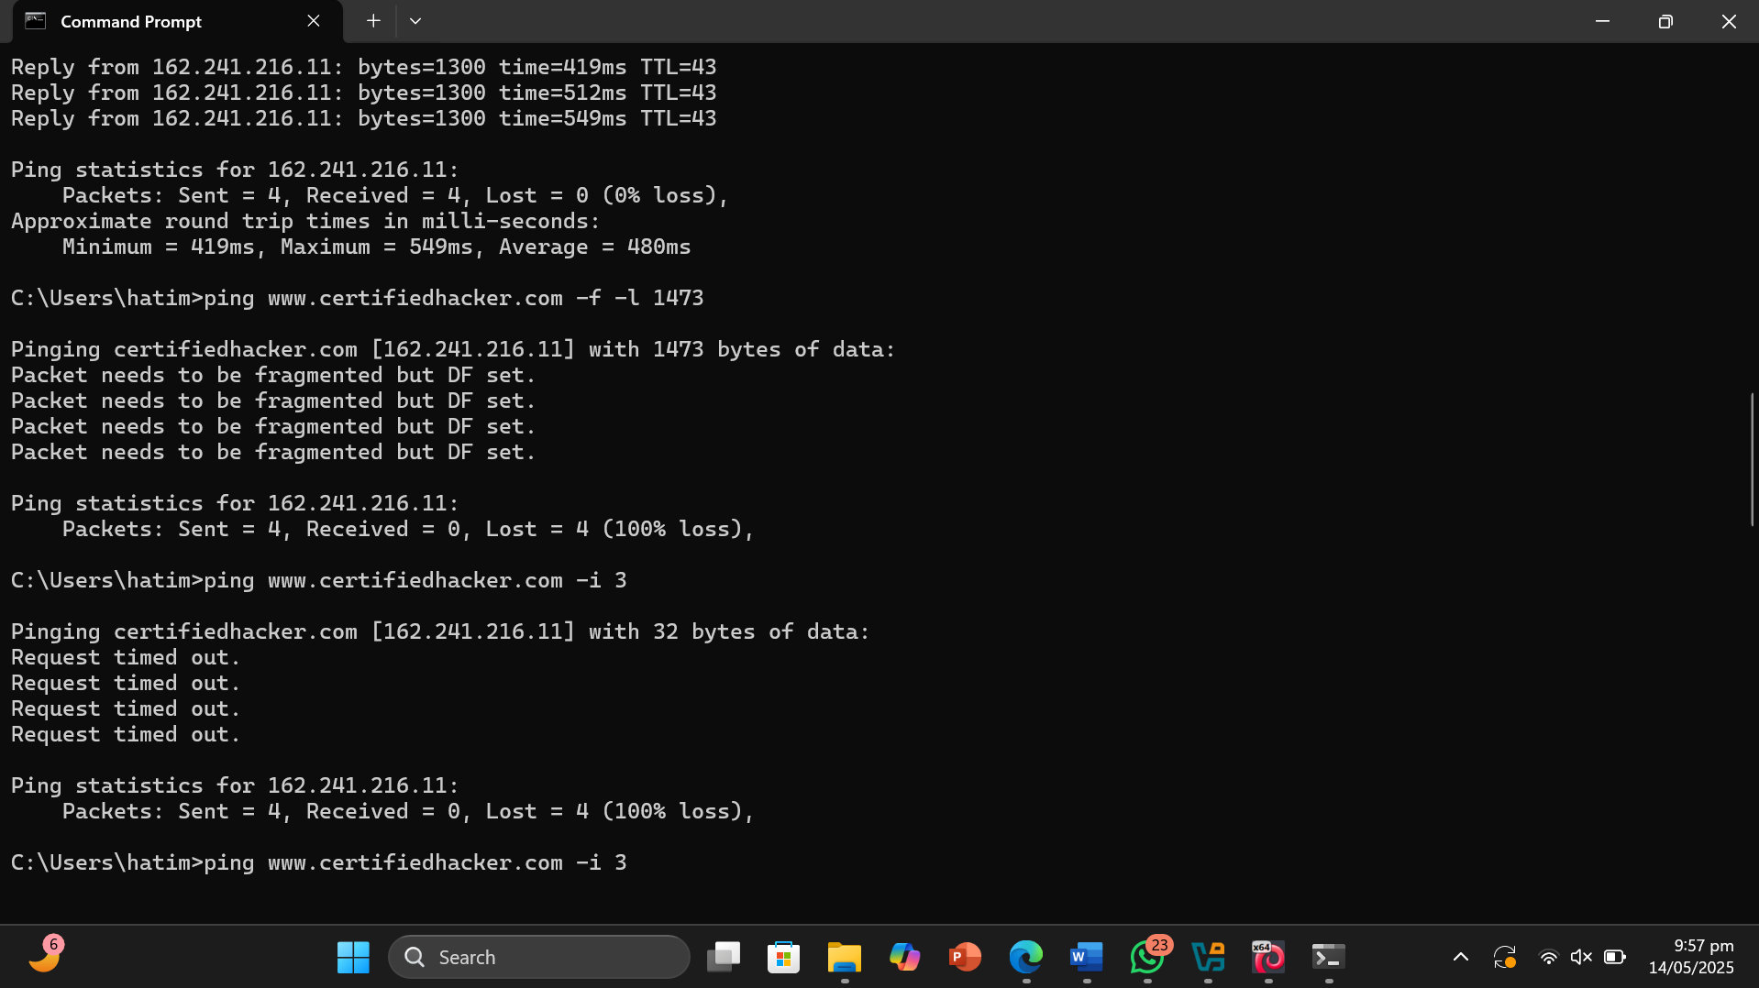

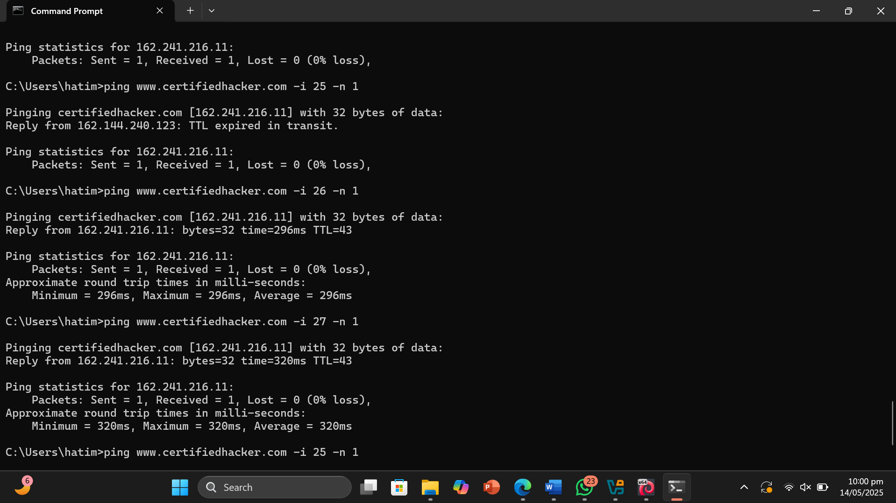

* Result or Output: The commands actually gave the result of the packets that were sent to the website . These commands told us whether our packets were being received by the website or not . I kept on changing the TTL value until I got my desired outcome as the commands kept making TTL expire in transit .
* Interpretation: I learned that website footprinting can be performed using the command prompt. By sending packets to a website, we can determine whether they are received, which helps verify connectivity. Additionally, we can identify the number of routers between the source and destination using the concept of 'hops.' The TTL (Time To Live) value indicates how many routers the packet passes through before reaching its destination.

Objective of Task 2: Gather Information About a Target Website using Photon

Target Website : [www.certifiedhacker.com](http://www.certifiedhacker.com)

* Command or Procedure Used:

1. Open Parrot OS terminal.
2. Entered sudo su.
3. Went to the directory where file is kept.
4. Created and activated a virtual environment with name myenv.
5. Installed tld using pip install tld.
6. Installed requests.
7. Entered python3 photon.py -u <http://www.certifiedhacker.com> .
8. Entered python3 photon.py -u <http://www.certifiedhacker.com> -I 3 -t 200 --wayback
9. Got Results.

* Screenshot:

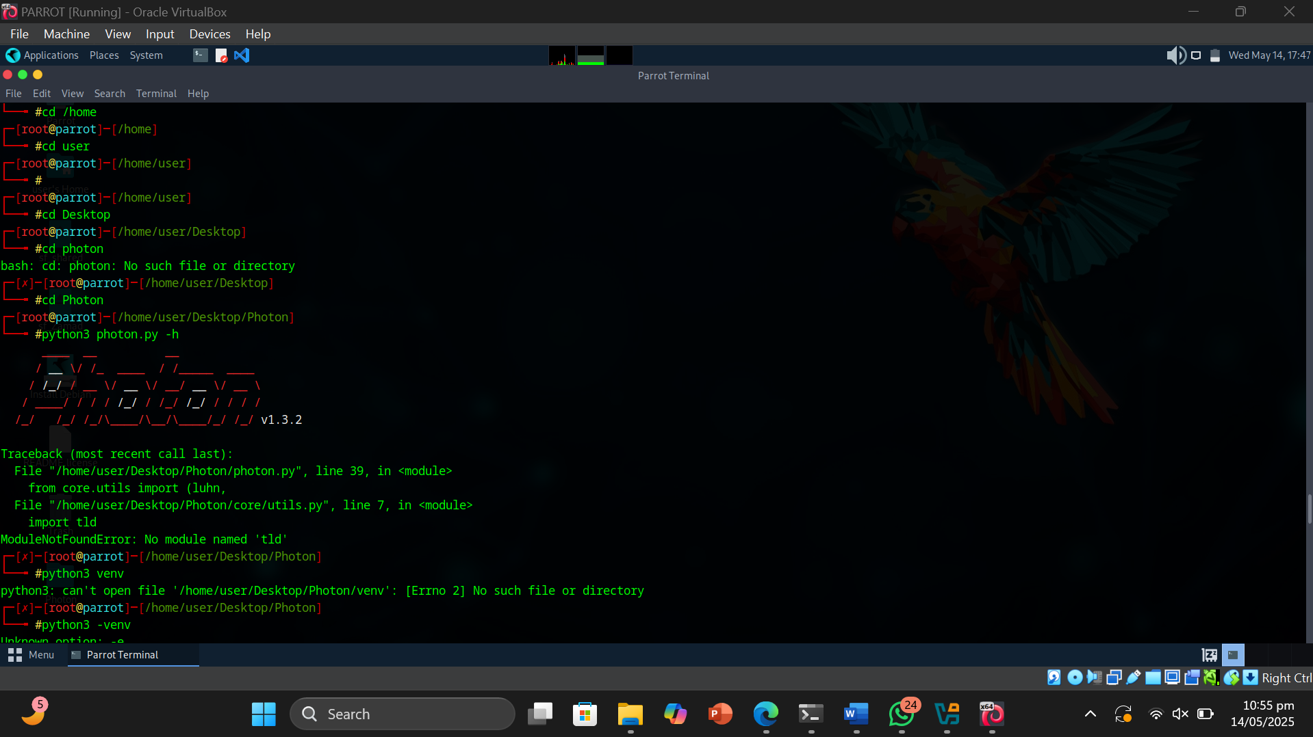

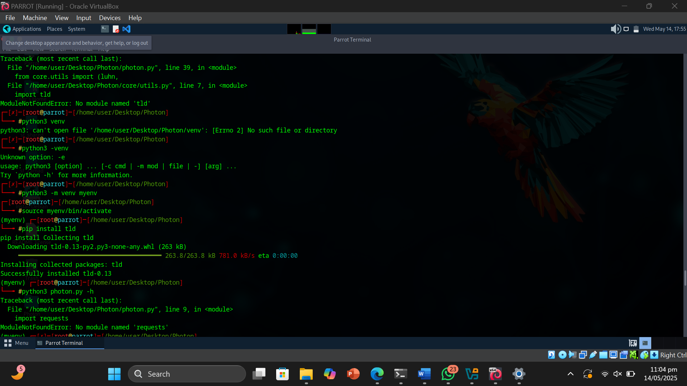

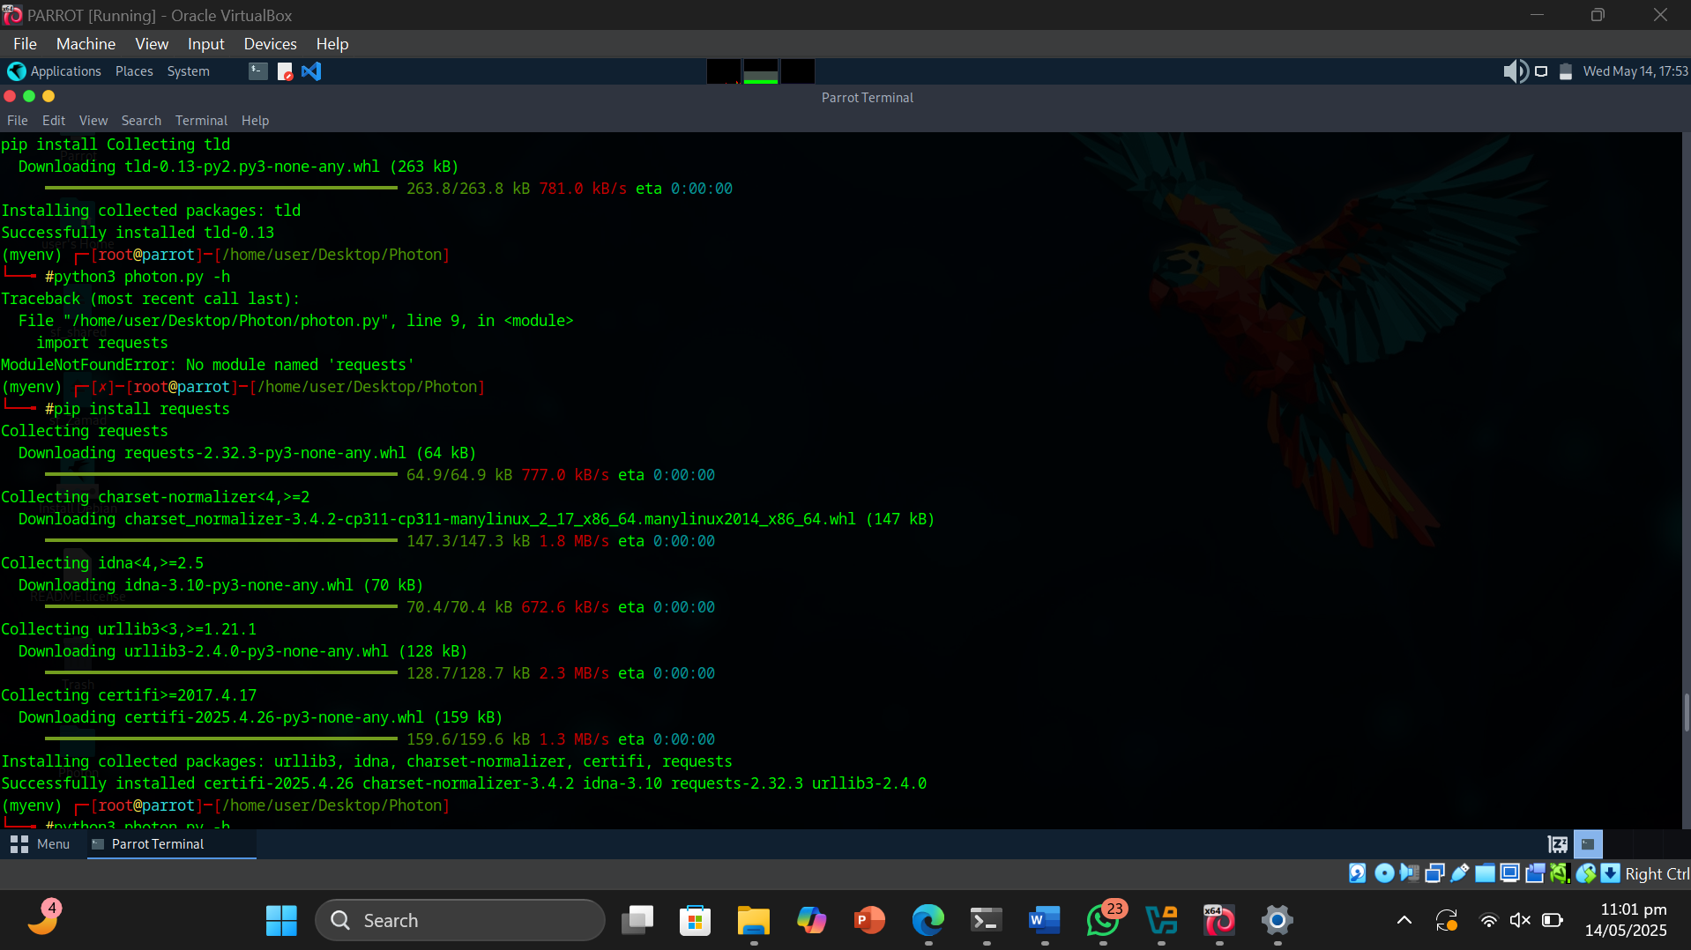

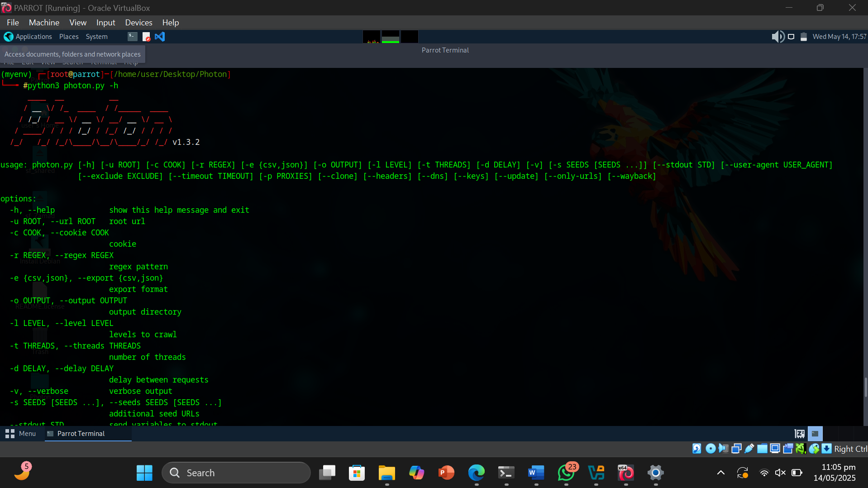

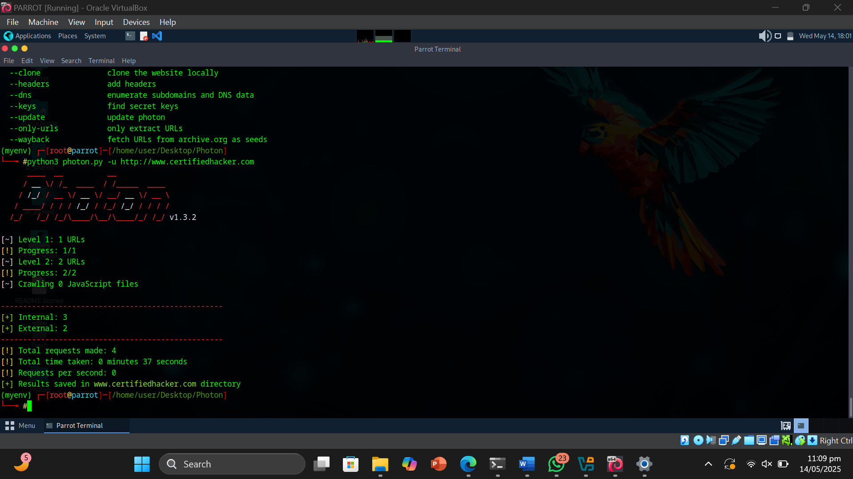

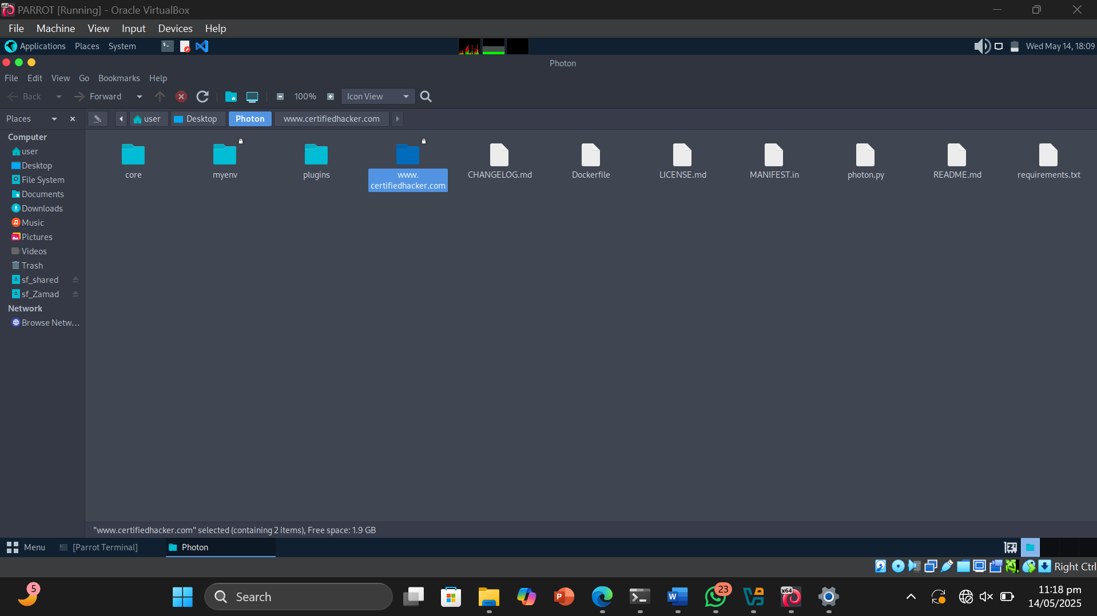

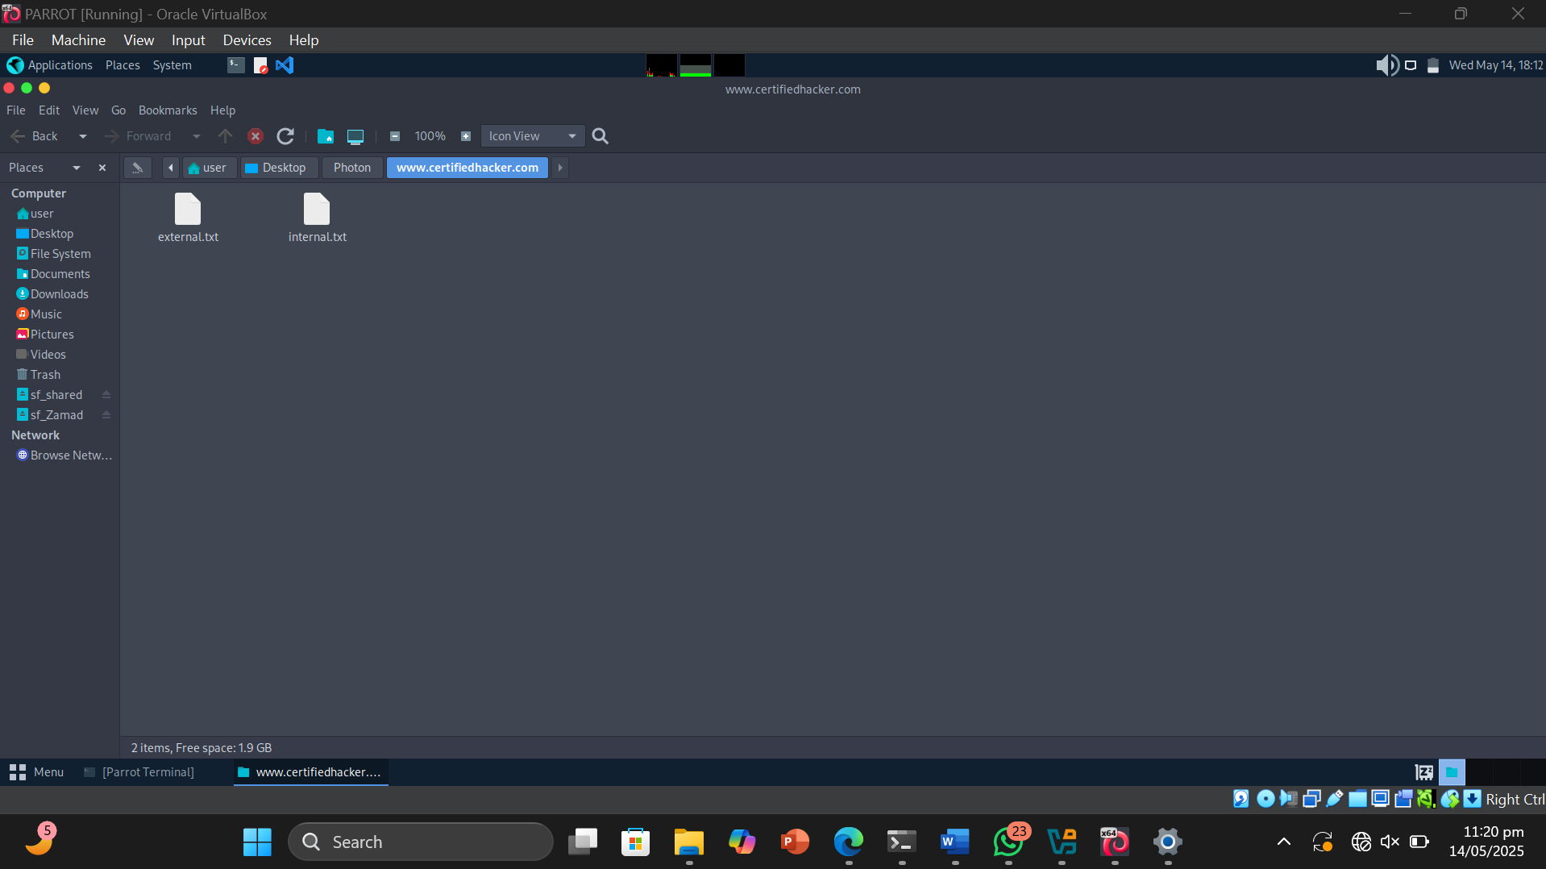

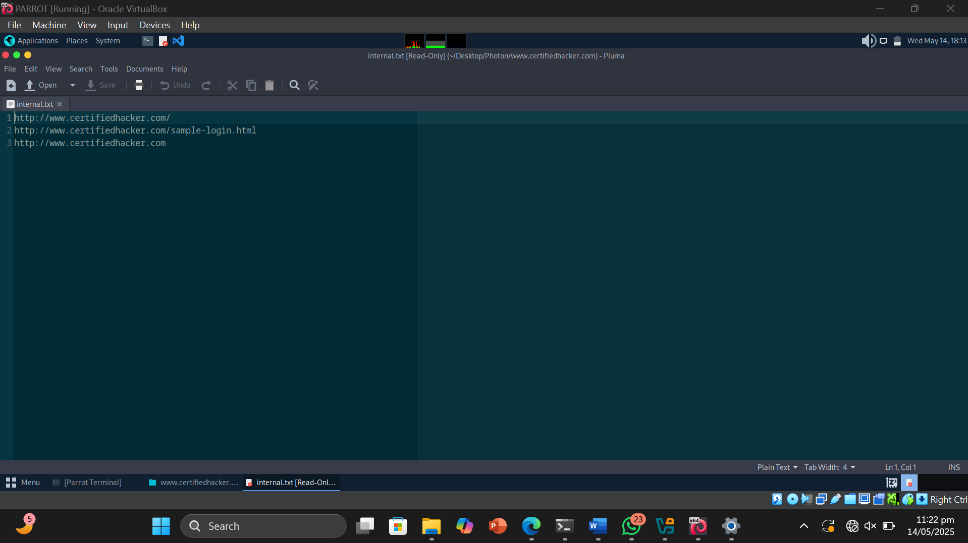

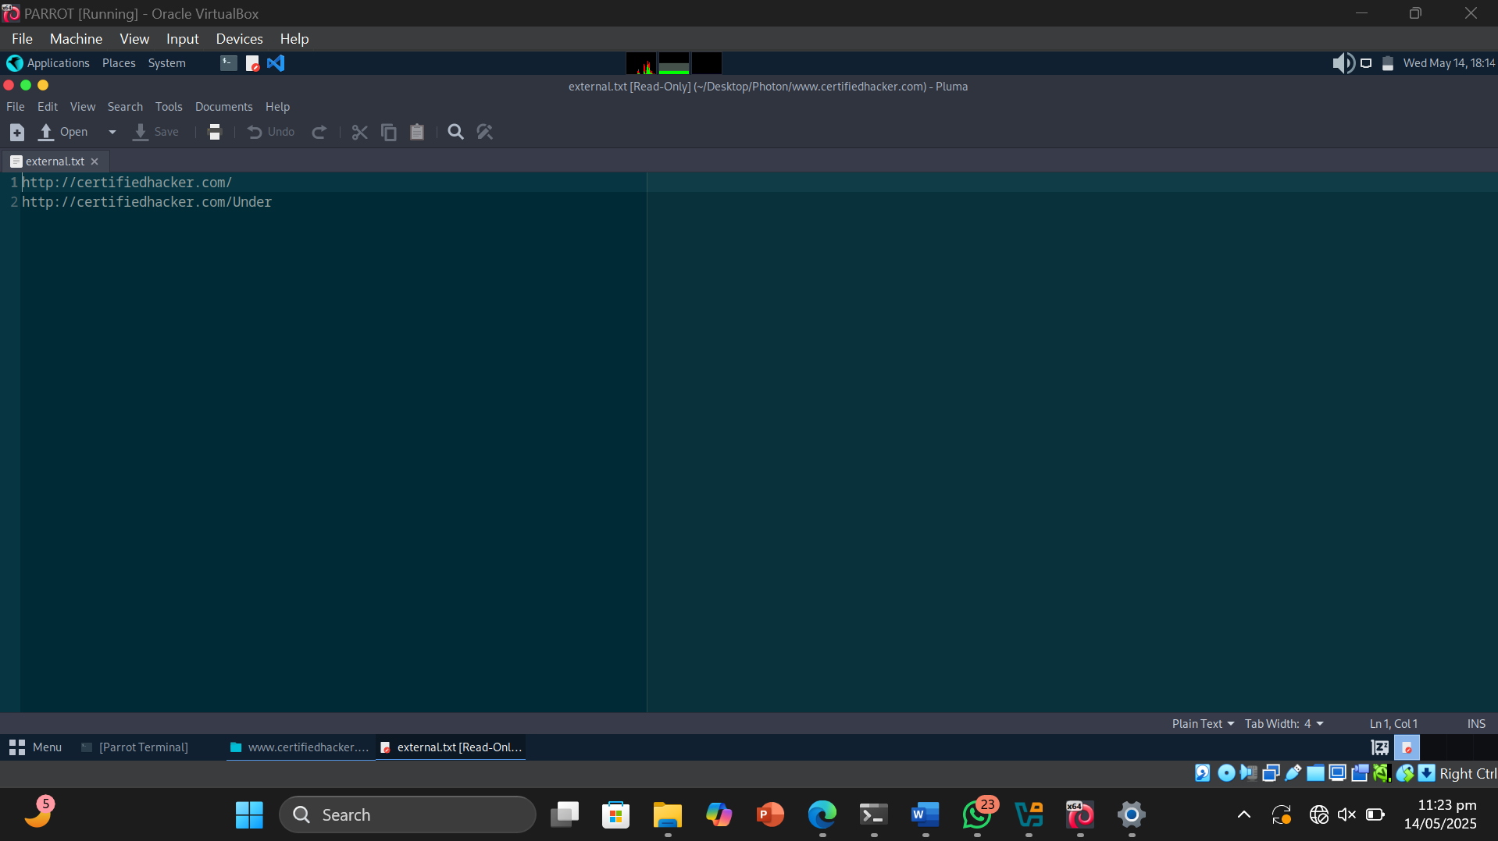

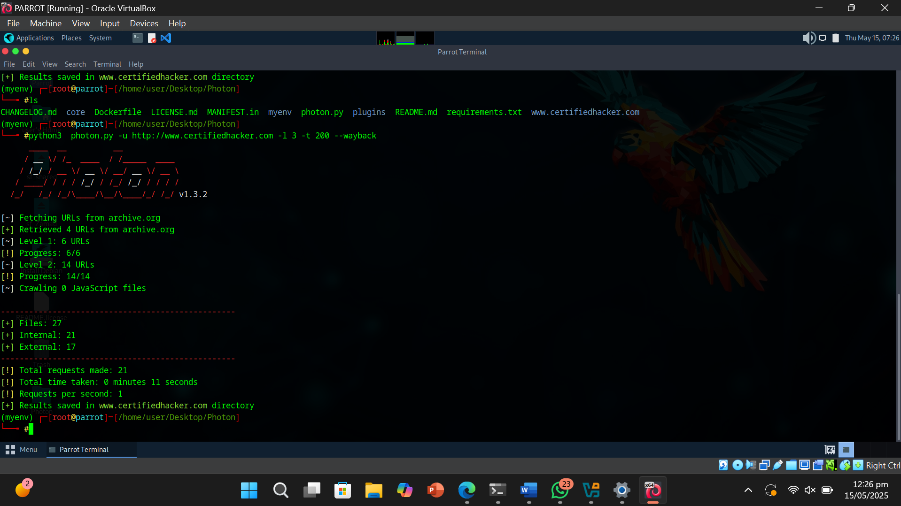

* Result or Output: The Photon tool was used to analyze the target domain www.certifiedhacker.com. It successfully crawled the website and retrieved URLs from multiple levels, including level 1 and level 2, by following internal links recursively. During the scan, Photon extracted both internal and external links, as well as JavaScript files embedded or linked within the pages. Additionally, the tool leveraged the Wayback Machine to gather archived URLs and historical data related to the target domain. The collected information was organized into separate files and directories, categorizing the results such as internal URLs, external URLs, JavaScript files, and Wayback data for easier analysis and further investigation
* Interpretation: I learned that website footprinting can be effectively performed using the Photon tool. It helps in gathering valuable information about a target website by extracting its URLs, internal and external links, JavaScript files, and other related data. This information can be useful for understanding the structure and components of the website, which is essential in reconnaissance during cybersecurity assessments.

Objective of Task 3: Gather Information About a Target Website using Central Ops

Target Website : [www.certifiedhacker.com](http://www.certifiedhacker.com)

* Command or Procedure Used:

1. Opened Windows 11 OS .
2. Visited <https://centralops.net/>.
3. Pasted target url and pressed Go .Got the Result.

* 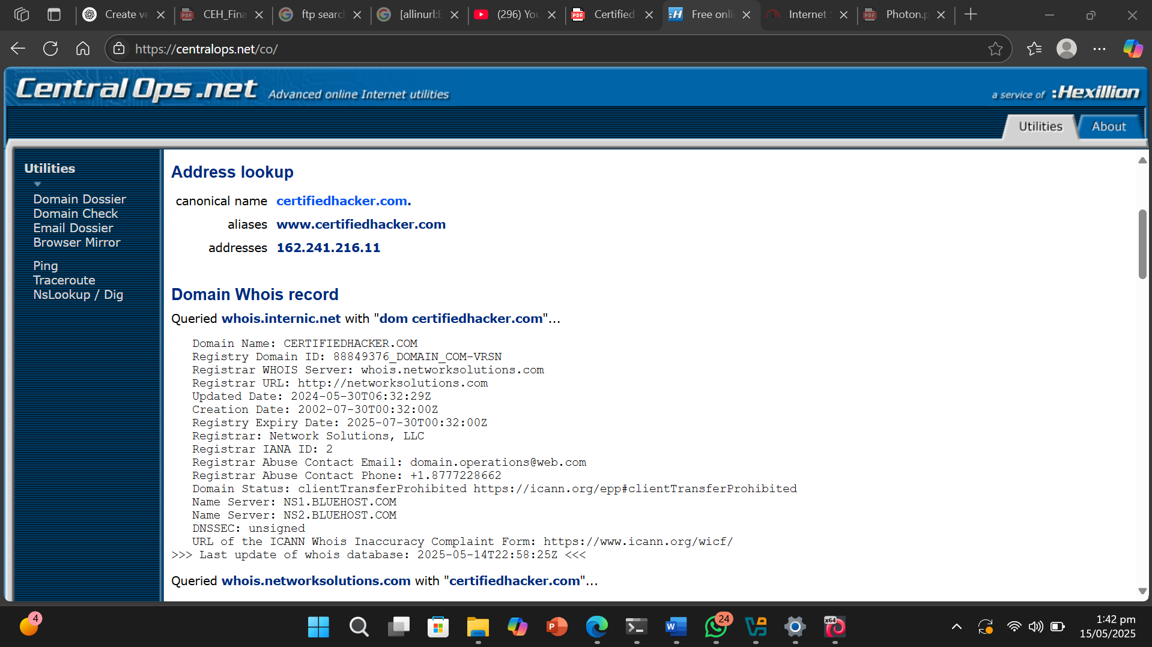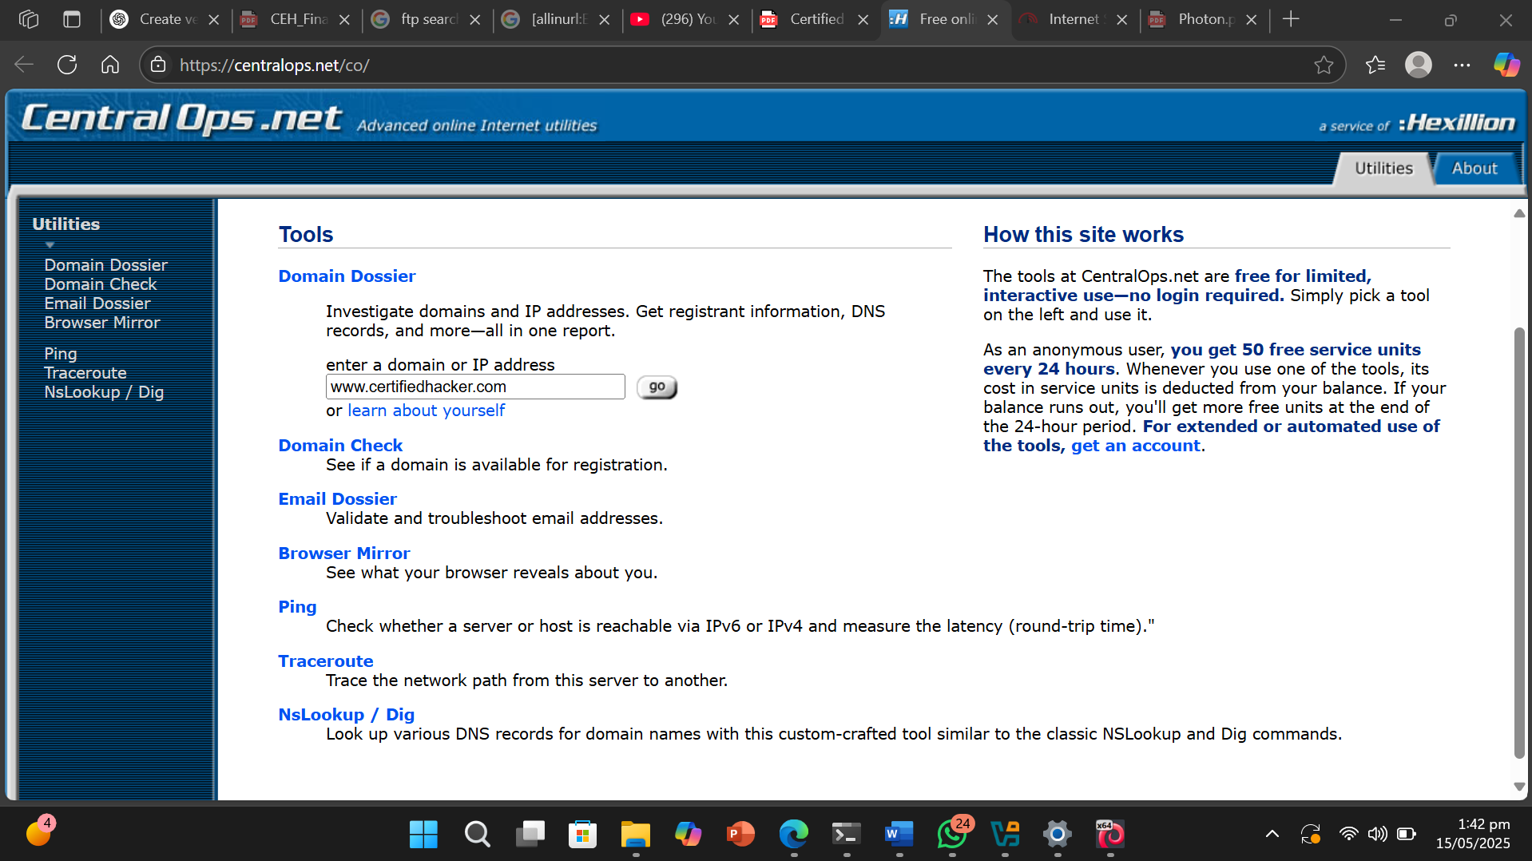Screenshot:

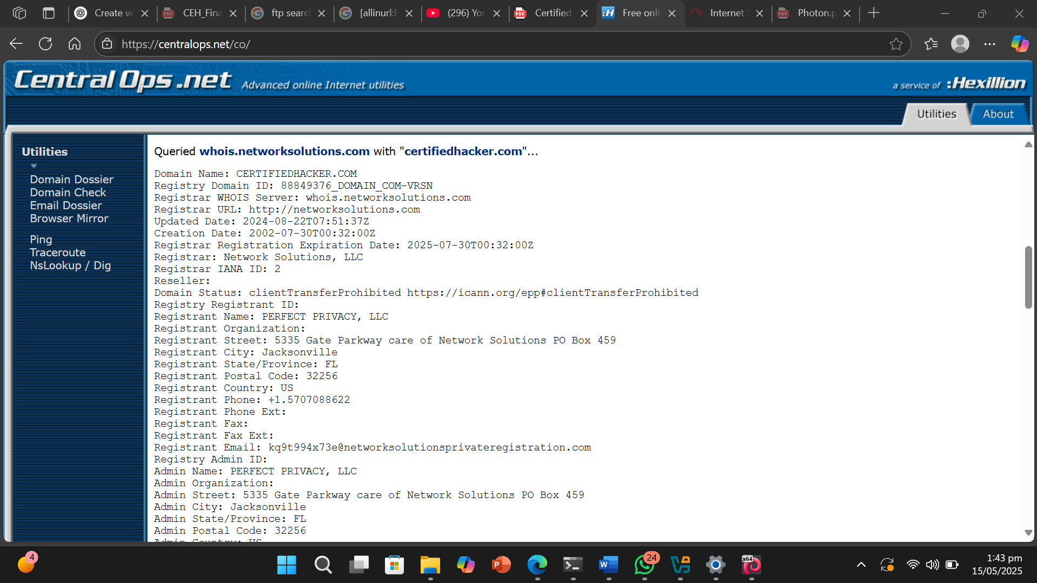

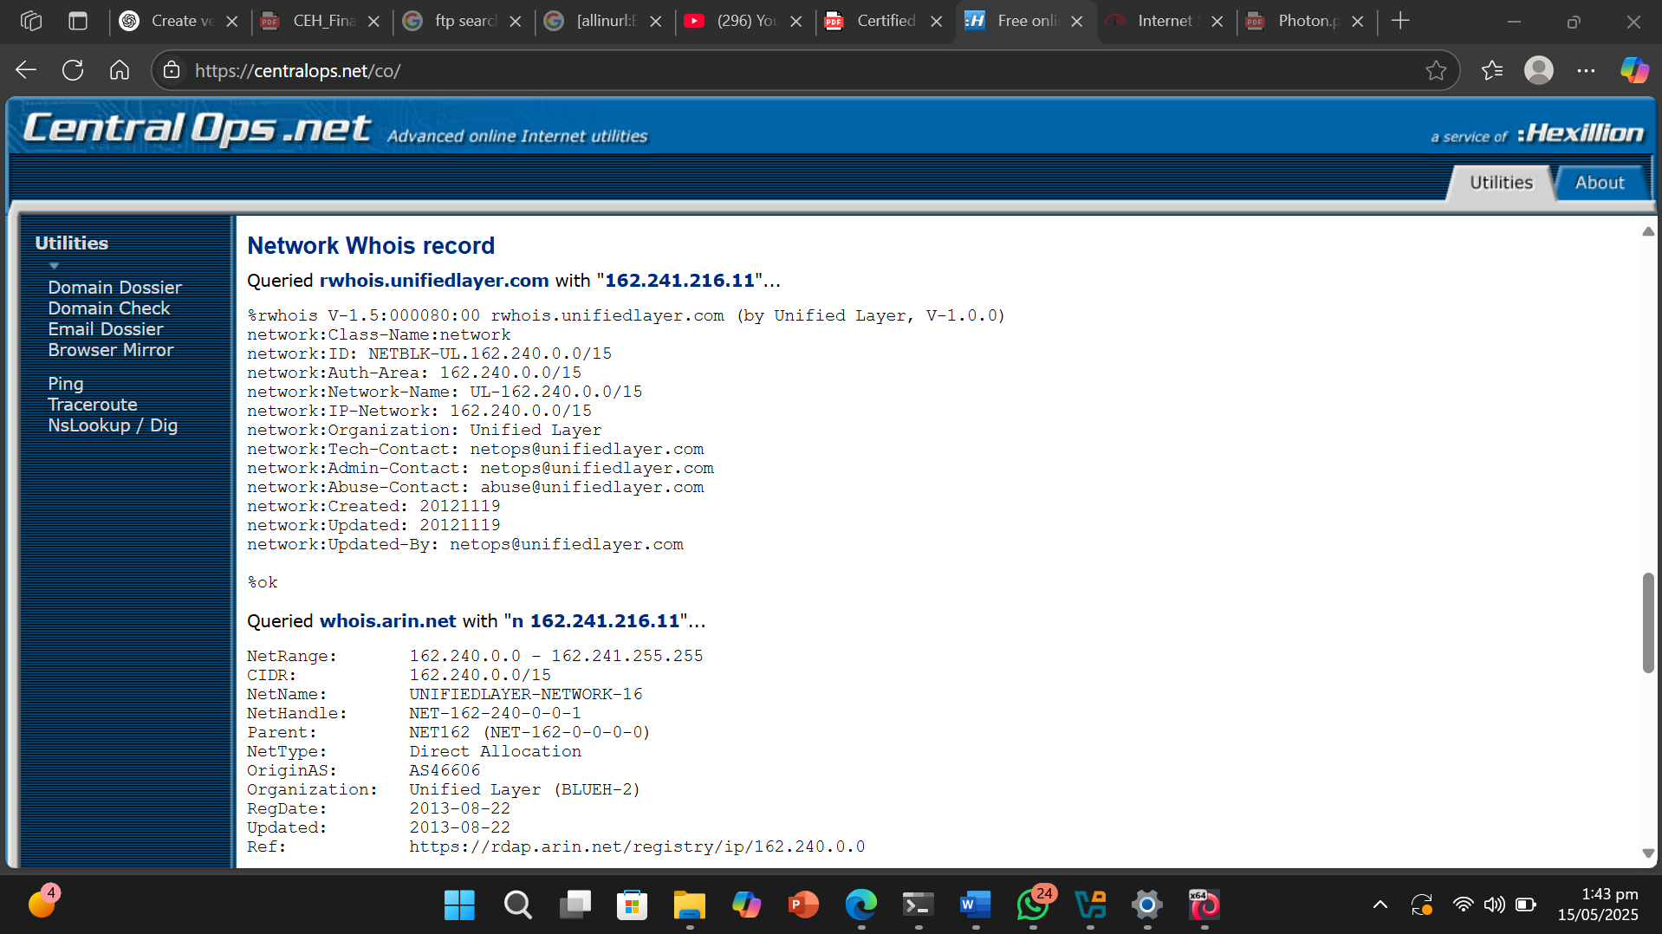

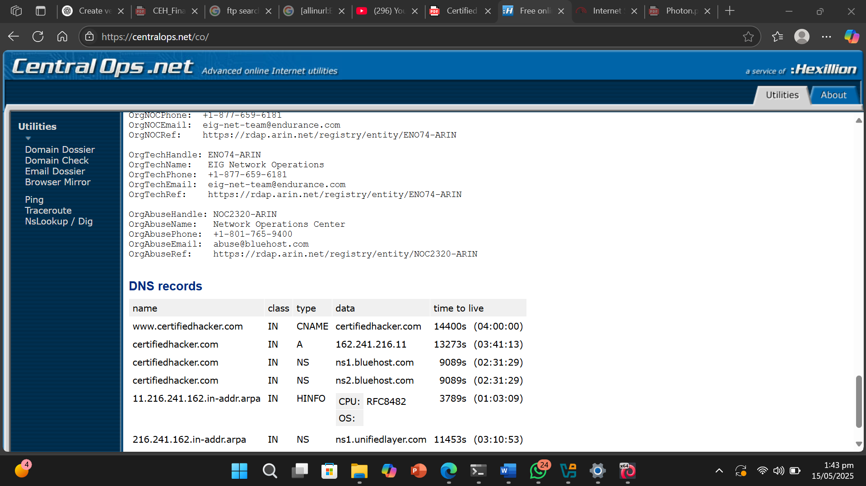

* Result or Output: By using the online tool available at *centralops.net*, I was able to gather various types of information about the target website. The tool provided detailed outputs such as WHOIS records, DNS records, address lookup, domain dossier, email dossier, and traceroute information. These features allowed me to identify the domain’s ownership details, server location, IP addresses, email configuration, and overall network structure related to the website.
* Interpretation: Through this exercise, I learned that website footprinting can be effectively performed using the *CentralOps* web-based tool. It offers a user-friendly interface to retrieve important reconnaissance data without requiring any software installation. I understood how DNS records reveal the mapping between domain names and IP addresses, while WHOIS records provide essential information about the domain’s registrant, registration dates, and contact details. This tool proved to be very useful for collecting preliminary intelligence on a target website, which is a crucial step in ethical hacking and cybersecurity assessments.

Objective of Task 4: Extract a Company’s Data using Web Data Extractor

Target Website : [www.certifiedhacker.com](http://www.certifiedhacker.com)

* Command or Procedure Used:

1. Opened Windows 11 OS .
2. Opened webdata extractor .
3. Created a new session and pasted our target website URL and started it .
4. Got Result.

* Screenshot :

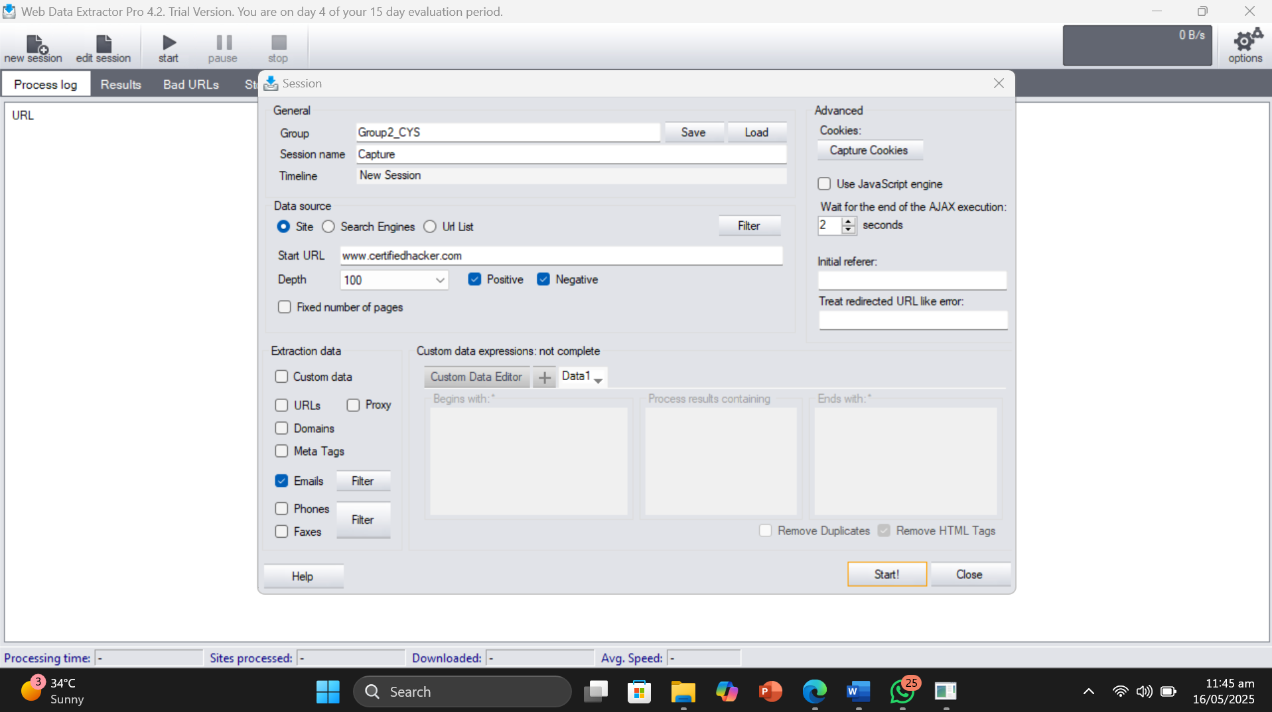

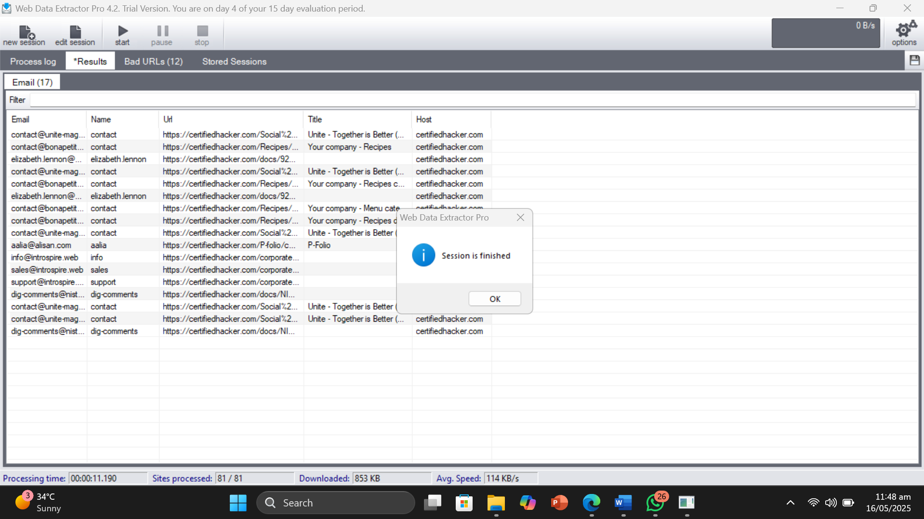

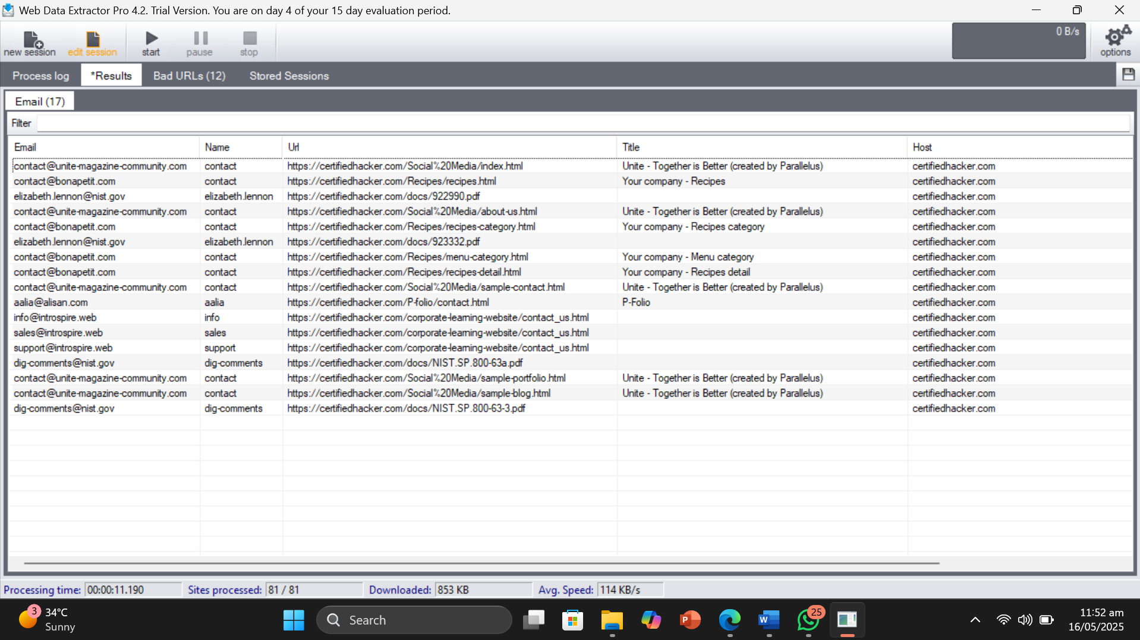

* Result or Output: Using *Web Data Extractor*, I was able to extract valuable information from the target company’s website. I got contact details such as email addresses, phone numbers, and fax numbers, along with URLs and meta tags including titles, descriptions, and keywords. All this data was collected automatically by the tool through its web crawling capabilities.
* Interpretation: I understood that footprinting can be performed efficiently using tools like *Web Data Extractor*. It acts as a web spider (also called a web crawler or robot) that scans websites and retrieves specific data without manual effort. The extracted information—such as contact info, URLs, and meta tags—is essential for ethical hackers during the reconnaissance phase. This tool simplifies the data-gathering process and helps identify key details that could be useful in further analysis or vulnerability assessment.

Objective of Task 5: Mirror a Target Website using HT Track Web Site Copier

Target Website : www.example.com

* Command or Procedure Used:

1. Opened Windows 11 OS.
2. Opened HTTrack Website Copier.
3. Created a project , clicked next , pasted url , clicked next .
4. Ticked the checkbox , Download when finished.
5. Got the Resut nd then Browsed Mirror Website.

* Screenshot :

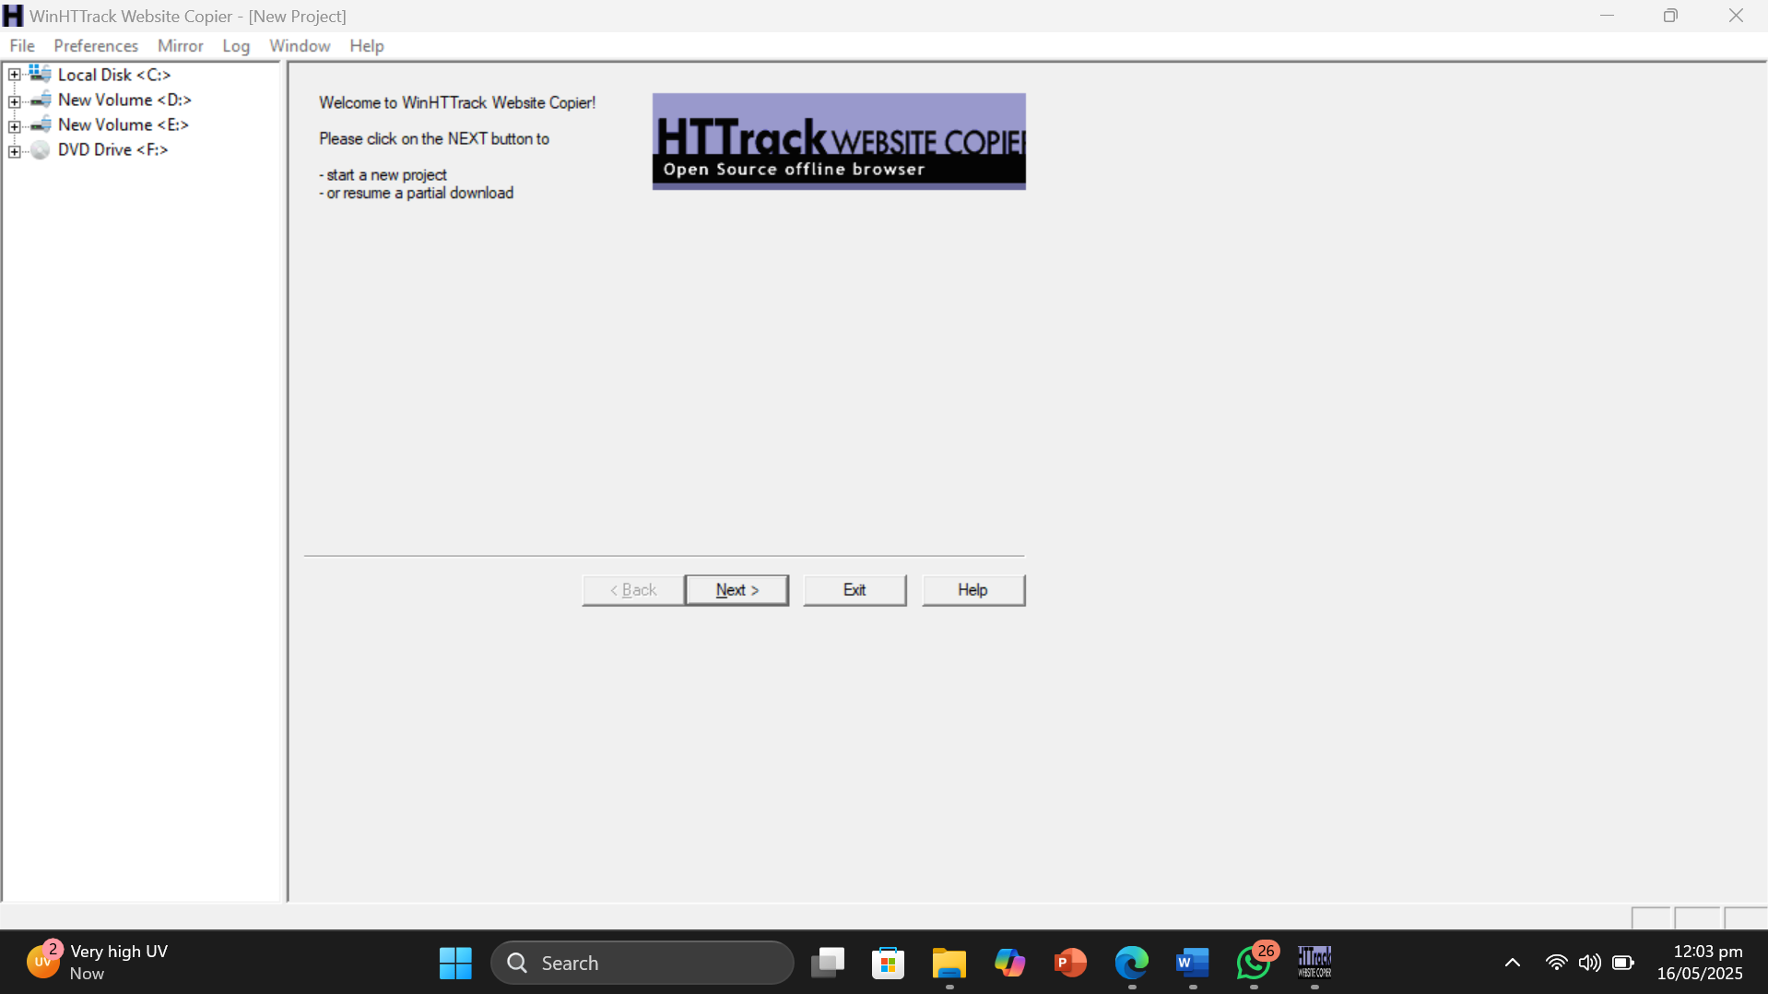

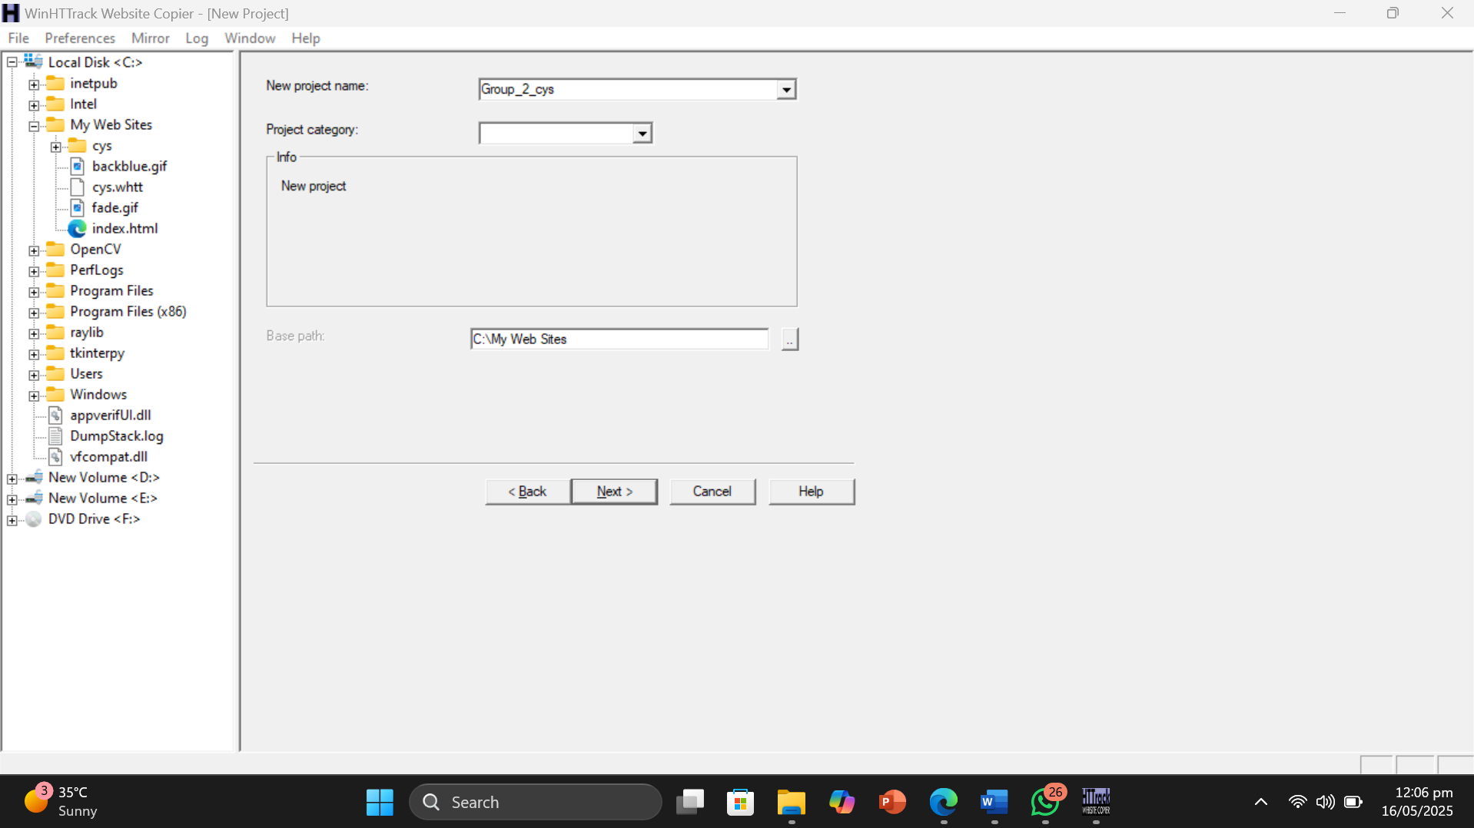

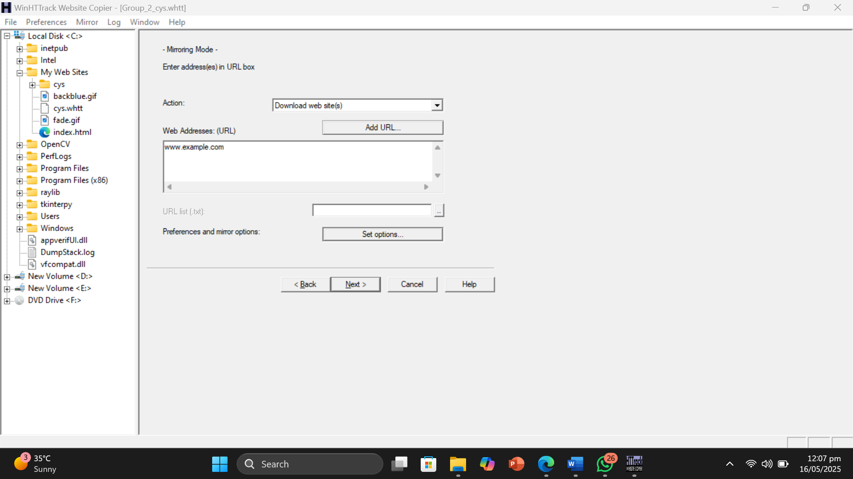

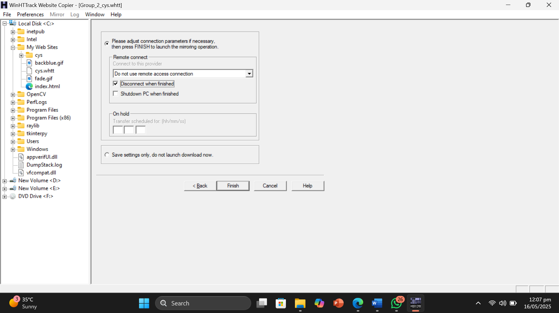

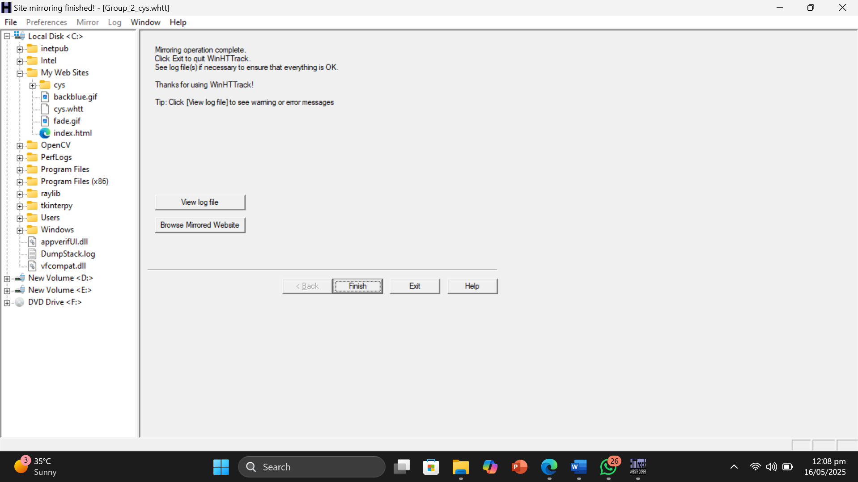

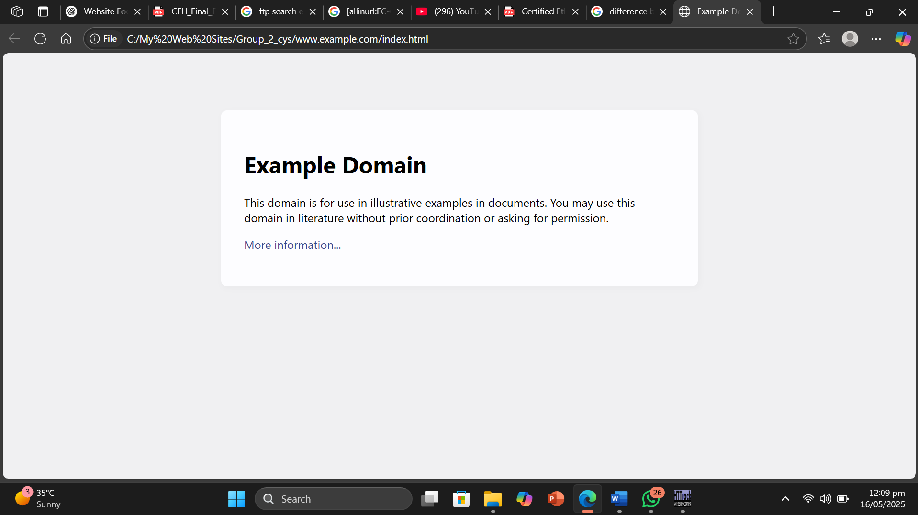

* Result or Output: Using *HTTrack Website Copier*, I was able to successfully mirror the website [**www.example.com**](http://www.example.com). The tool downloaded the full content of the page, including the HTML structure and styling elements. The mirrored version could be opened and browsed offline, preserving the look and structure of the original page.
* Interpretation: I understood that HTTrack Website Copier can be used to clone or mirror websites for offline analysis. Even though [**www.example.com**](http://www.example.com) is a simple and static demonstration site, this exercise helped me learn how the tool works. HTTrack automatically downloads all accessible components of the target website, including linked resources and internal pages. This can be especially useful in ethical hacking and footprinting for analyzing a site’s structure, identifying exposed directories or files, and preparing for deeper investigation without making repeated online requests to the original server

Objective of Task 6: Gather Information About a Target Website using GRecon

Target Website : www.example.com

* Error: The GRecon tool is currently outdated, and a newer version has been released. Unfortunately, the older version is no longer supported. Additionally, the official GitHub repository and related posts for GRecon have been removed or deleted. As a result, the original page is no longer accessible, and users cannot find the official resources.
* Error Proof: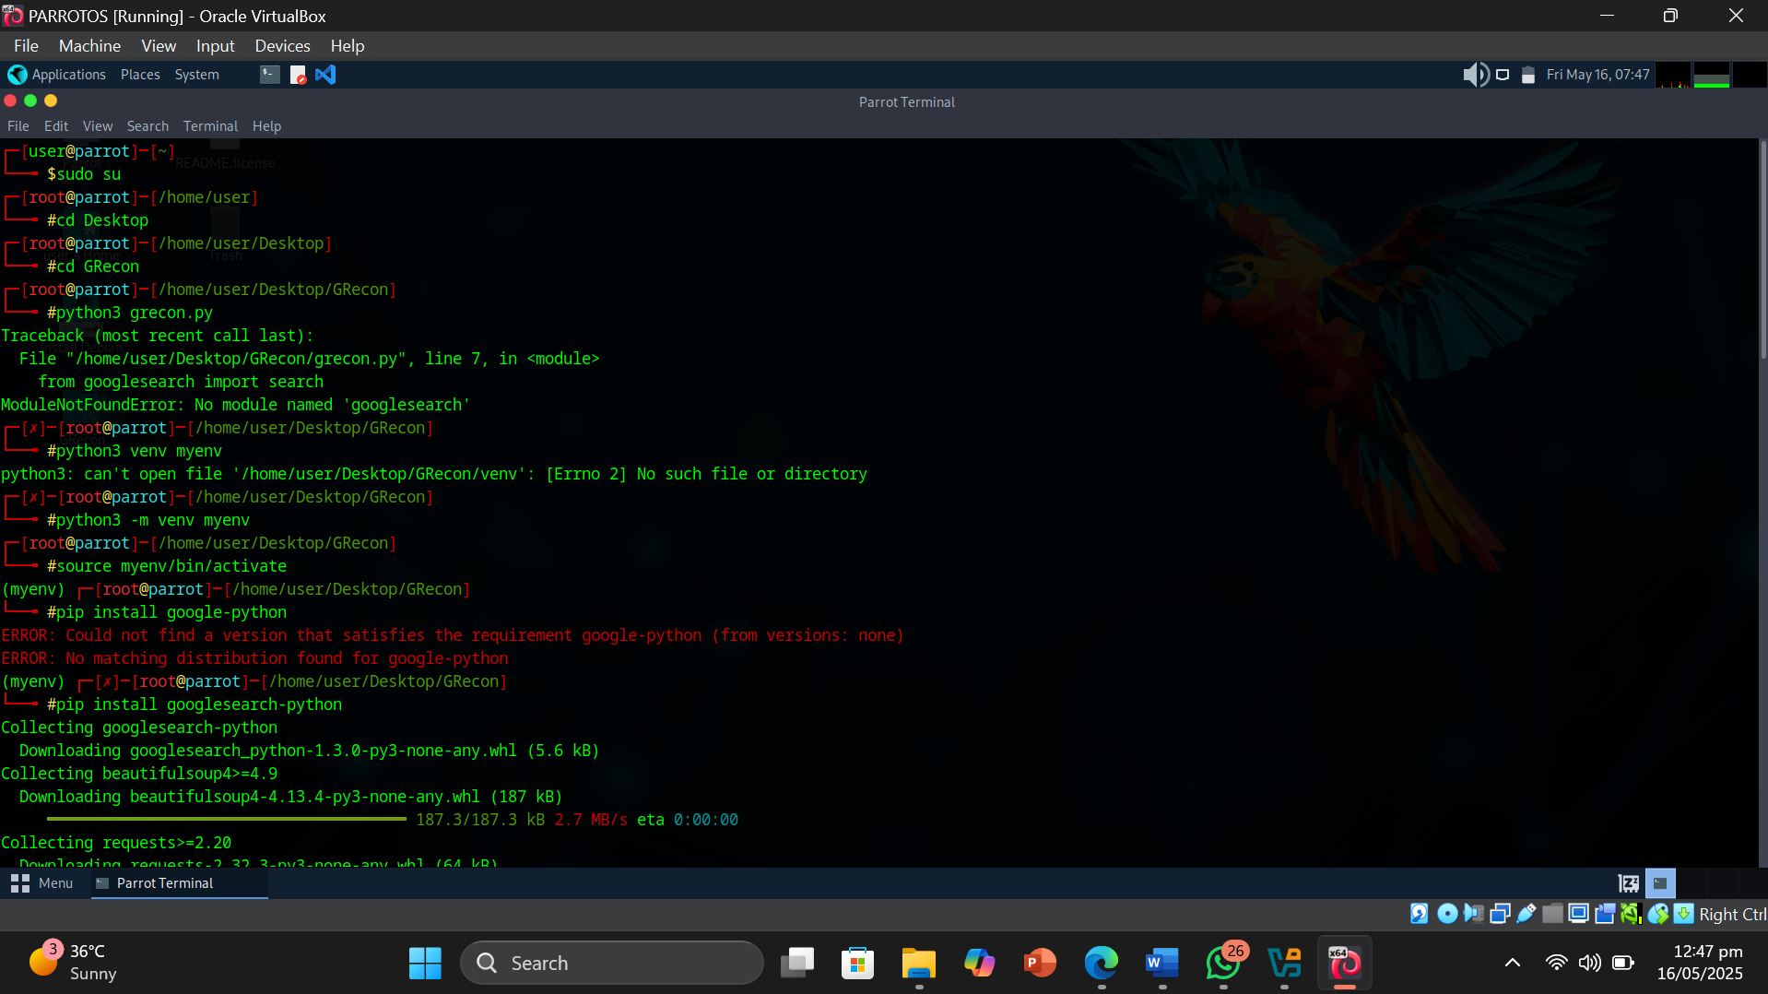

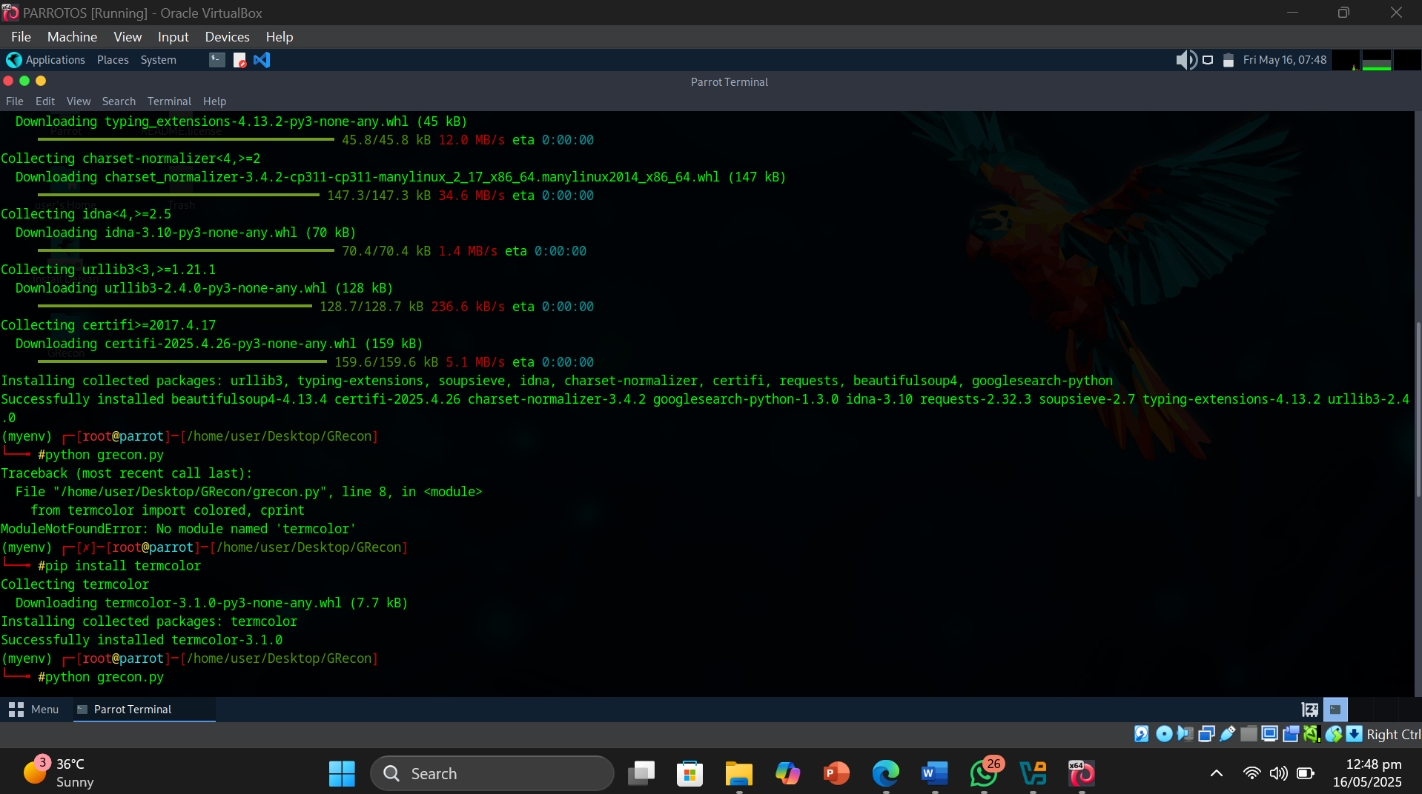

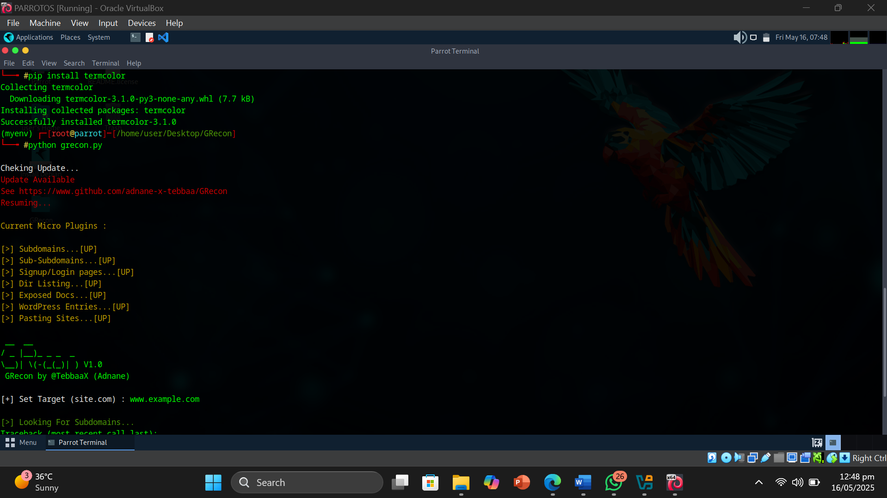

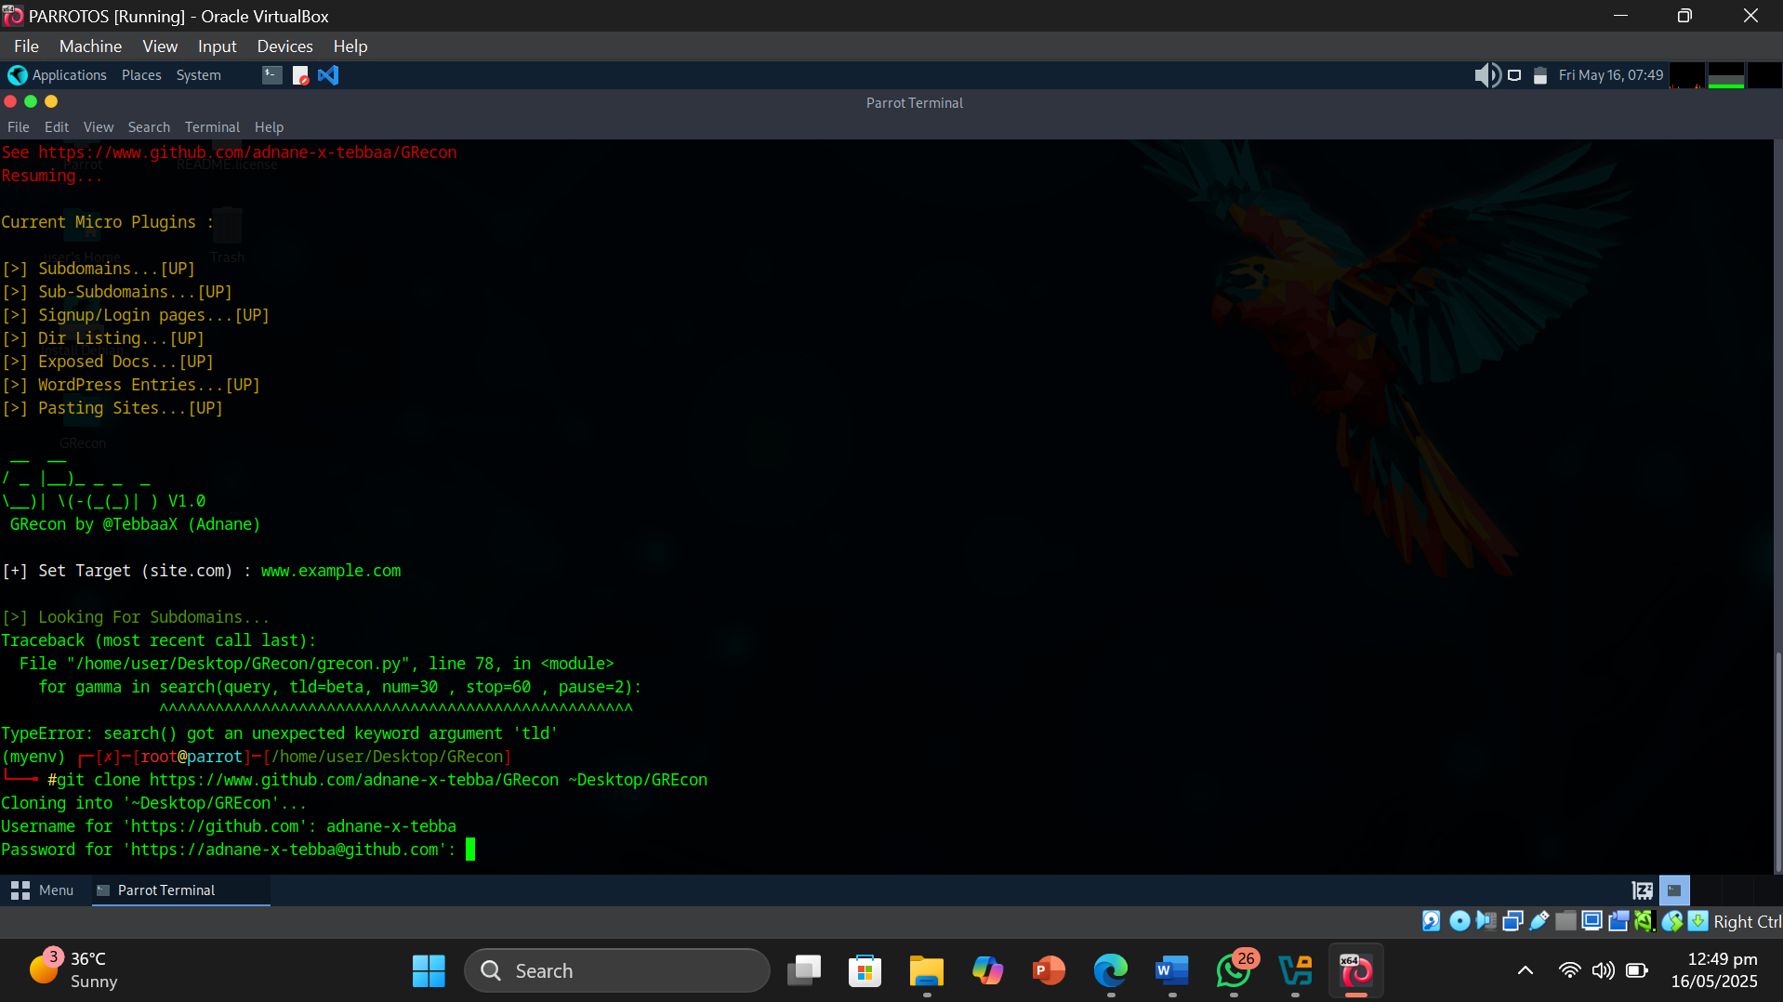

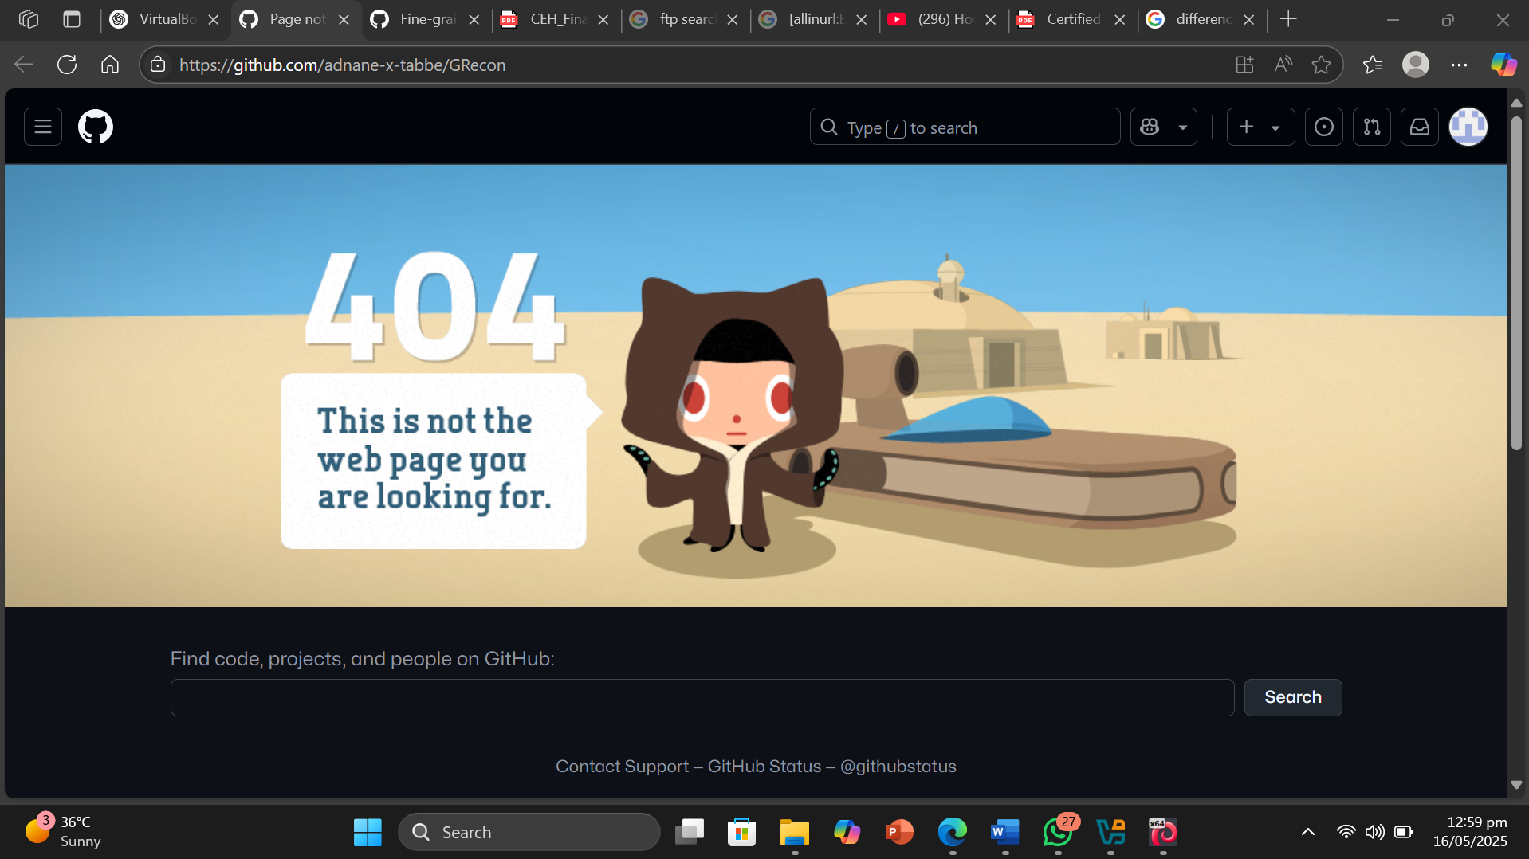

Objective of Task 7: Gather a Wordlist from the Target Website using CeWL

Target Website : www.example.com

* Command or Procedure Used:

1. Opened Parrot OS terminal.
2. Typed cewl -d 2 -m 5 www.example.com .
3. Got the words out,.
4. Stored them in wordlist.txt .
5. Viewed the result.

* 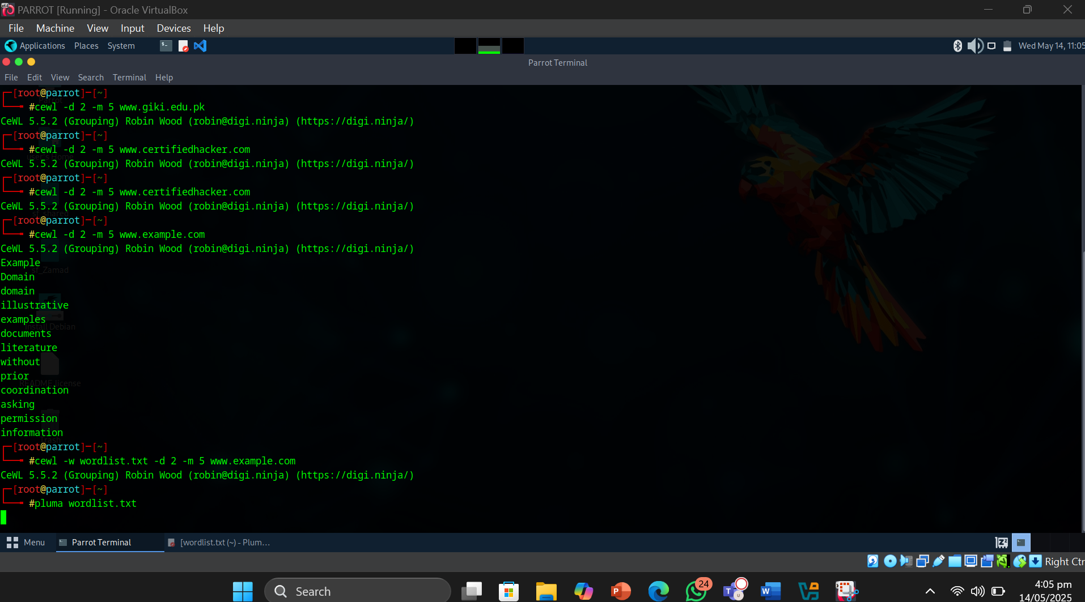Screenshot :

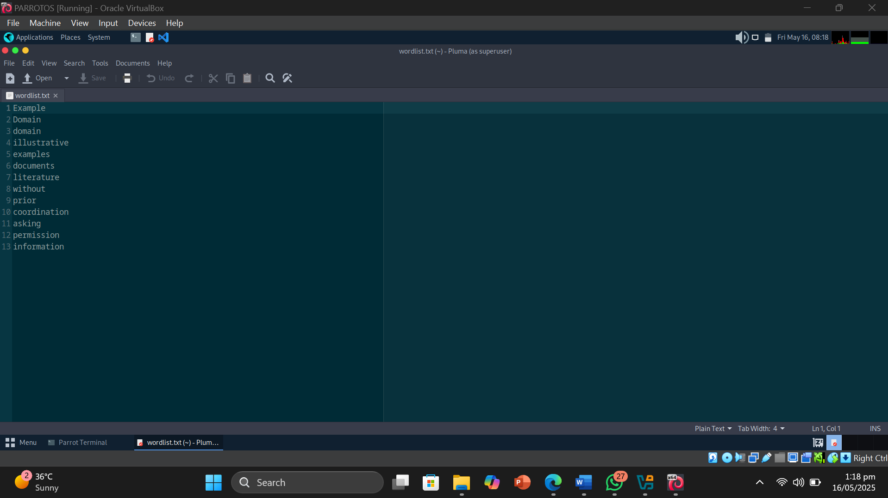

* Result or Output: Using the command cewl -d 2 -m 5 www.example.com, I successfully extracted words from the target website. The tool crawled the site up to two levels deep, collecting words that are at least five characters long. The collected words were stored in a file named wordlist.txt. This wordlist can be used for password cracking or further security assessments
* Interpretation: I learned that CeWL is an effective tool for creating custom wordlists by crawling websites and extracting relevant words based on specific parameters such as crawl depth and minimum word length. This method helps gather context-specific words which may be more useful for password guessing compared to generic wordlists. This exercise highlighted how automated word extraction can aid ethical hacking tasks such as footprinting and reconnaissance by providing targeted data without manual effort.

Module 3: Lab 3 Perform OS Discovery

Objective of Task 1: Identify the Target System’s OS with Time-to-Live (TTL) and TCP Window Sizes using Wireshark

Target Machine : Windows Server 2019 and Parrot OS

* Command or Procedure Used:

1. Opened Windows OS VM.
2. Opened Control panel and searched for Windows Defender Firewall.
3. Went to the Advanced Settings in the firewall and added a custom inbound rule to allow all ICMPv4 packets.
4. Did the same for Windows Server 2019 .
5. Got the ip address of Windows Server 2019 .
6. Pinged Windows Server 2019.(to check if it works).
7. Opened Wireshark and chose the Wifi Network.
8. Pinged Windows Server 2019 .
9. Got the Result . (TTL =128)
10. Got the ip address of Parrot OS VM.
11. Pinged Parrot OS.
12. Got the Result. (TTL=64)

* Screenshot:

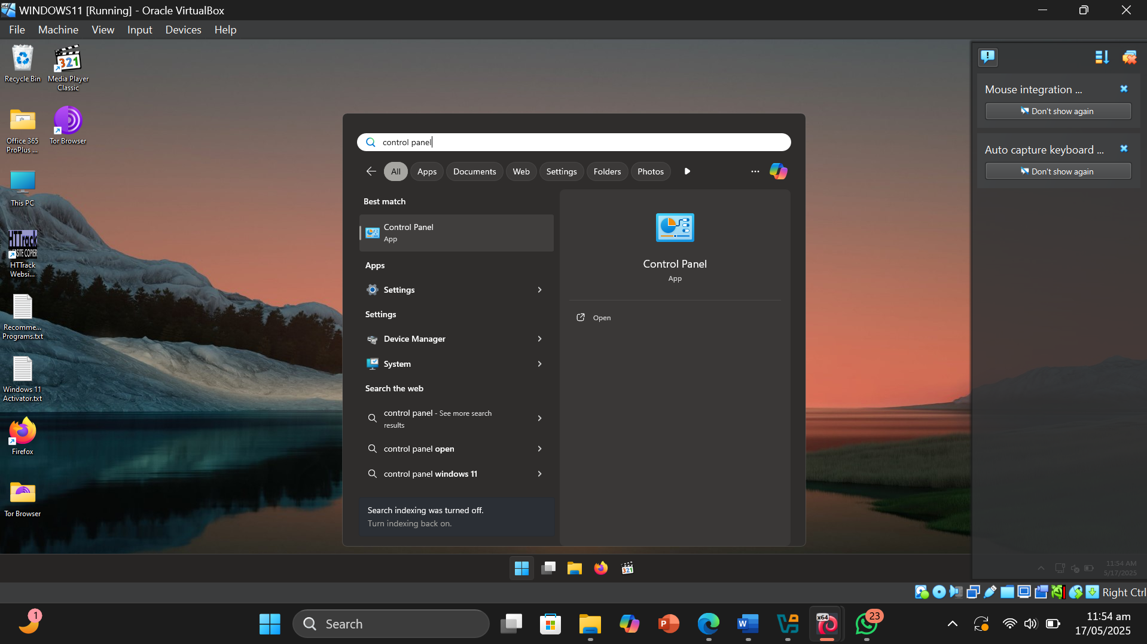

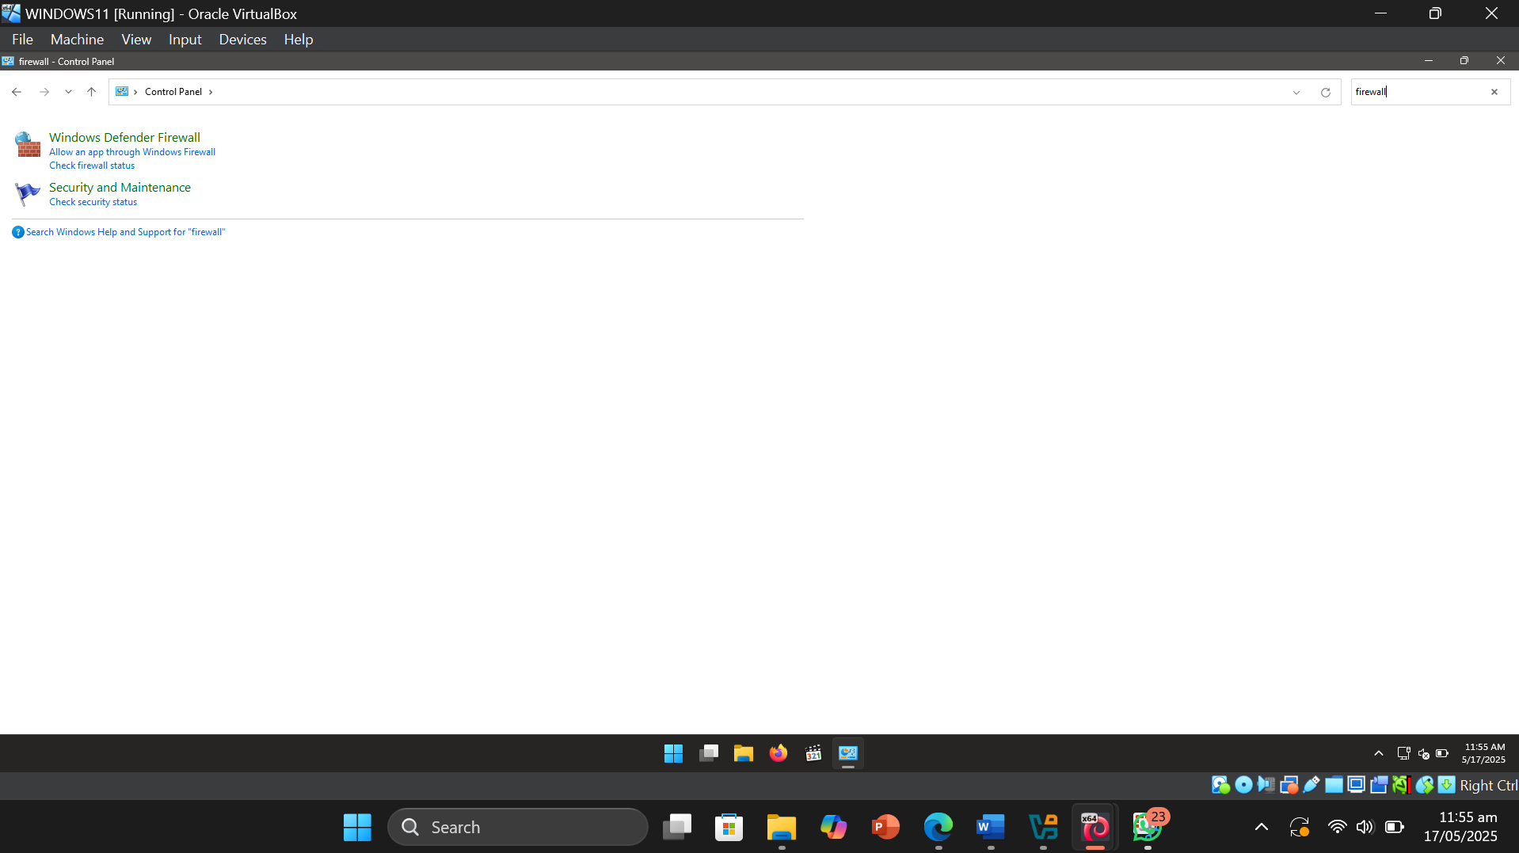

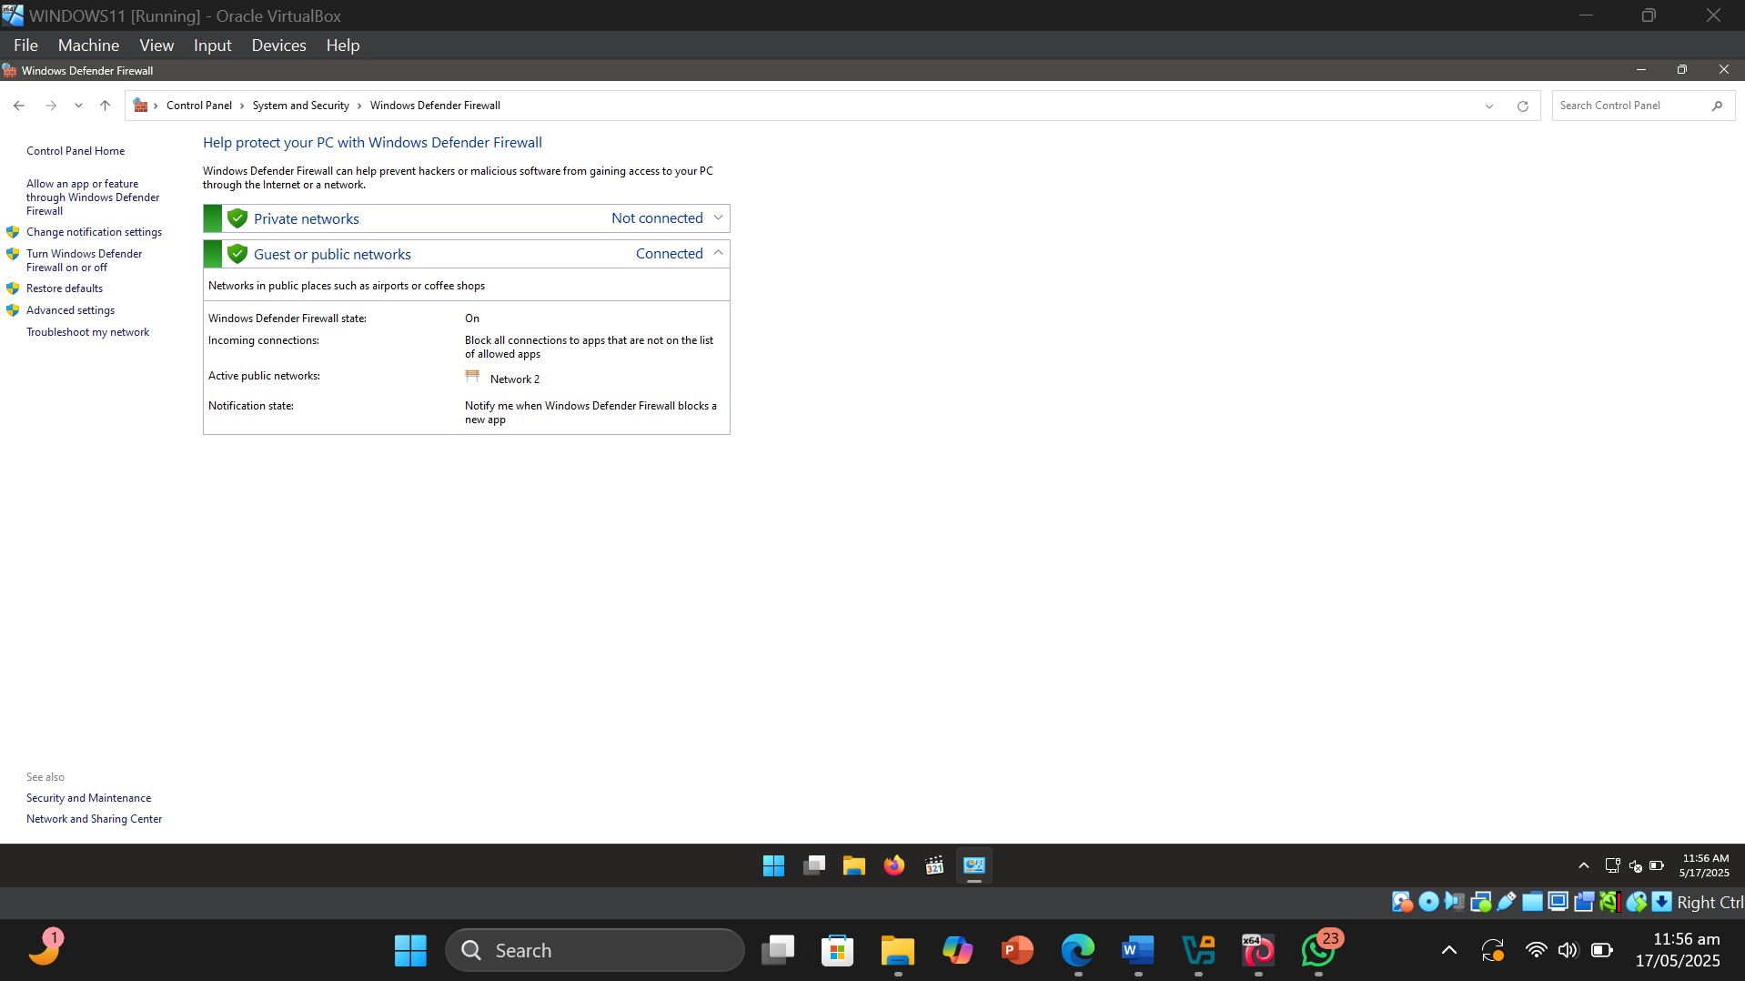

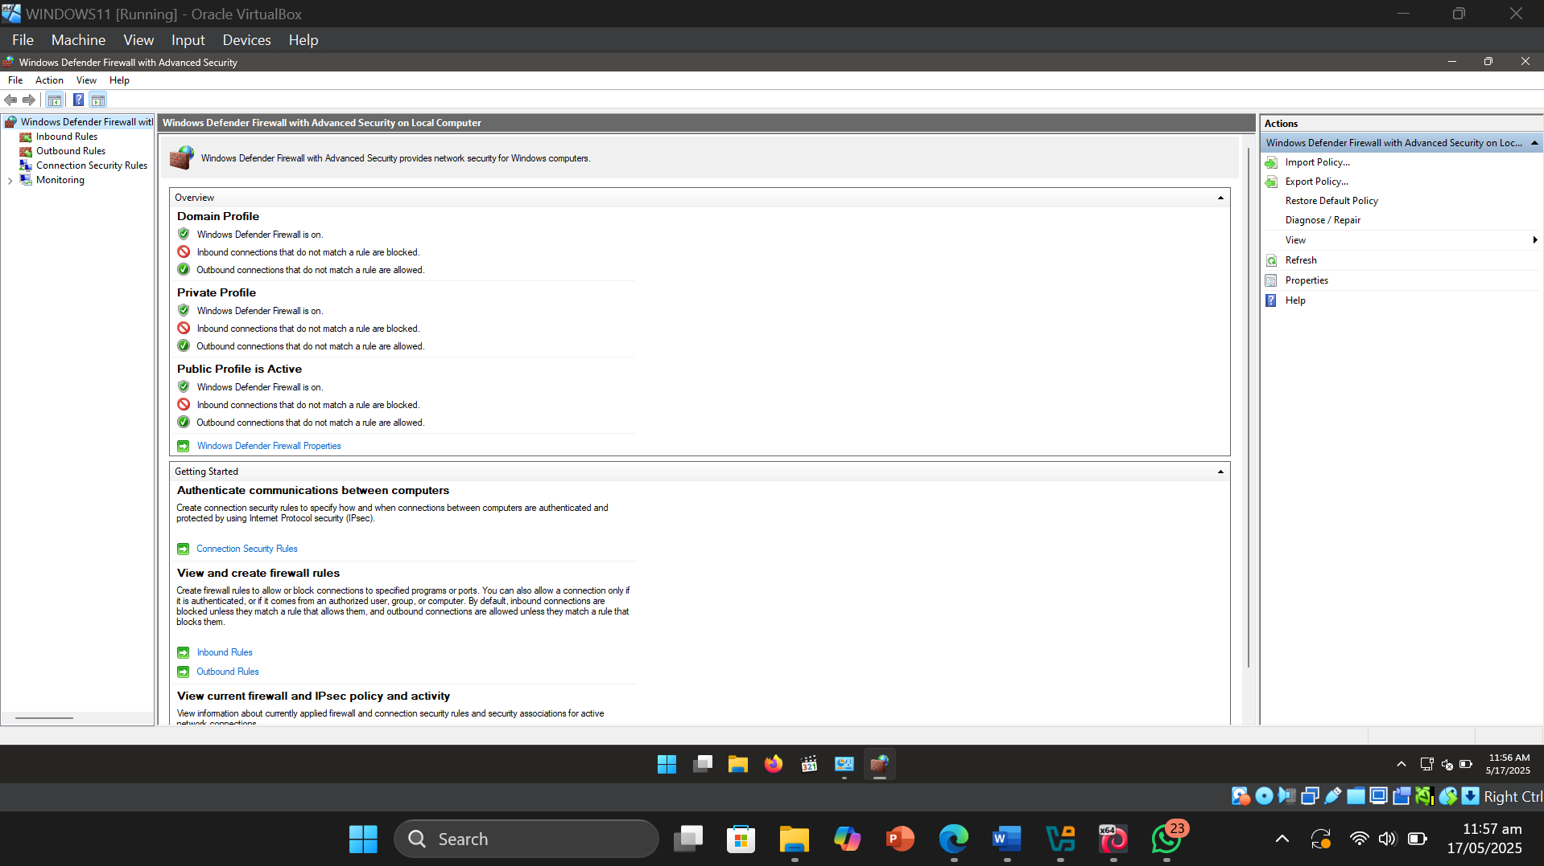

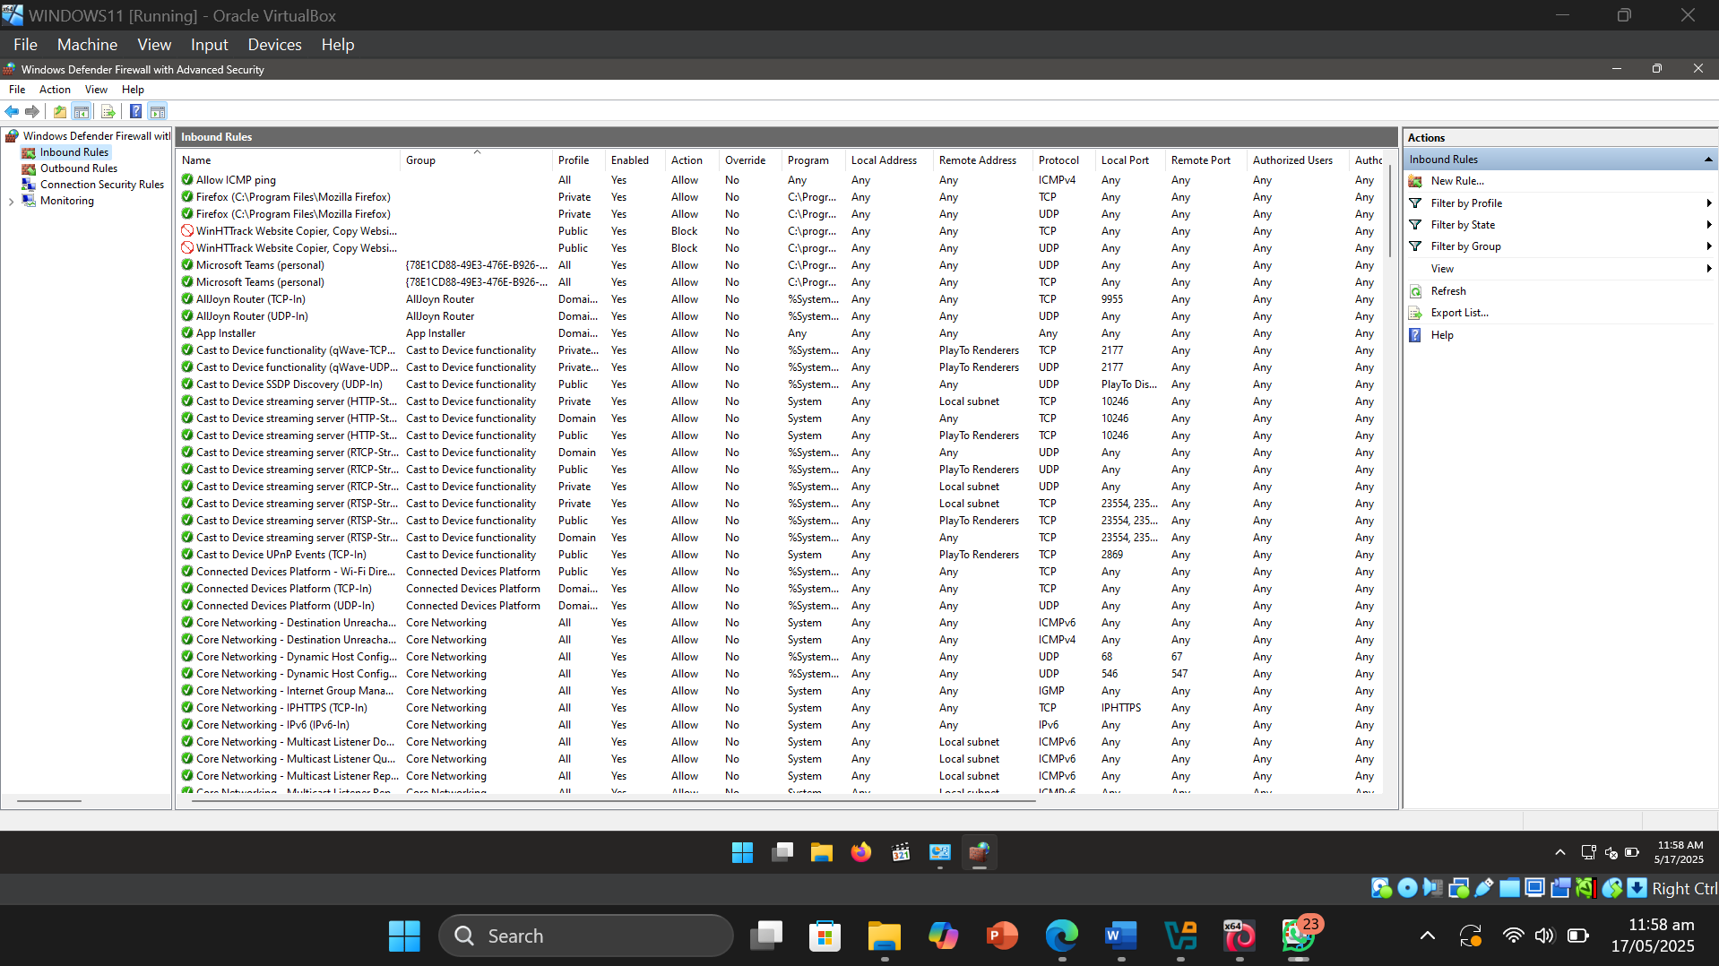

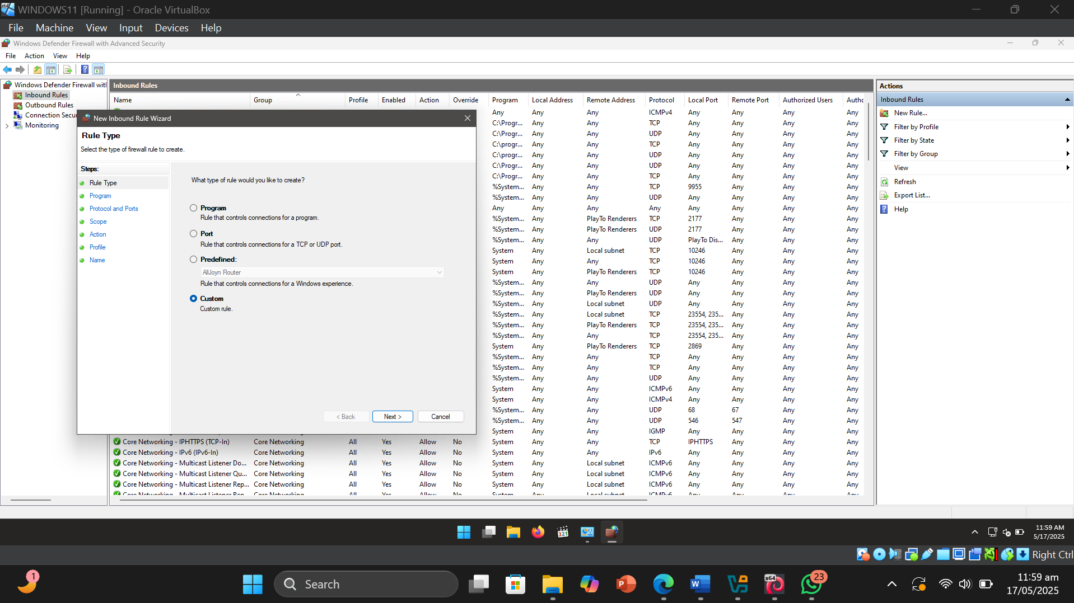

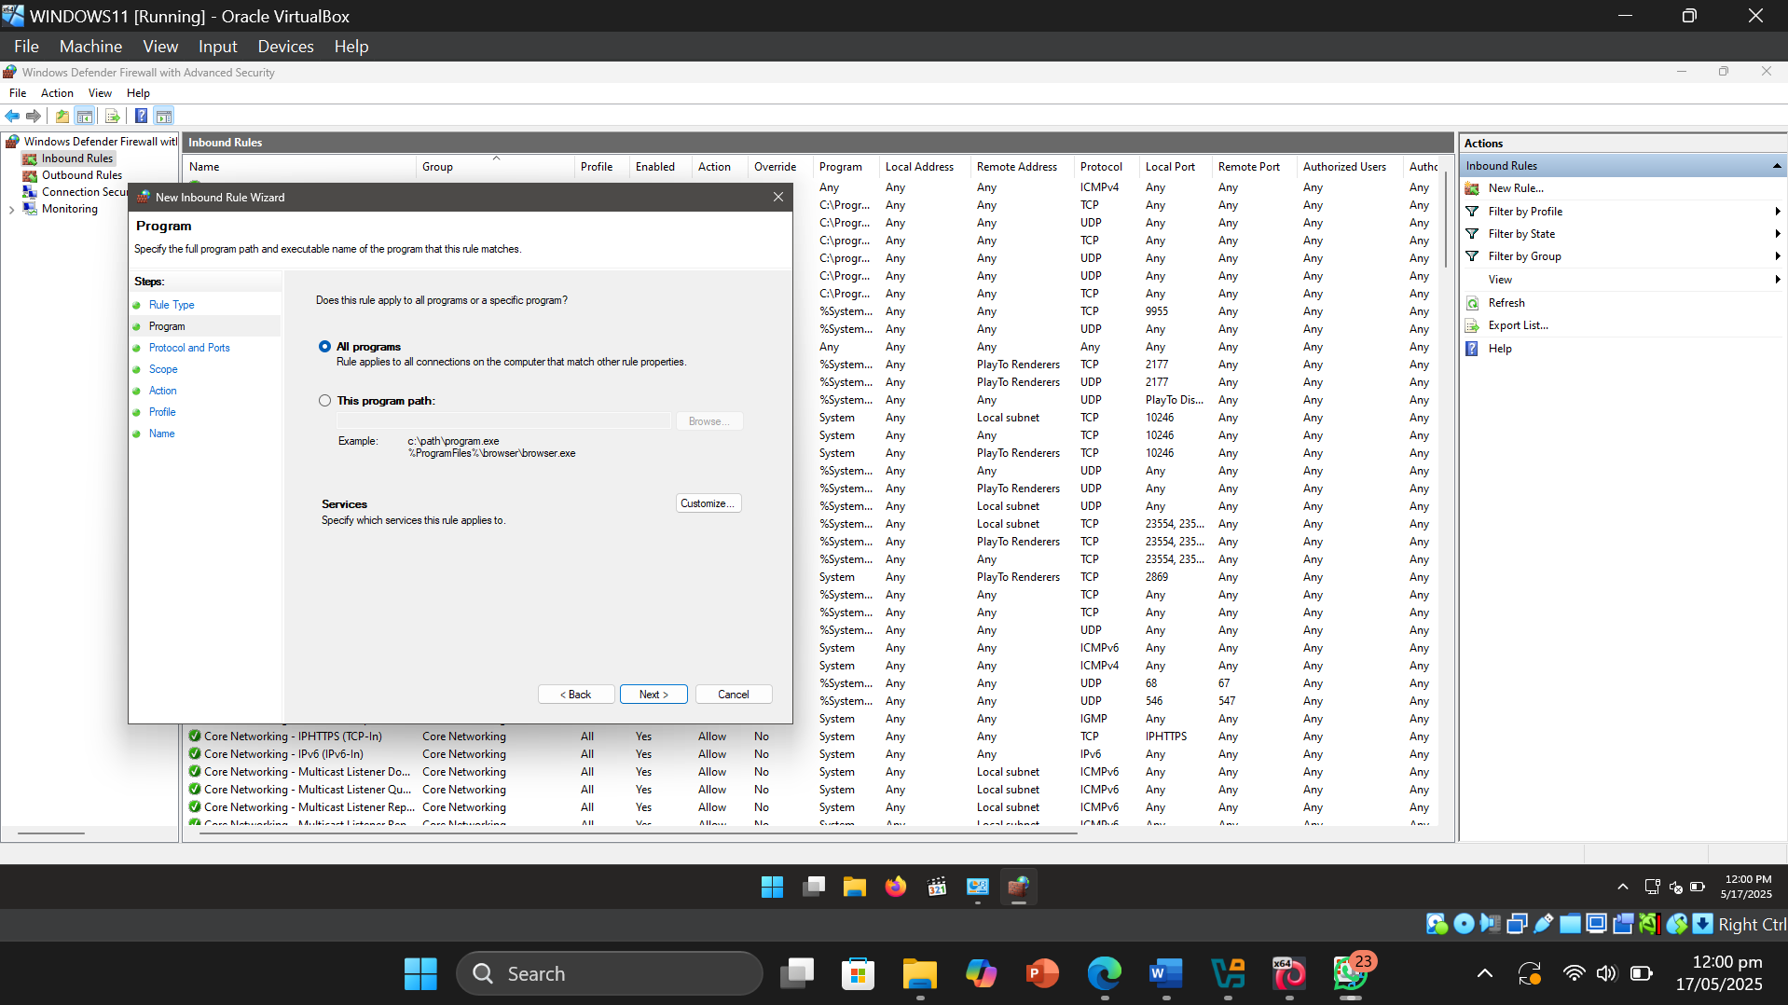

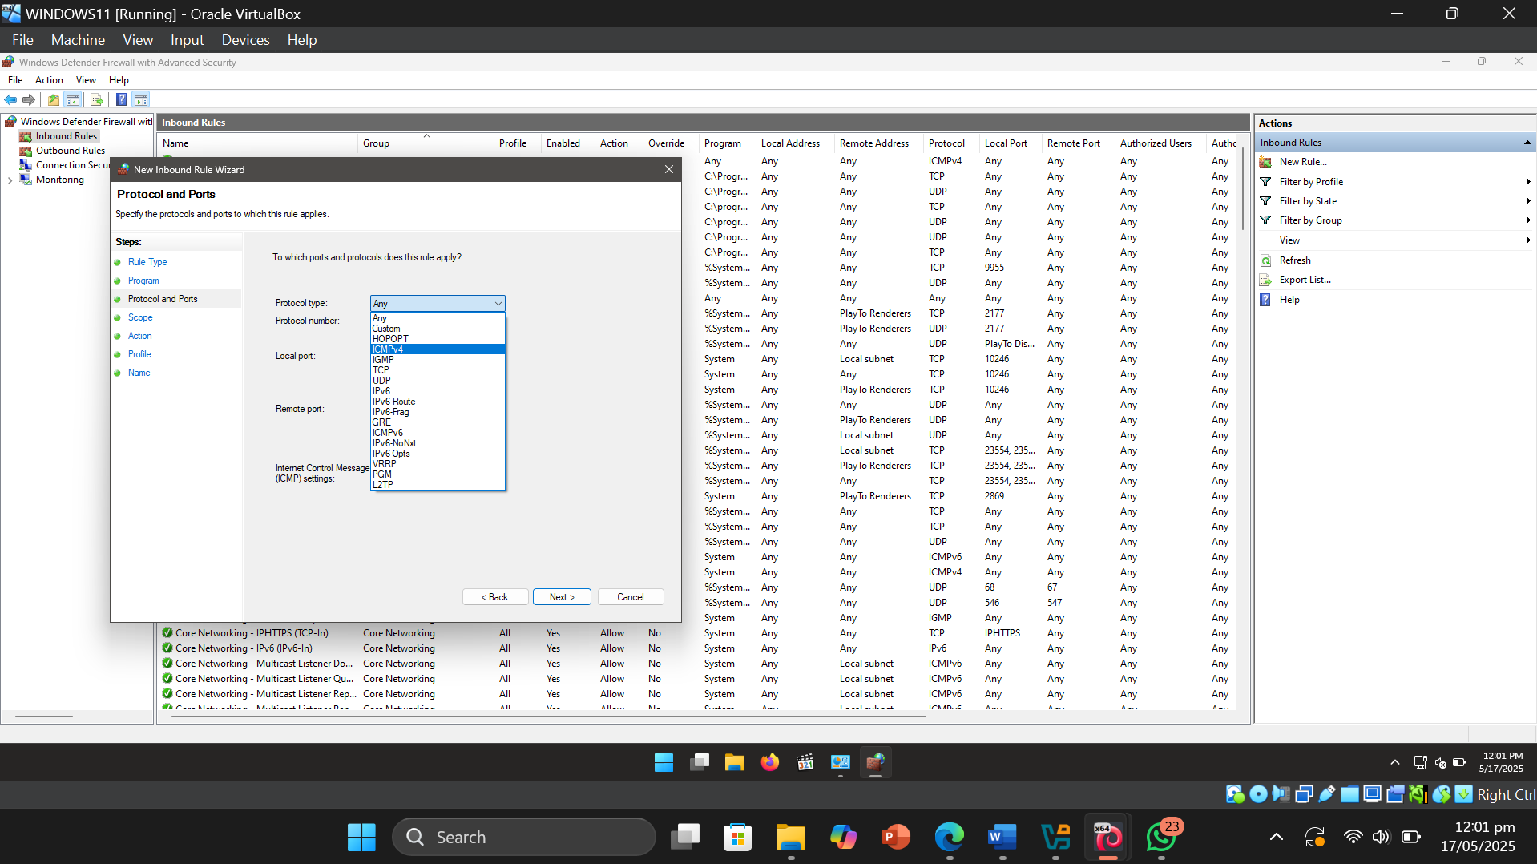

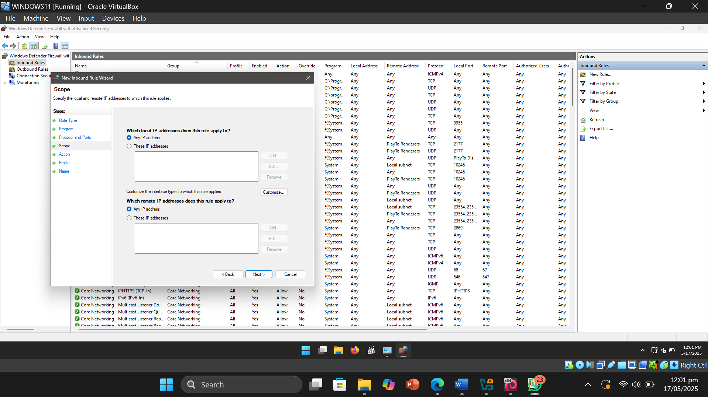

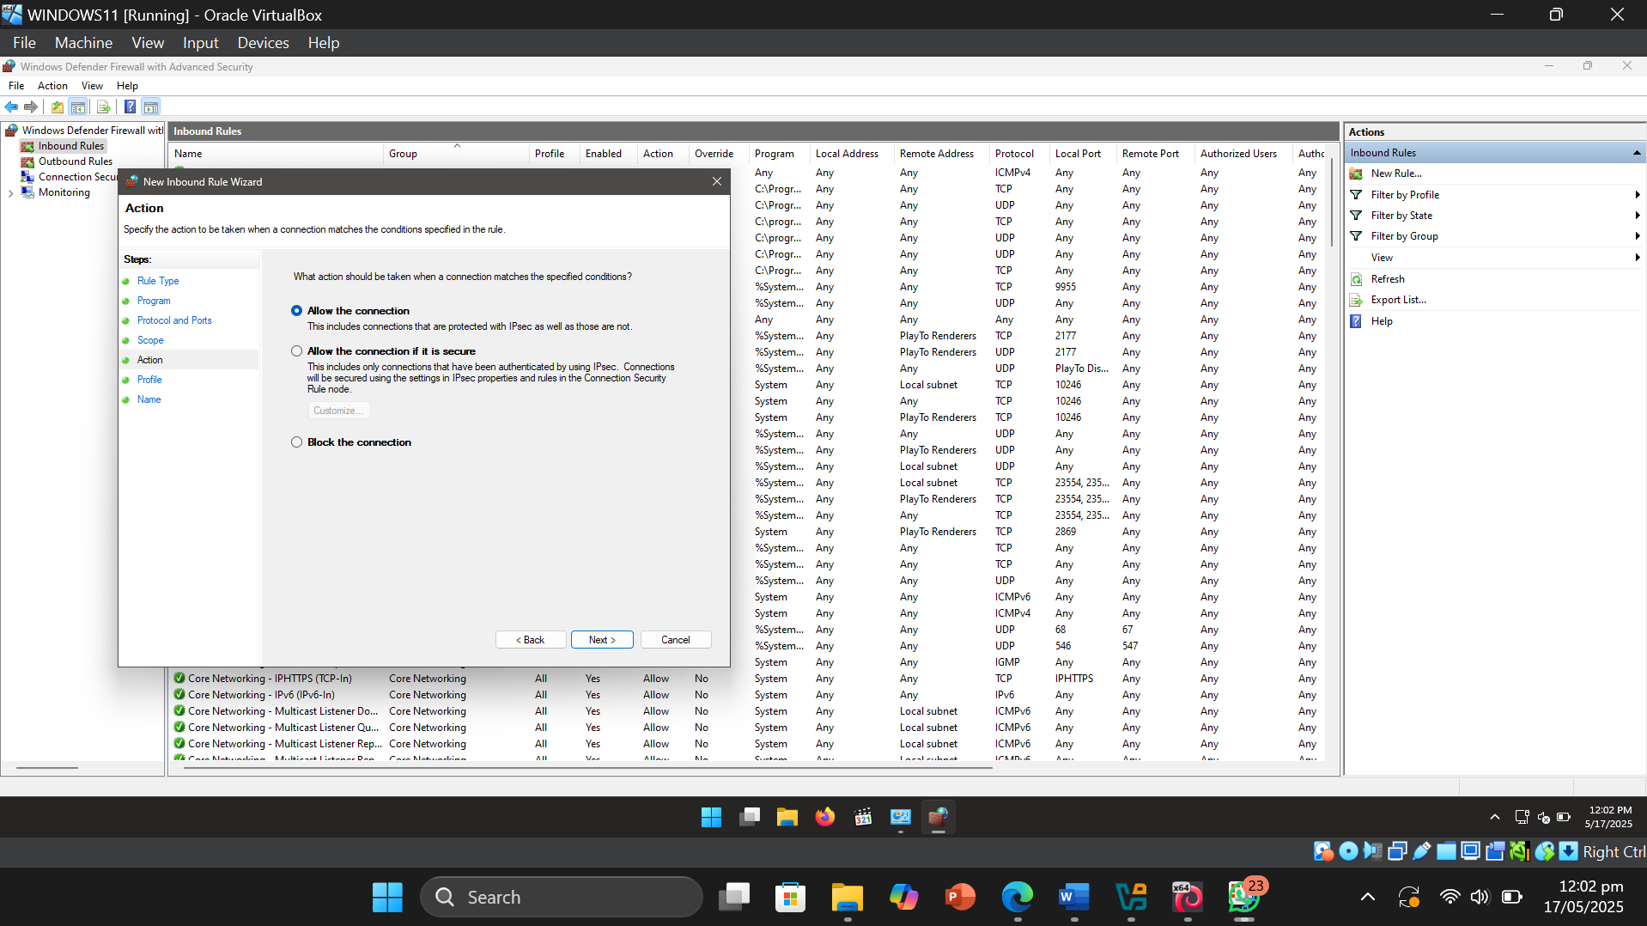

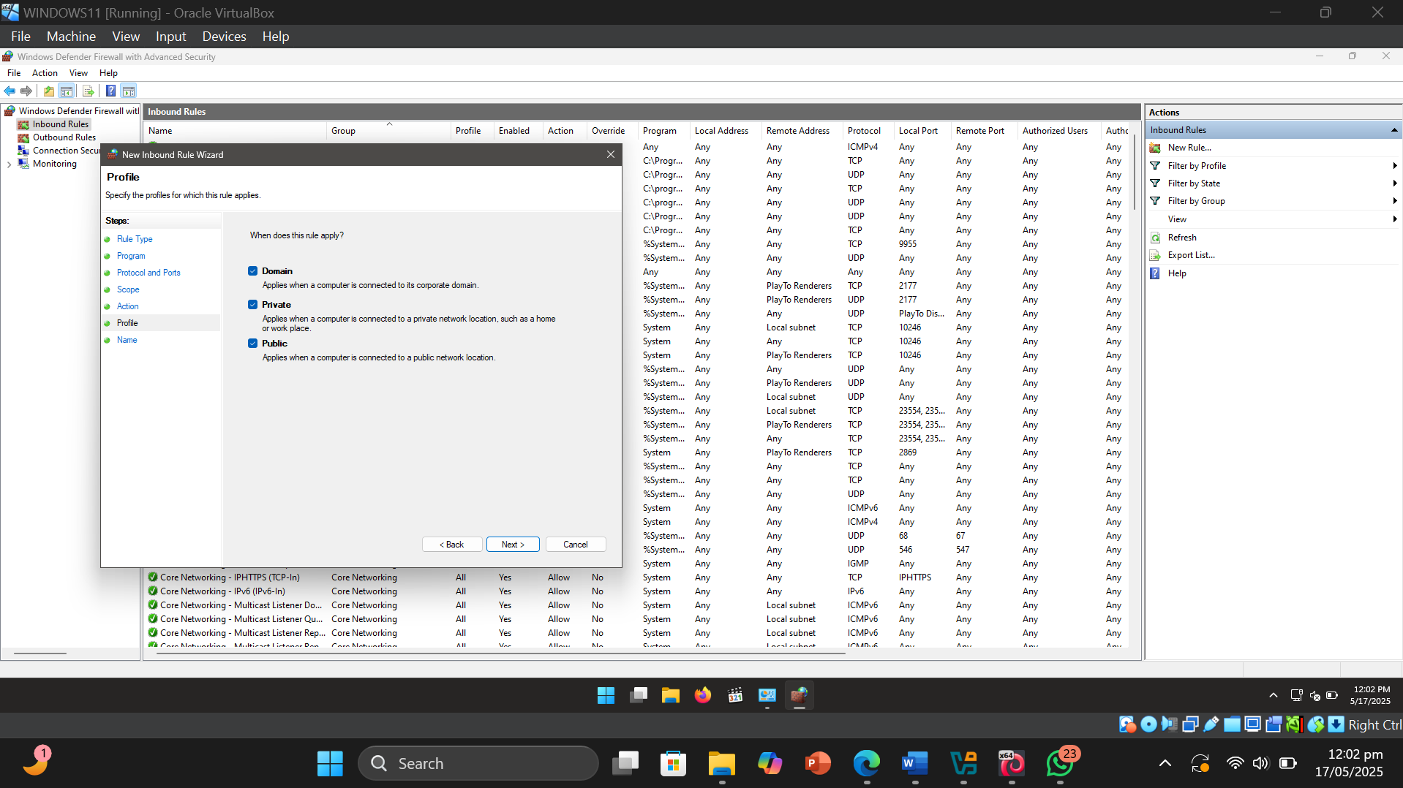

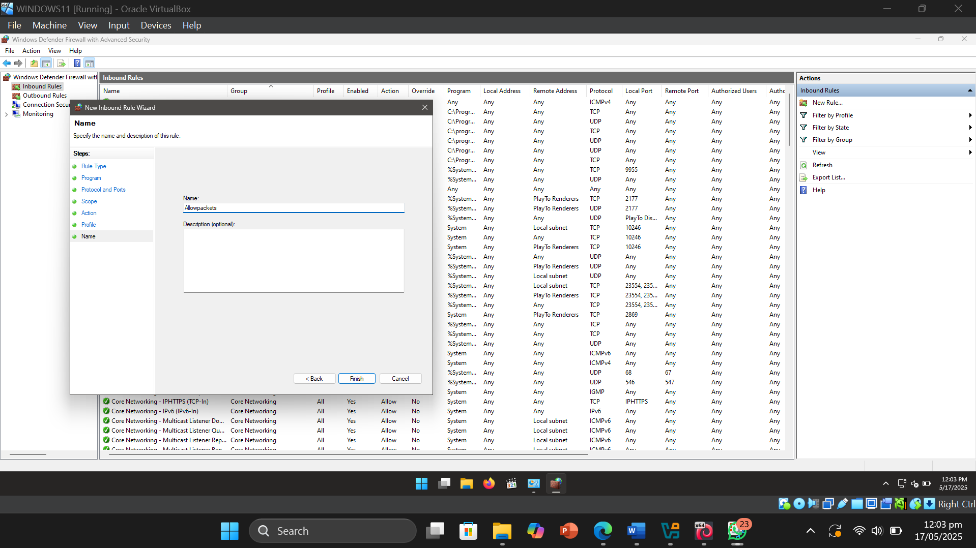

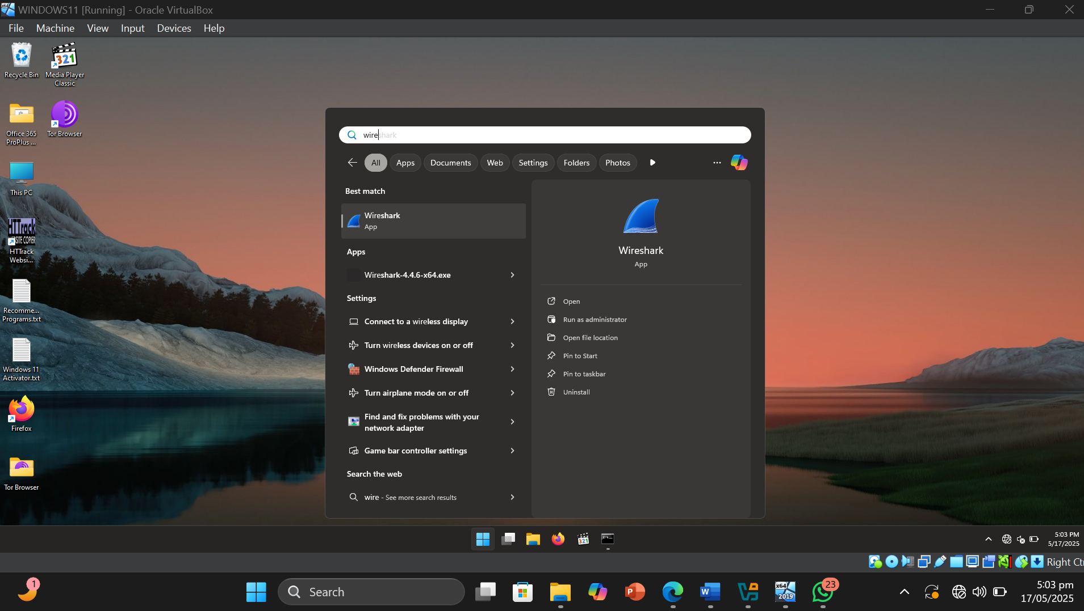

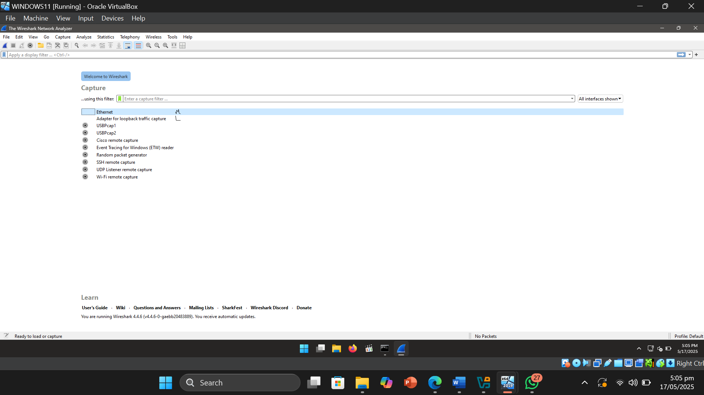

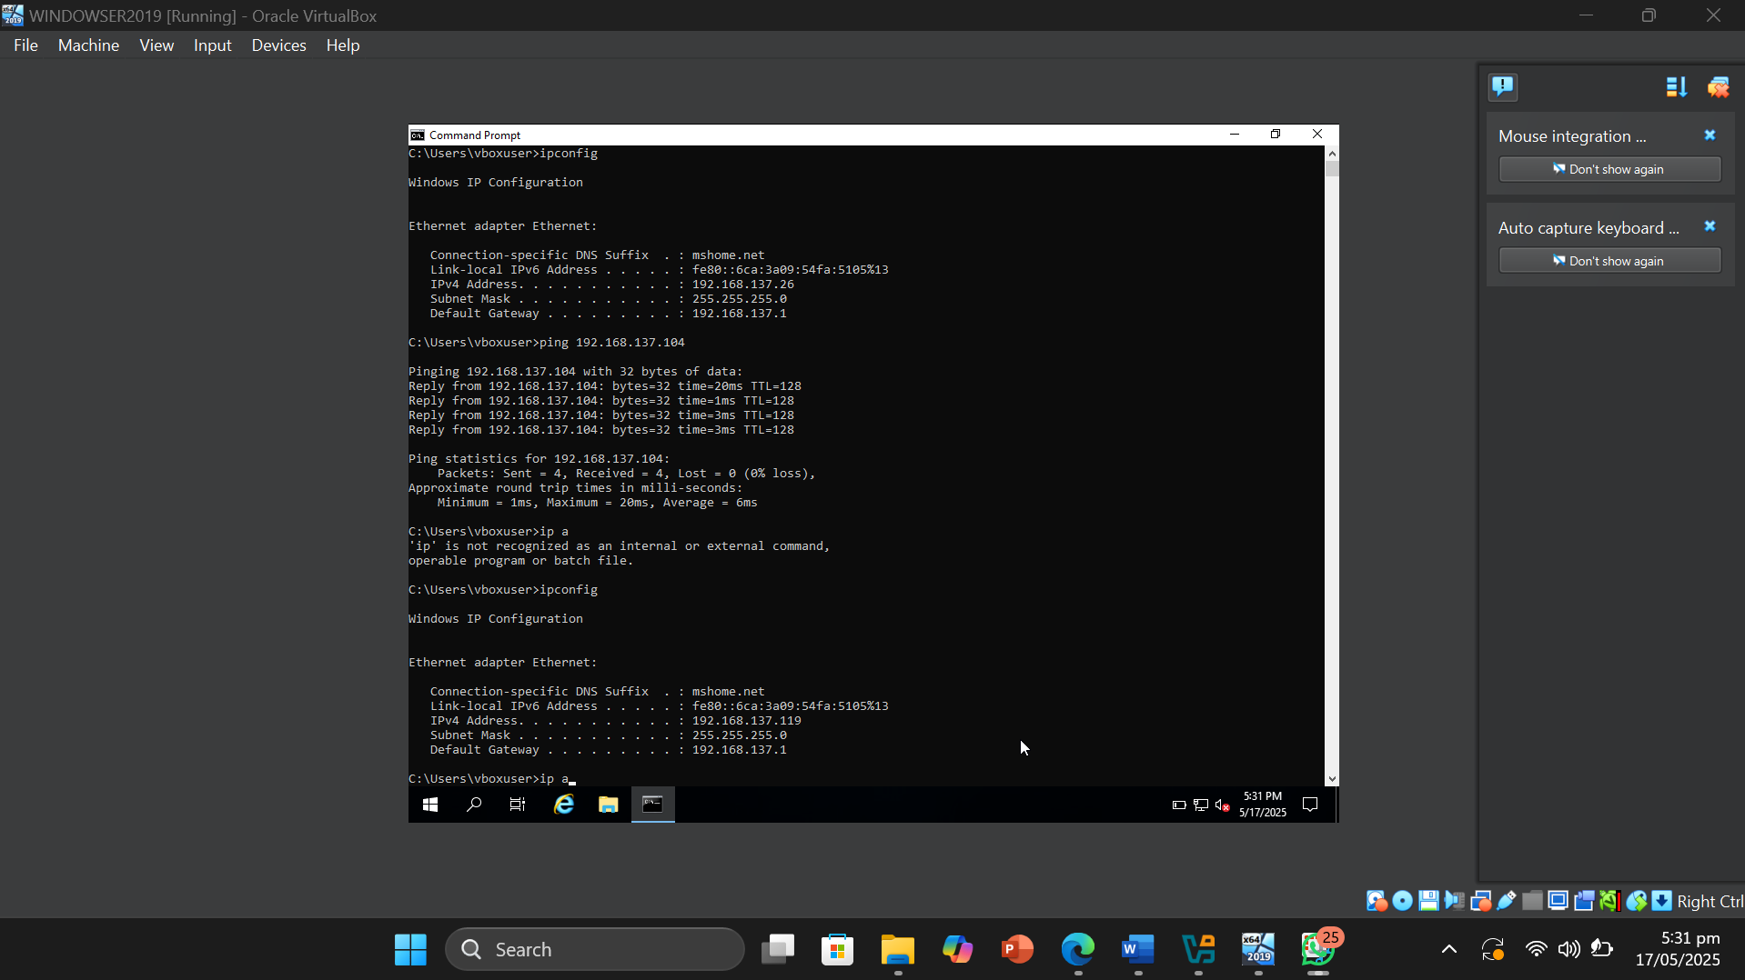

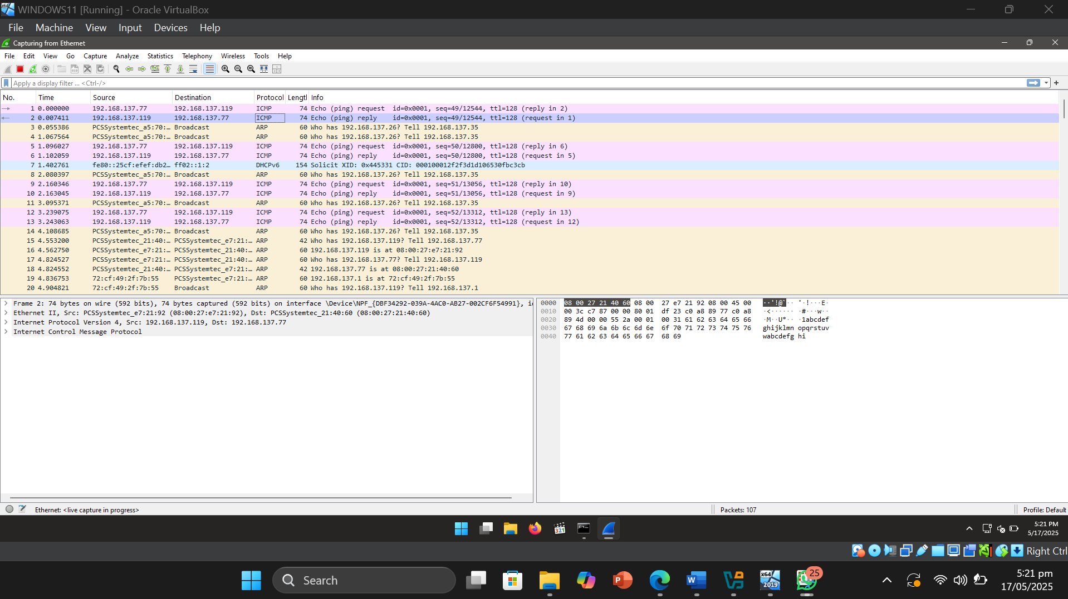

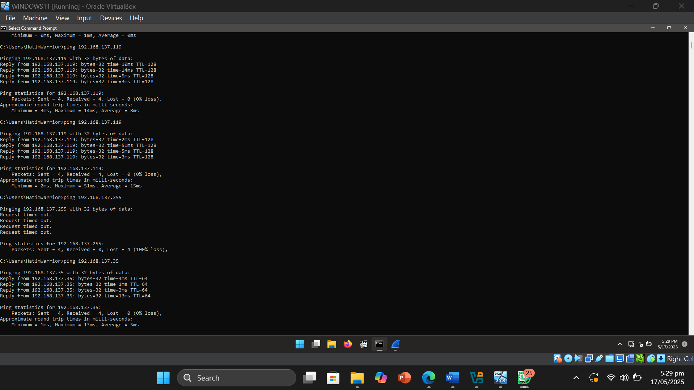

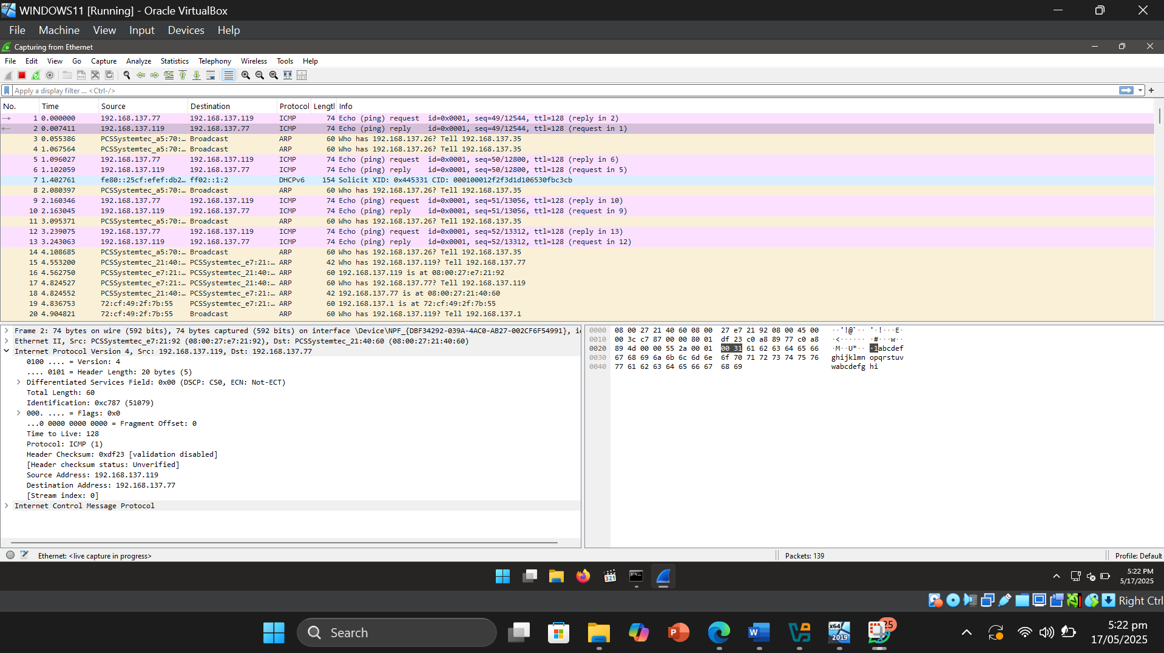

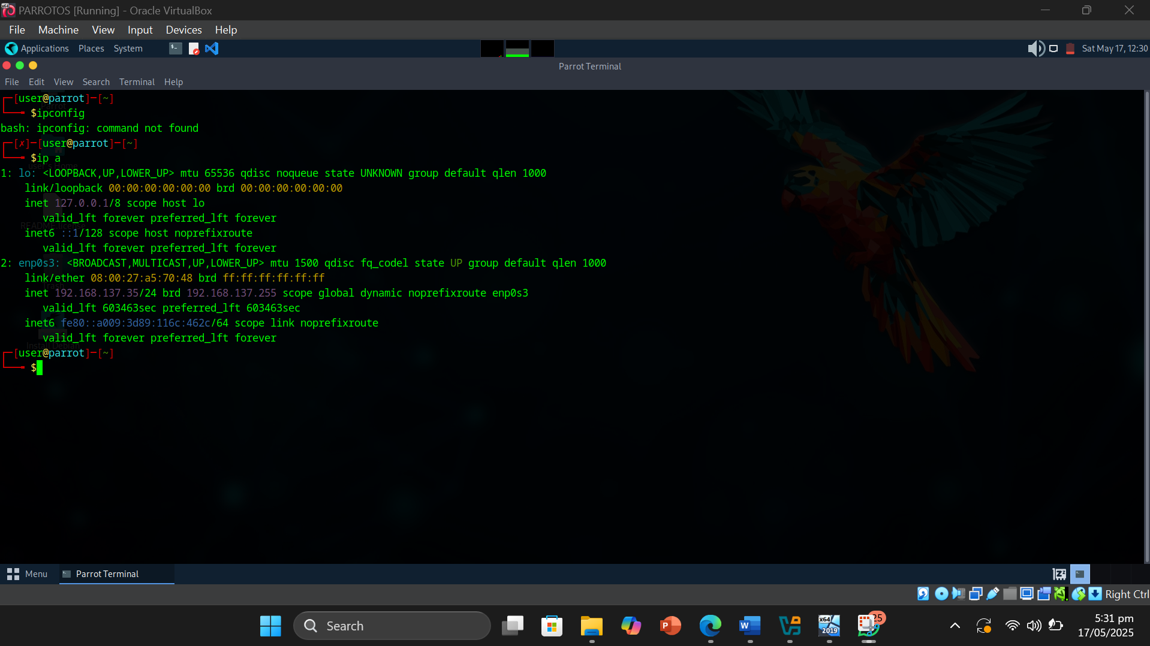

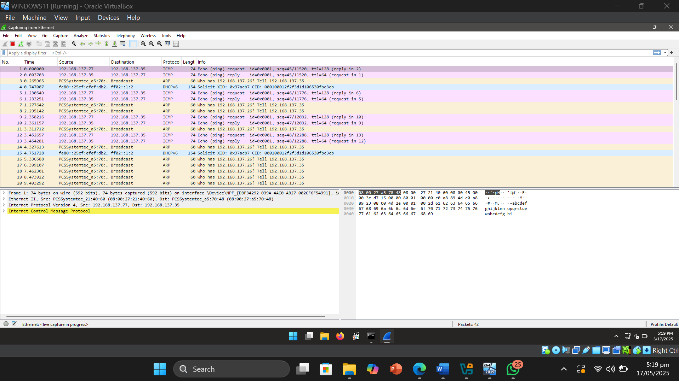

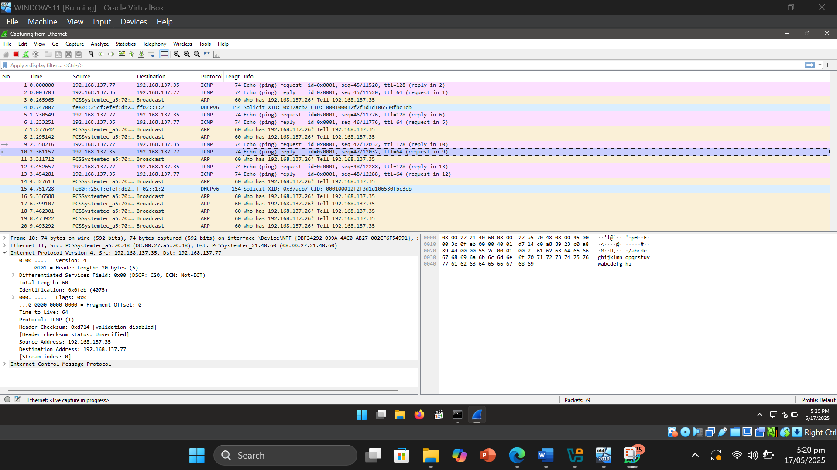

* Result or Output: During the experiment, ICMP packets were exchanged between a Windows 11 system, a Windows Server 2019 machine, and Parrot OS. Wireshark was used to capture and analyze the traffic. By inspecting the IPv4 headers of the captured packets, the Time To Live (TTL) values were identified. Packets originating from both Windows 11 and Windows Server 2019 had a TTL value of 128, while packets from Parrot OS had a TTL value of 64. These TTL values remained consistent across multiple ping attempts, providing a reliable indication of the operating system running on each host.
* Interpretation: Through this activity, I understood how Wireshark can be used as an effective tool for network traffic analysis and system identification during the early stages of network monitoring. By passively capturing packets and inspecting specific fields such as the TTL (Time To Live) value in the IPv4 header, it becomes possible to make informed assumptions about the operating system of remote devices. This approach involves no active probing or exploitation, yet it reveals valuable information about the systems on the network. I learned that such analysis techniques help in identifying connected hosts, understanding their behavior, and assessing the network landscape, which is essential for maintaining visibility and preparing for more advanced security evaluations while keeping detection risk minimal.

Objective of Task 2: Perform OS Discovery using Nmap Script Engine (NSE)

Target Machine : Windows Server 2019 OS

* Command or Procedure Used:

1. Opened Windows Server 2019 OS VM .
2. Added an inbound rule for Port .
3. Added a role based feature .
4. Started the site <http://localhost> on port 80.
5. Once everything was in place , switched to Parrot OS and opened terminal .
6. Entered sudo su.
7. Entered nmap -A [Target IP Address] (here, the target machine is Windows Server 2019 OS [192.168.216.214])
8. Entered nmap -O [Target IP Address] (here, the target machine is Windows Server 2019 OS [192.168.216.214])
9. Got Result .

* Screenshot:

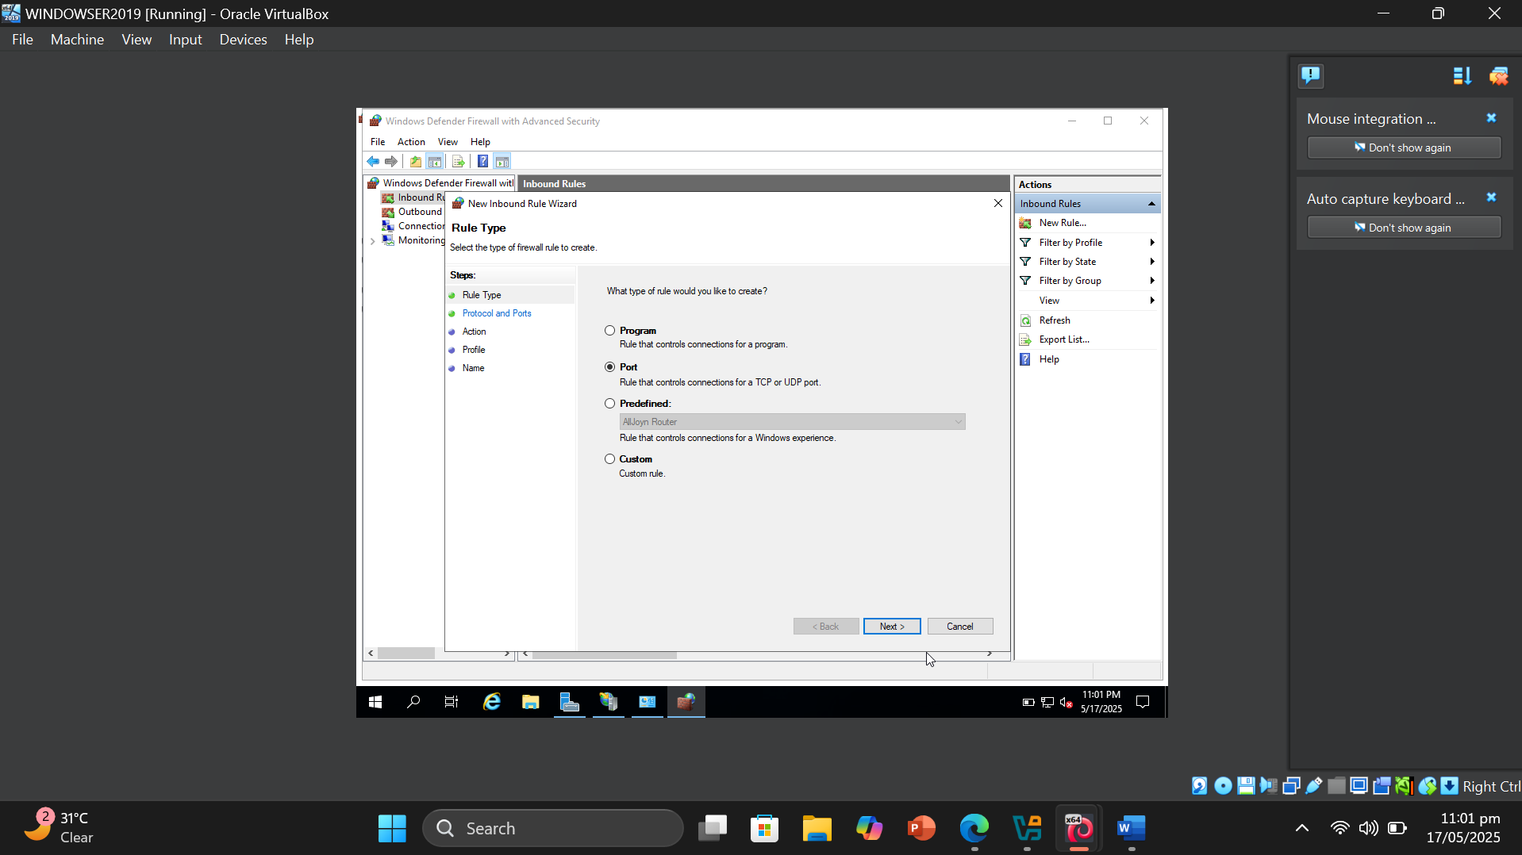

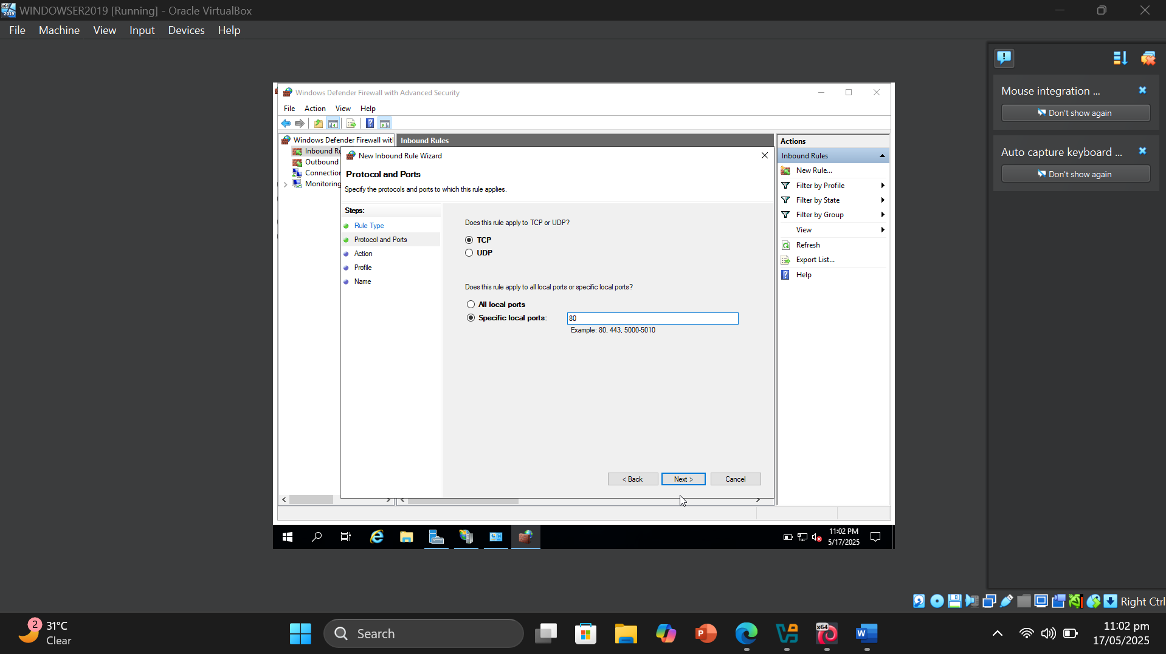

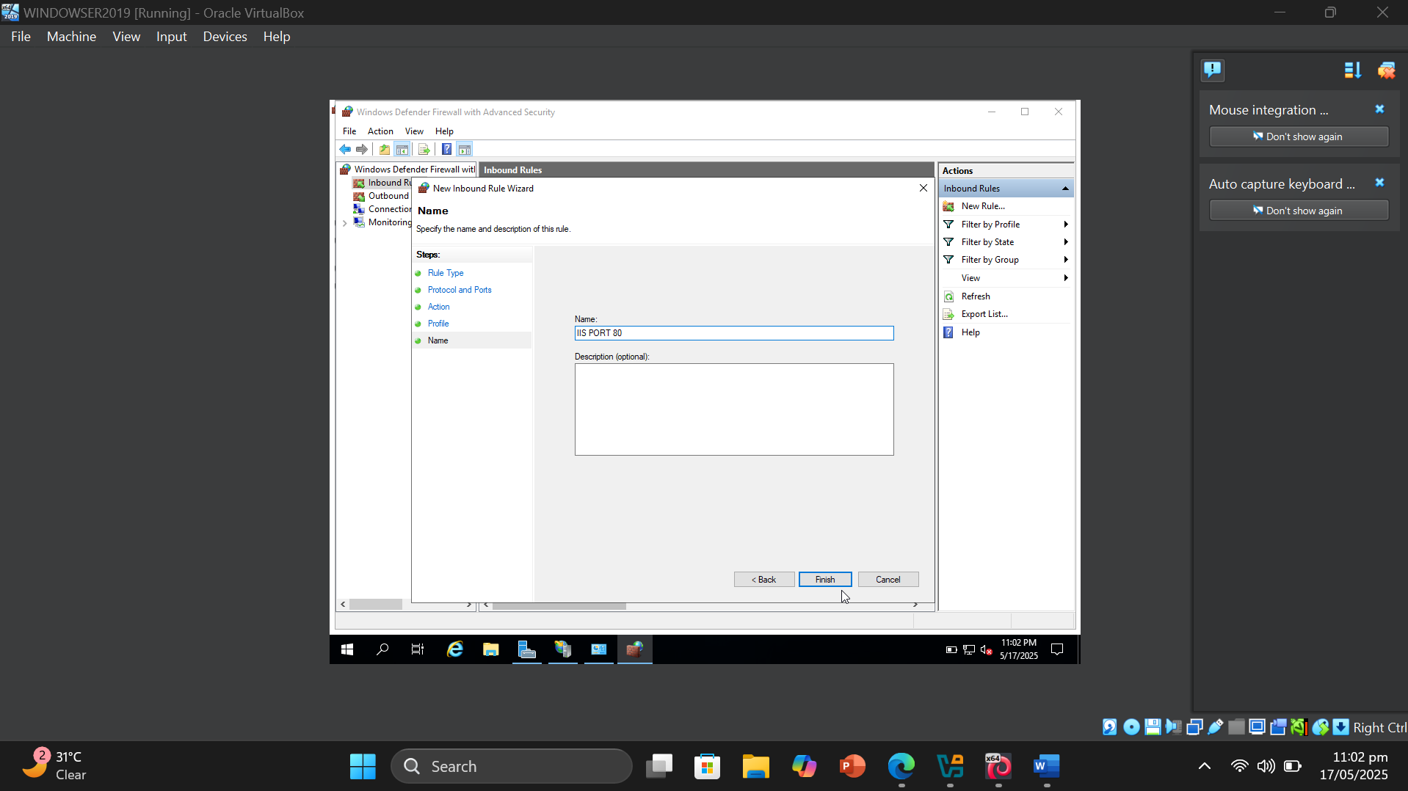

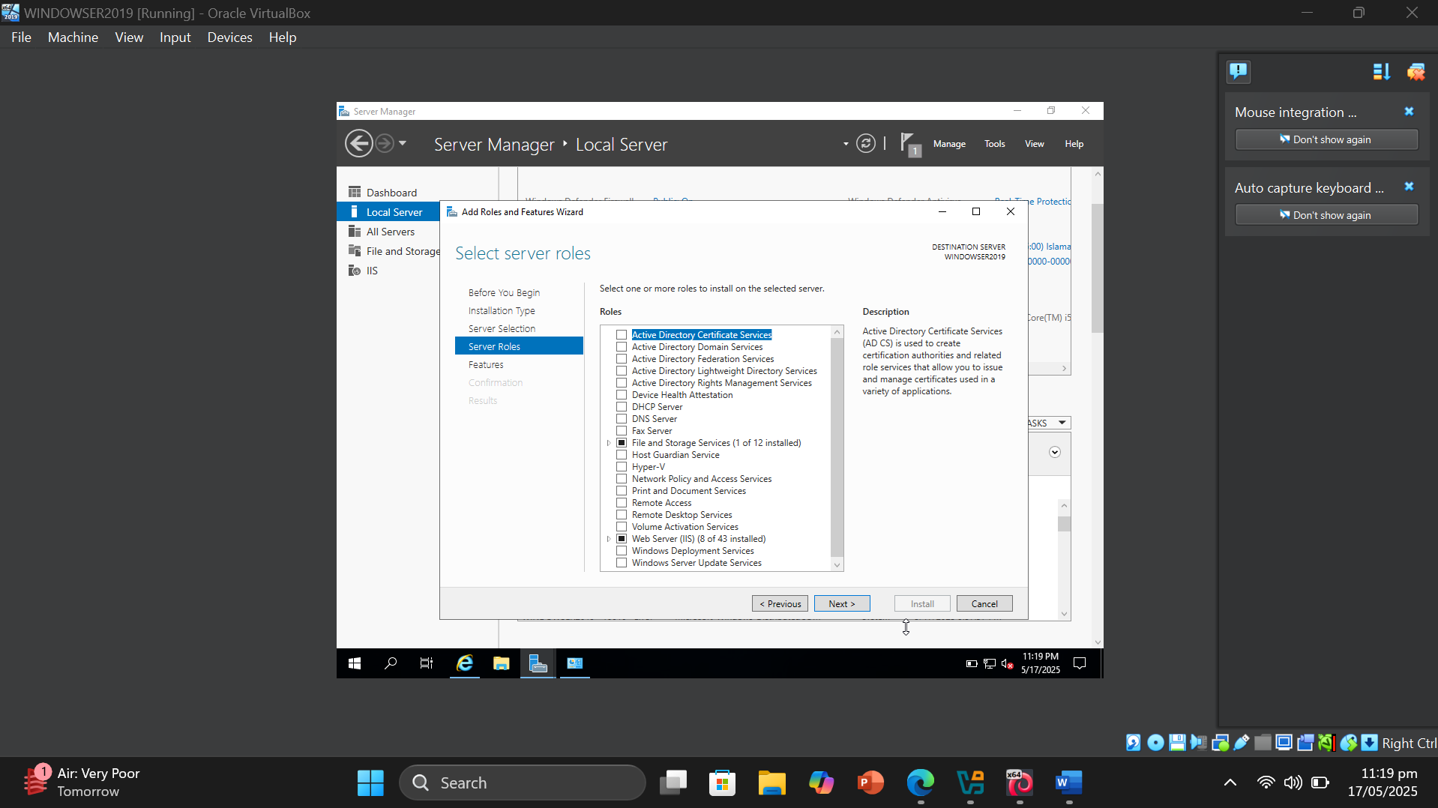

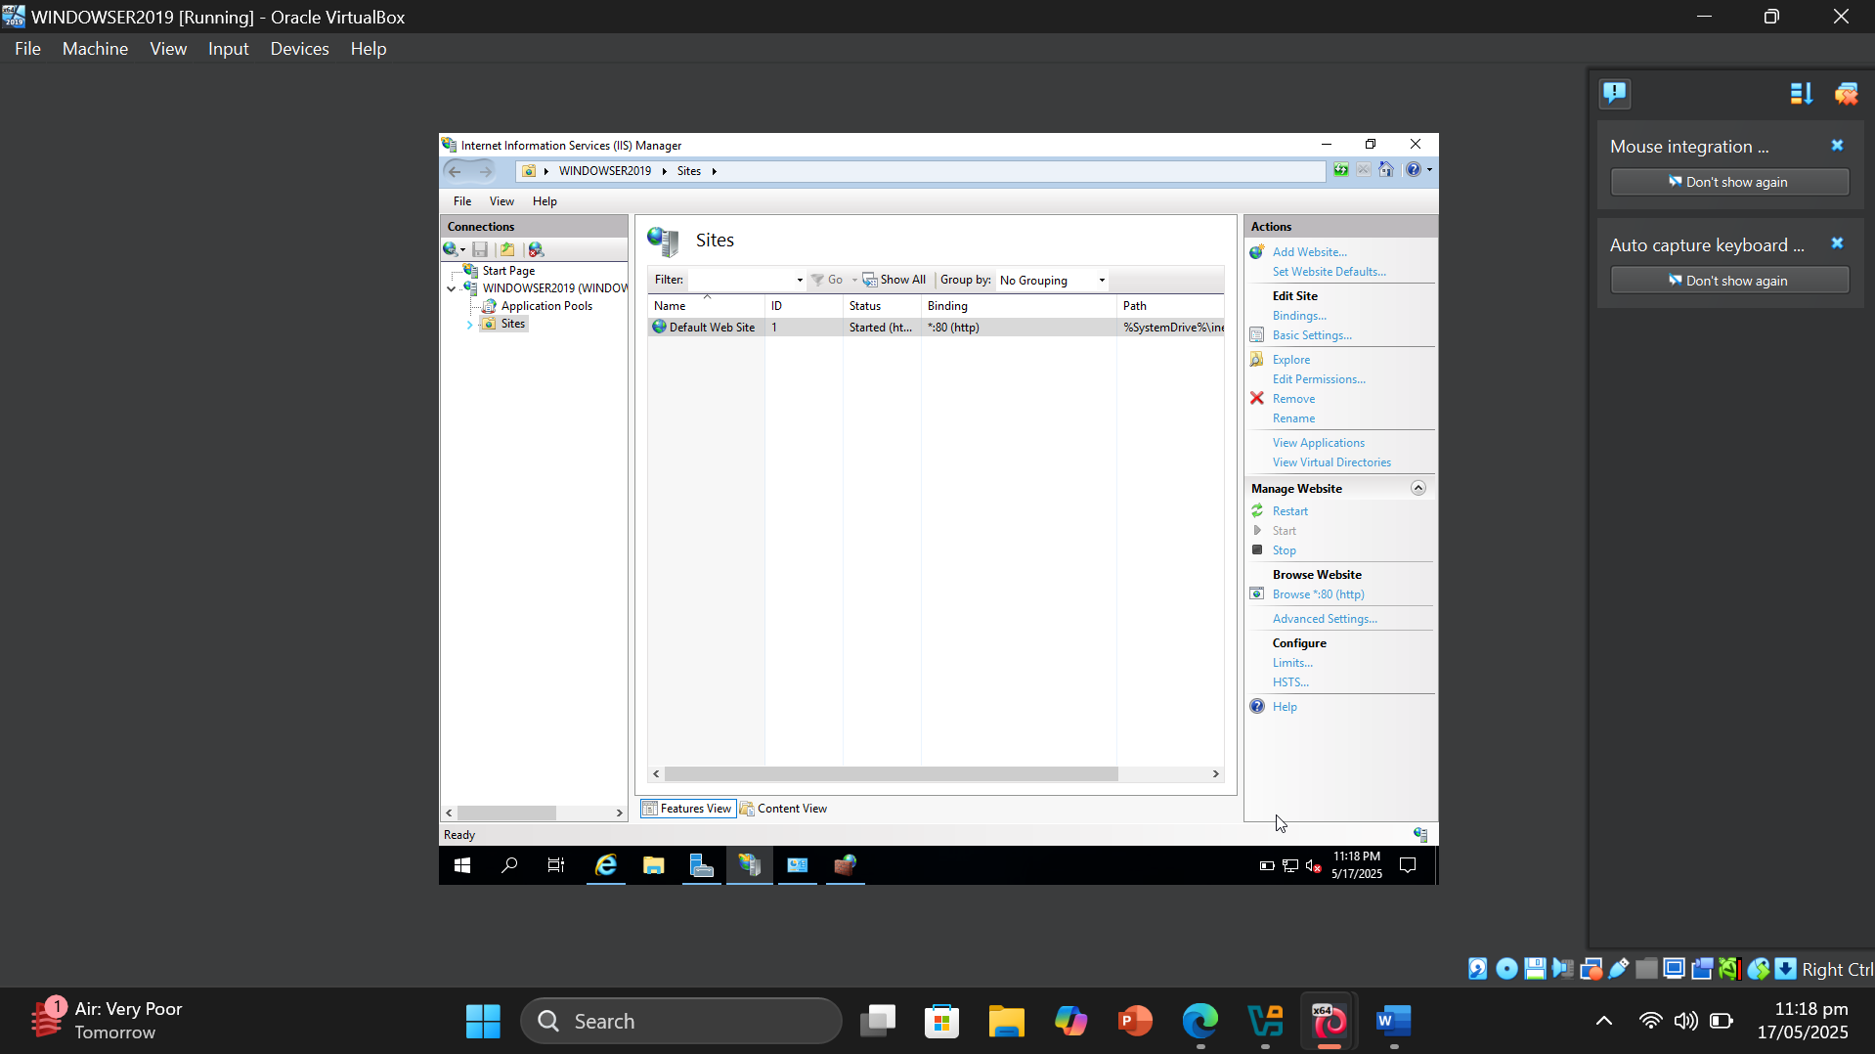

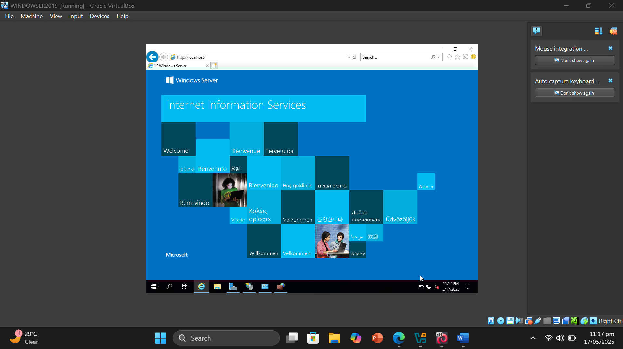

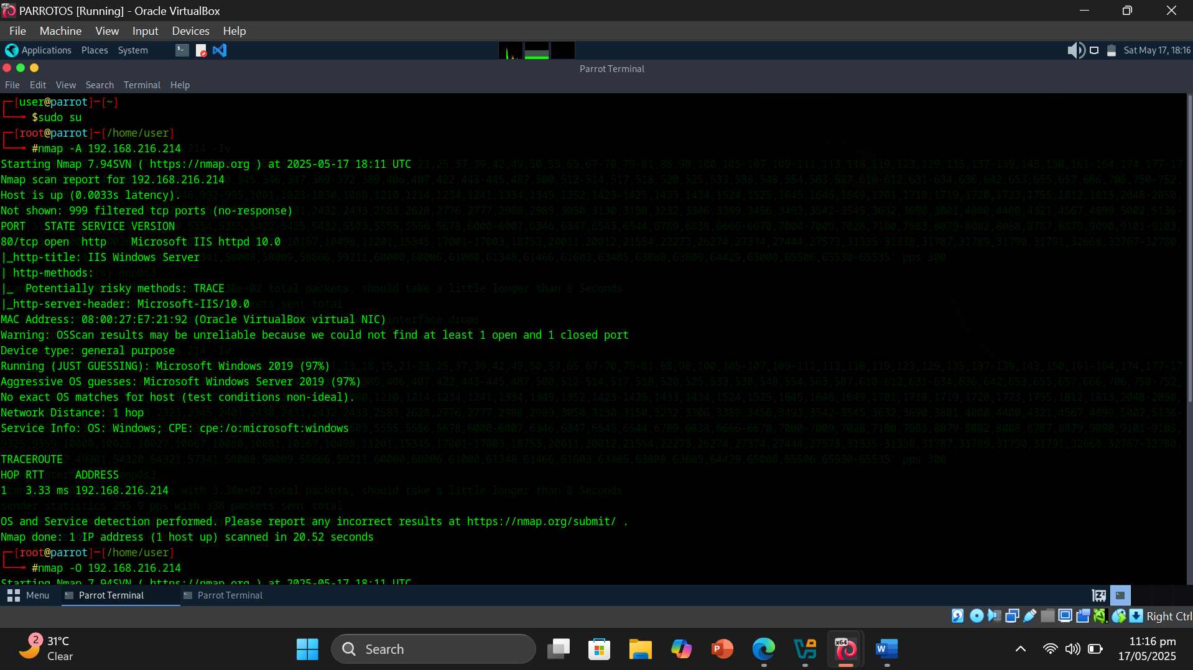

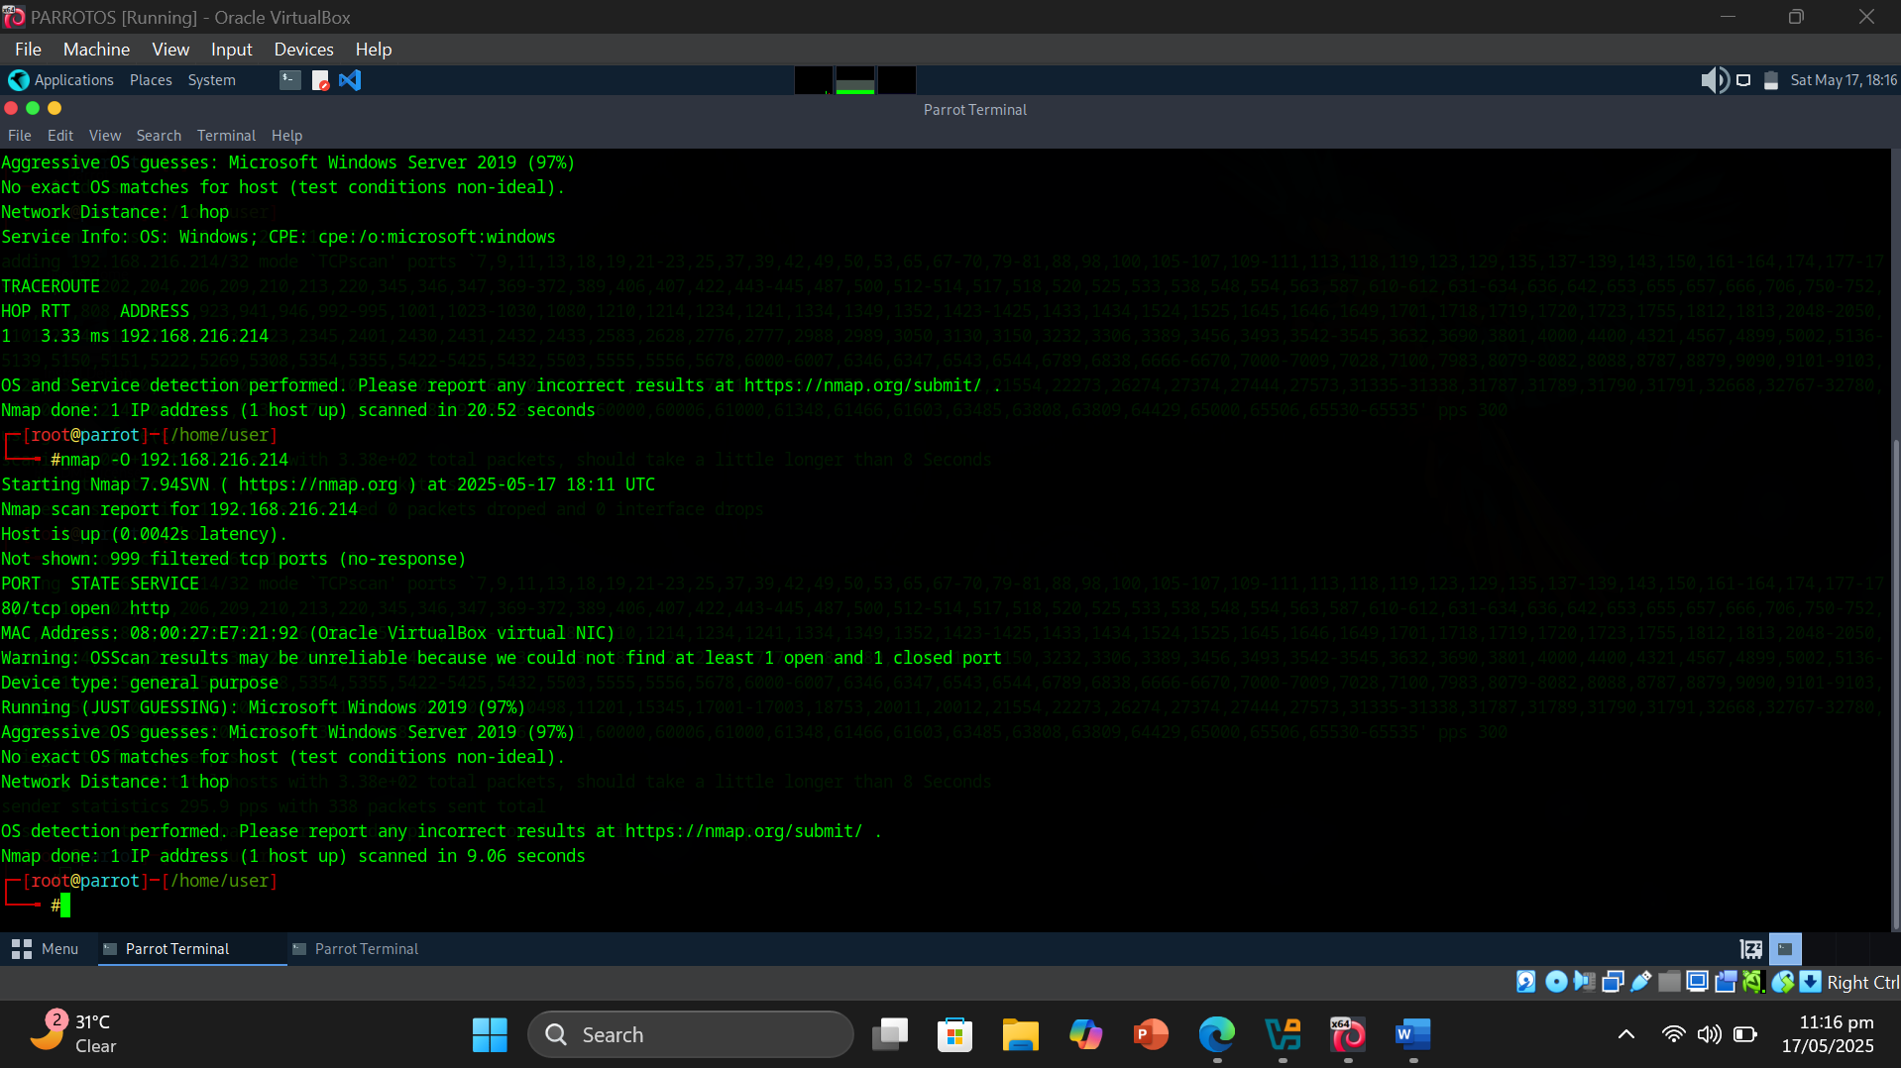

* Result or Output: Using the commands nmap -A <target_address> and nmap -O <target_address>, I performed an aggressive scan and operating system discovery on the target machine. The aggressive scan (-A) enabled multiple Nmap features, including OS detection, version detection, script scanning, and traceroute. It provided detailed information such as open ports, running services and their versions, potential vulnerabilities, and system uptime. The scan showed that **port 80** was open, indicating a web server running on the target. The OS detection command (-O) analyzed the TCP/IP stack behavior and returned an estimated operating system match with a confidence level. The results revealed the likely operating system, service fingerprints, and a comprehensive overview of the target’s network surface.
* Interpretation: Through this activity, I gained a deeper understanding of how Nmap’s scripting engine and scanning techniques contribute to effective network scanning and monitoring. The aggressive scan combined multiple probing methods to extract detailed information about the target system without requiring login credentials or direct interaction. I observed how Nmap uses protocol behaviors and service responses to accurately identify open ports, detect running services and their versions, and estimate the operating system. The OS detection feature showcased how fingerprinting techniques analyze subtle differences in packet replies to classify systems. This hands-on experience helped me realize how network administrators or security professionals can use Nmap to monitor systems, assess exposed services, and evaluate potential vulnerabilities, ultimately supporting the secure management of network infrastructure.

Objective of Task 3: Perform OS Discovery using Unicornscan

Target Machine : Windows Server 2019 OS and Parrot OS

* Command or Procedure Used:

1. Created a new Parrot OS VM and named it Parrot OS 2.
2. Got its ip address by running ip a in terminal.
3. Got ip address of Windows Server 2019 OS VM.
4. Switched to Parrot OS 1 and ran the terminal.
5. Typed sudo su.
6. Typed unicornscan [Target address] -Iv.

Windows Server 2019 [192.168.216.214] .

1. Typed unicornscan [Target address] -Iv.

Parrot OS 2 [192.168.216.219] .

1. Got Result.

* Screenshot :

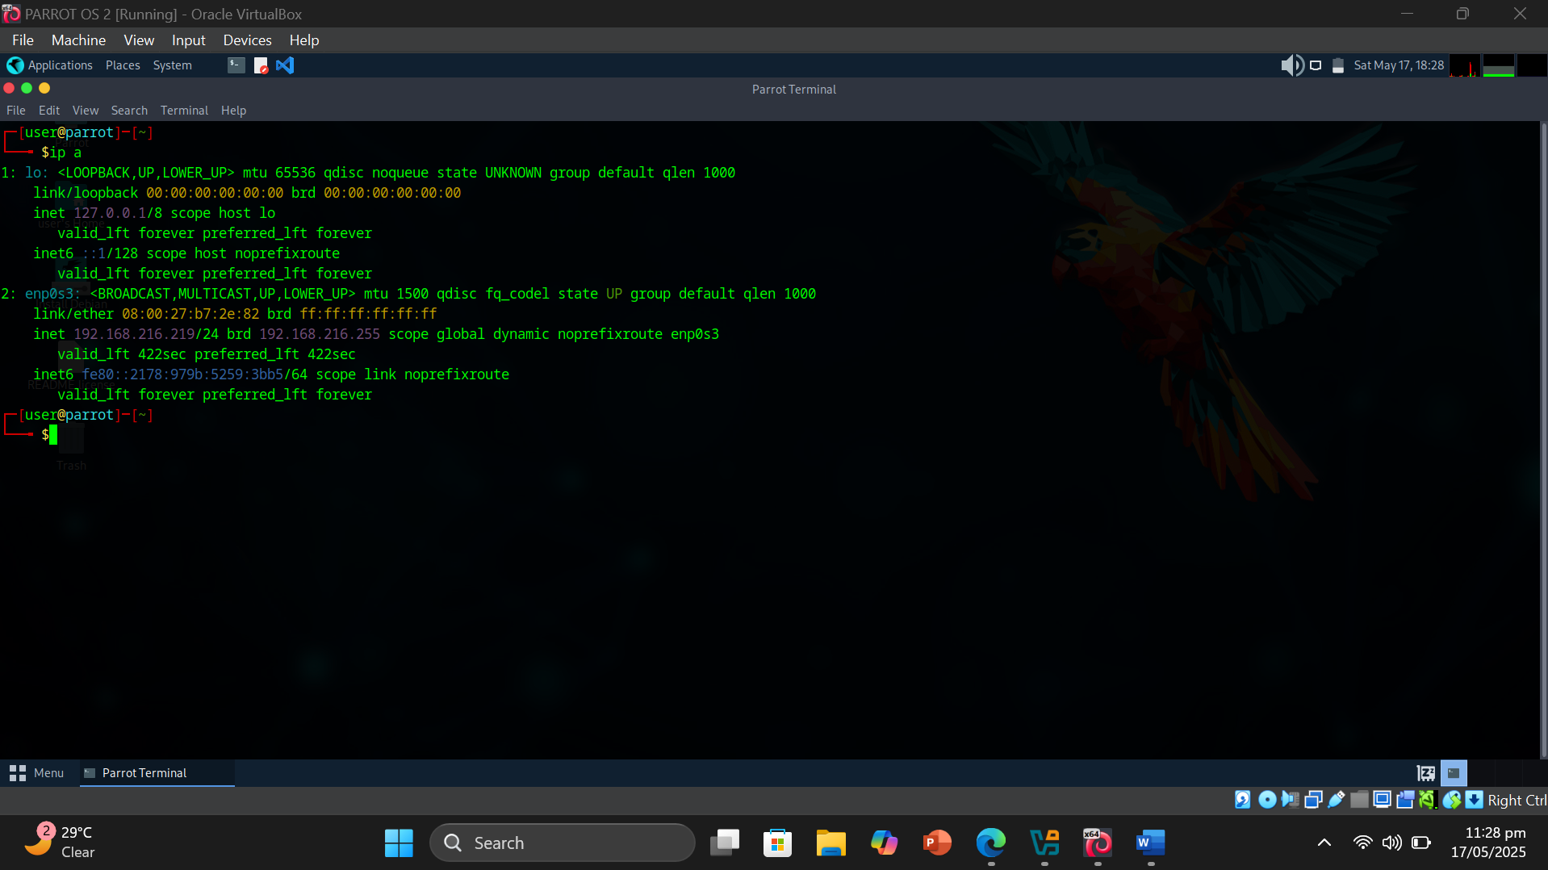

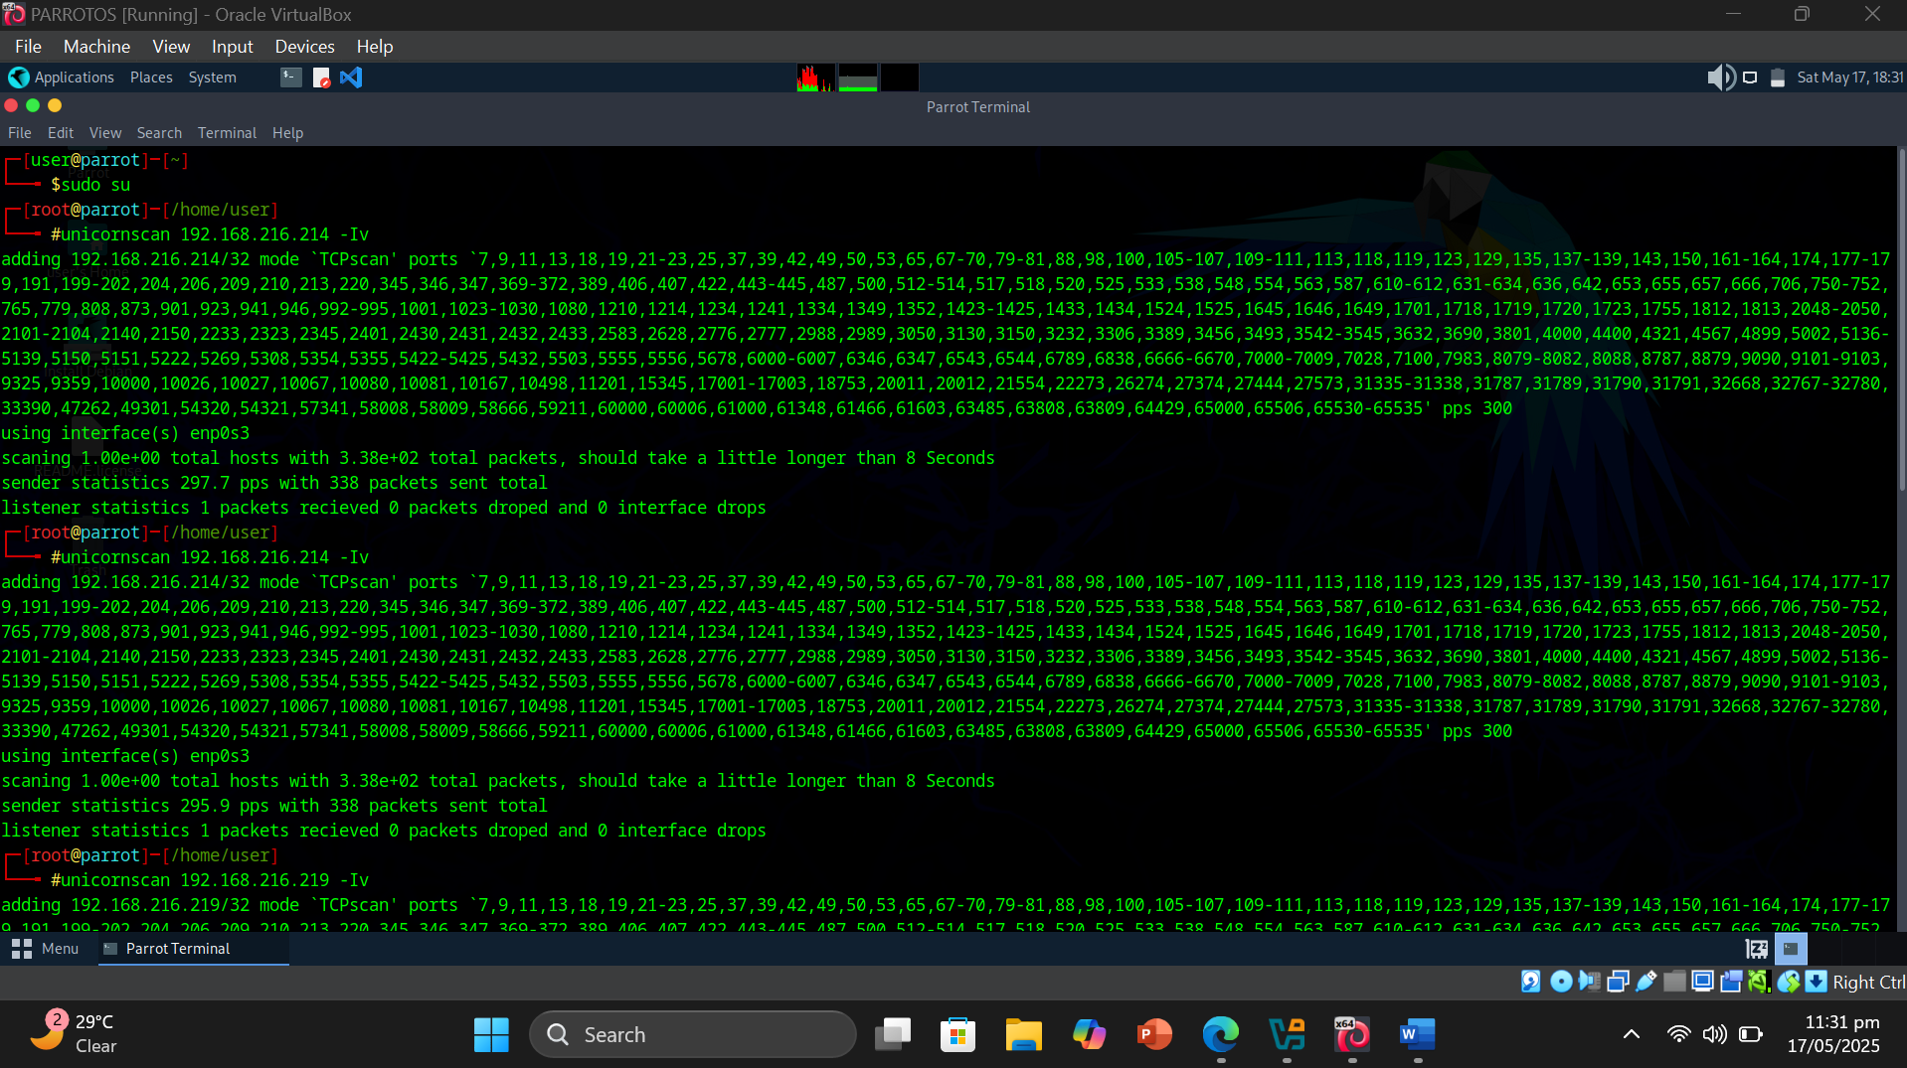

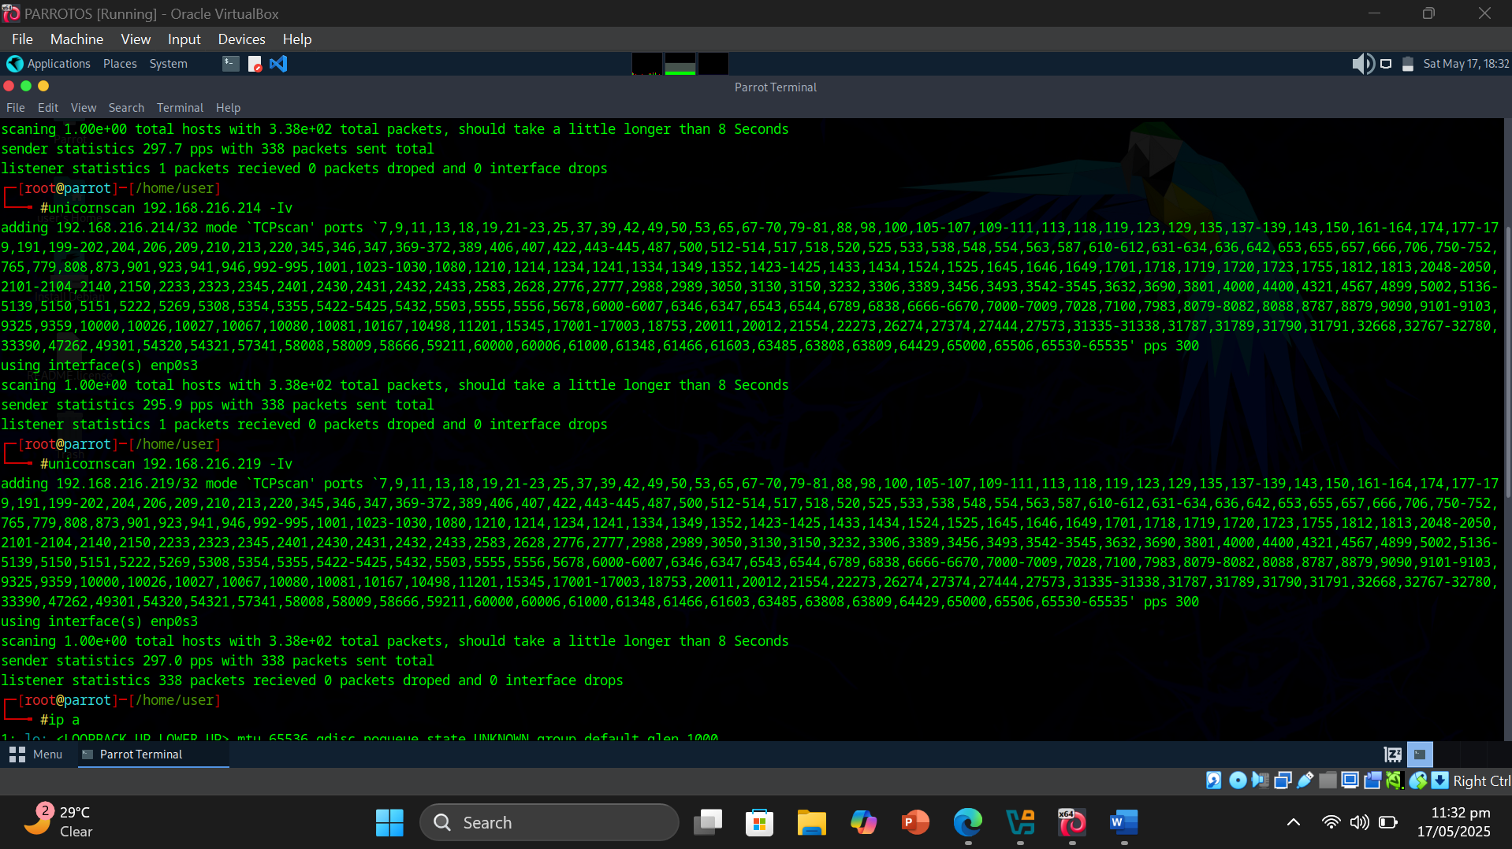

* Result or Output: I executed the command unicornscan <target_address> -Iv on Parrot OS to perform a port scan against a Windows Server 2019 machine. The scan completed very quickly and provided real-time updates on the status of the TCP ports being scanned. Throughout the process, Unicornscan displayed a comprehensive and detailed output, showing which ports were open, closed, or filtered. The verbose output also included technical information about the scanning progress, such as the rate of packets sent and received, as well as any anomalies detected during the scan. Overall, the tool gave a clear snapshot of the network surface of the target system in a matter of seconds
* Interpretation: This exercise allowed me to gain practical insight into how Unicornscan functions as a high-speed and efficient tool primarily used for OS discovery and port scanning. Unlike some other scanners that may take longer or produce less detailed results, Unicornscan demonstrated its capability to rapidly probe a target system and provide immediate feedback on port status. This efficiency is particularly valuable during the initial reconnaissance phase of a security assessment, where quick identification of open or vulnerable ports can guide further investigation and testing. The detailed output helped me appreciate the depth of information that can be gathered at this stage, improving my understanding of network scanning techniques and the practical use of specialized security tools.
* Errors Faced and How I Solved them :

While working with various OSINT and reconnaissance tools, I encountered multiple technical issues ranging from tool deprecation, missing dependencies, access restrictions, and firewall configurations. Below is a detailed list of the errors I faced and how I tackled each one.

1. **LinkedIn Harvester Tool Not Working**

* **Error**: The harvester tool no longer supports LinkedIn.
* **Solution**: Switched to using it for Bing instead, which worked for my footprinting needs.

1. **Sherlock Tool Command Outdated**

* **Error**: Sherlock's command python3 sherlock.py 'target person' was outdated.
* **Solution**: Cloned the latest GitHub repository and executed it from there, which fixed the issue.

1. **Followerwonk is Paid & Restricted**

* **Error**: Couldn't analyze Twitter profiles without purchasing premium access; alternatives were also paid and geo-blocked.
* **Solution**: Used a VPN to access the tools, but full functionality remained behind a paywall.

1. **Photon Tool Missing Dependencies**

* **Error**: Photon tool failed to run due to missing Python dependencies.
* **Solution**: Created a virtual environment, installed all required dependencies, and the tool worked fine afterward.

1. **HTTrack Couldn’t Copy CertifiedHacker.com**

* **Error**: HTTrack crashed while trying to copy certifiedhacker.com.
* **Solution**: Tested the tool on a simpler site (www.example.com) which confirmed the tool was working correctly.

1. **GRecon Tool Outdated & Unavailable**

* **Error**: The GRecon tool was outdated, and its GitHub repository was removed.
* **Solution**: Tried other alternatives but couldn’t find a reliable working option.

1. **Cewl Not Working on CertifiedHacker.com**

* **Error**: Couldn’t generate a wordlist from certifiedhacker.com; likely due to its secure structure.
* **Solution**: Ran the tool on www.example.com, and it successfully generated a wordlist.

1. **VMs Not Pinging Each Other (ICMP Timeout)**

* **Error**: One VM couldn’t ping the other — showed “request timed out” due to blocked packets.
* **Solution**: Added inbound firewall rules on both VMs to allow ICMP packets, which fixed the connectivity issue.

1. **Nmap OS Discovery - Port 80 Closed**

* **Error**: Couldn’t discover OS using Nmap as TCP port 80 was closed.
* **Solution**: Enabled the web server on localhost at port 80, added the necessary Windows firewall inbound rule, and re-ran the scan successfully.

**Total 4 Labs Performed by Mahad Aqeel 2023286**

1. Module 2: Lab 2
2. Module 2: Lab 5
3. Module 2: Lab 6
4. Module 3: Lab 1

## Environment Setup :

## Attacker OS: ParrotSec OS (Running in VirtualBox)

* **Target OS:** Windows 11 VM
* **Virtualization Tool Used:** Oracle VirtualBox 7.x
* **Network Settings:** NAT (used to allow Kali Linux to access internet-based tools like Netcraft, PeekYou, and perform Nmap scans)
* **Additional Dependencies or Tools Installed:**
  + theHarvester, and Nmap were pre-installed on ParrotOS
  + Angry IP Scanner installed separately on the host Windows machine
  + Browser-based tools (like WHOIS and Email Tracker Pro) accessed via Windows 11 VM browser
  + Tor Browser installed separately for dark web reconnaissance

| **Tool** | **Version** | **Purpose** |
| --- | --- | --- |
| **Nmap** | v7.94 | Used for host discovery and port/service scanning on target IPs. |
| **theHarvester** | Built-in | Used to collect emails, subdomains, and hosts from public sources. |
| **Netcraft** | Web-based | Used to identify domain info, server technologies, and subdomains. |
| **WHOIS** | Web-based | Used to gather domain registration and ownership details. |
| **PeekYou** | Web-based | Used to find personal/public profiles of individuals across websites. |
| **Censys.io** | Web-based | Used to explore publicly exposed ports, SSL certs, and services on domains. |
| **EmailTrackerPro** | Web-based | Used to trace the origin of email headers and locate sender IP. |
| **Tor Browser** | v12+ | Used to explore .onion websites and gather OSINT from the dark web. |
| **Angry IP Scanner** | v3.9.x | Used to quickly discover live hosts on a subnet from the Windows VM. |

**Module 2: Lab 6 Perform WHOIS Footprinting**

1. Open Windows11 VM and search for whois.domaintools.com
2. Enter URL of target website
3. Review domain registrar, contact details, name servers, and expiration info.
4. Analyze potential attack vectors based on domain ownership data.
5. Capture output or page for your report

**Objective of Task:**  
To gather domain ownership, registrar, and technical details using WHOIS lookup.

**•Command or Procedure Used:**

1. Opened browser on Windows 11 VM.
2. Visited whois.domaintools.com.
3. Entered the target domain name and initiated the WHOIS search.

**• Result or Output:**  
The tool displayed registrar name, domain creation/expiry date, name servers, and the contact email of the admin.

**• Interpretation:**  
The domain was registered via GoDaddy and is set to expire in 2025. The admin contact and organization name can be used for further recon. This was a **passive information gathering** task.

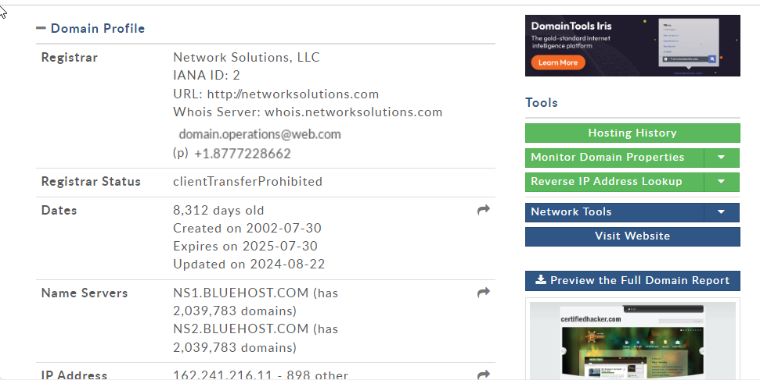

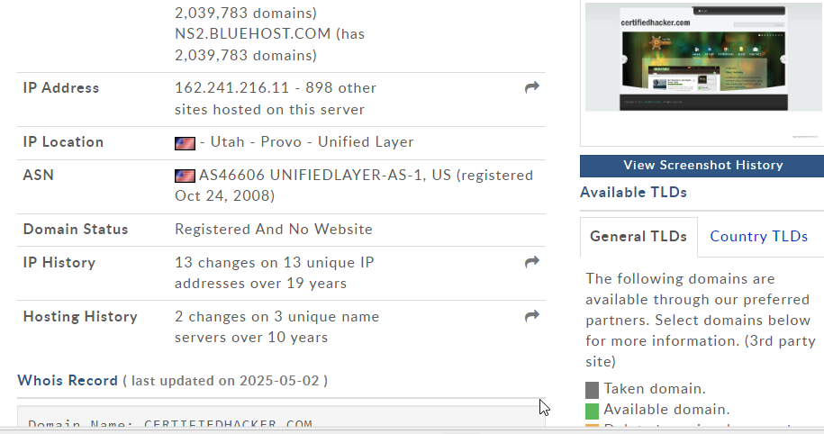

**Module 2: Lab 2 Performing Footprinting through Web Services**

**• Objective of Task:**  
To collect emails, subdomains, and public info using online services.

**• Command or Procedure Used:**

1. Used **Netcraft** to identify subdomains and IP addresses.
2. Used **theHarvester** in Parrot Security OS
3. Visited **PeekYou** to search for personal info using names/emails.

**• Result or Output:**

* Netcraft listed multiple subdomains.
* theHarvester extracted emails from public sources.
* PeekYou returned multiple public profiles of employees.

**• Interpretation:**  
This helped in mapping the target’s infrastructure and identifying employee data that could be exploited in **social engineering** or **phishing** scenarios.

**Task 1 – Find the Company’s Domains and Subdomains Using Netcraft**

1. Open the Netcraft site: https://sitereport.netcraft.com.
2. Enter the target company domain (e.g., example.com).
3. View details such as DNS, hosting provider, IP addresses, and subdomains.
4. Take a screenshot for documentation.

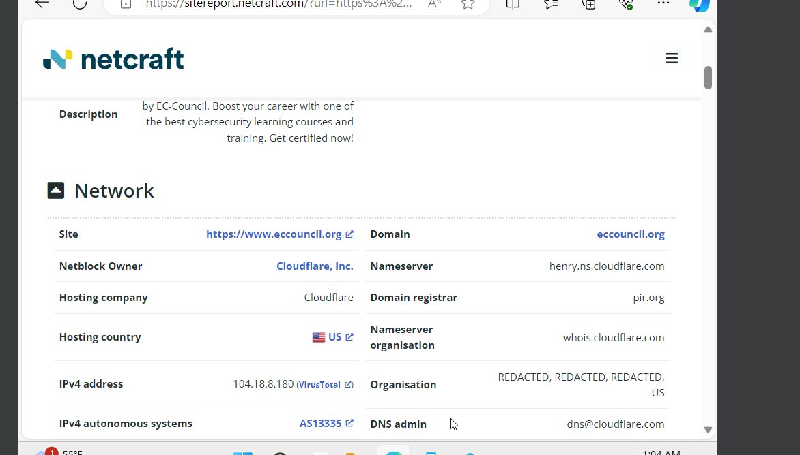

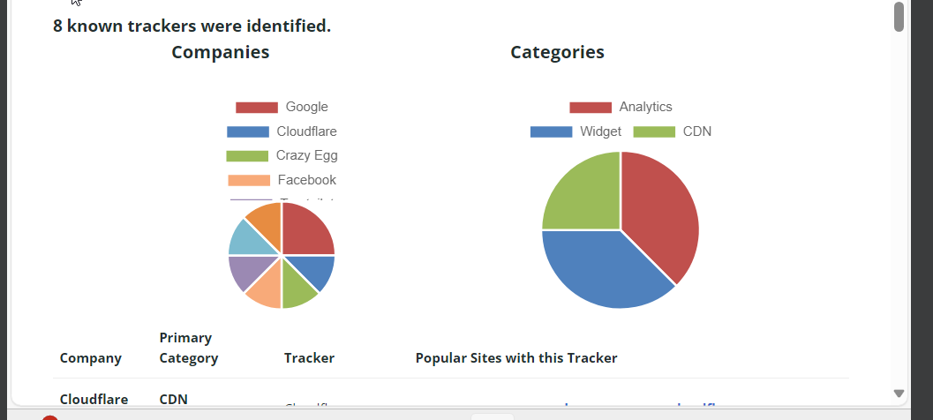

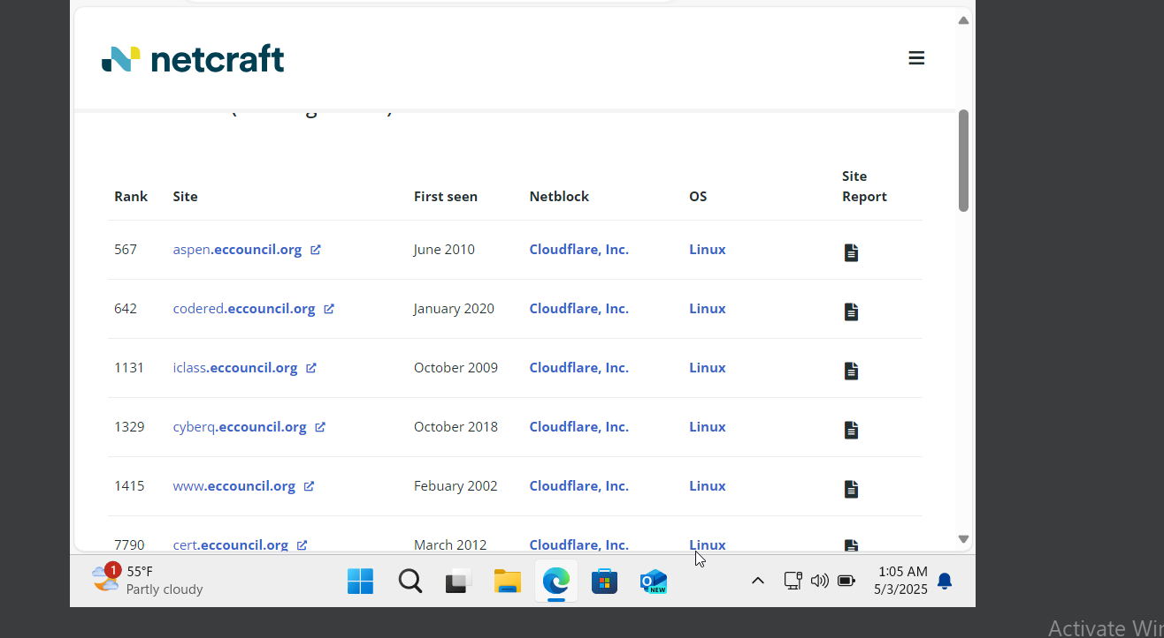

**Task 2 – Gathering Personal Information Using PeekYou**

1. Go to <https://www.peekyou.com>.
2. Search for a person’s name, alias, or email.
3. Review results across social media and public info.
4. Note relevant findings and capture screenshot evidence.

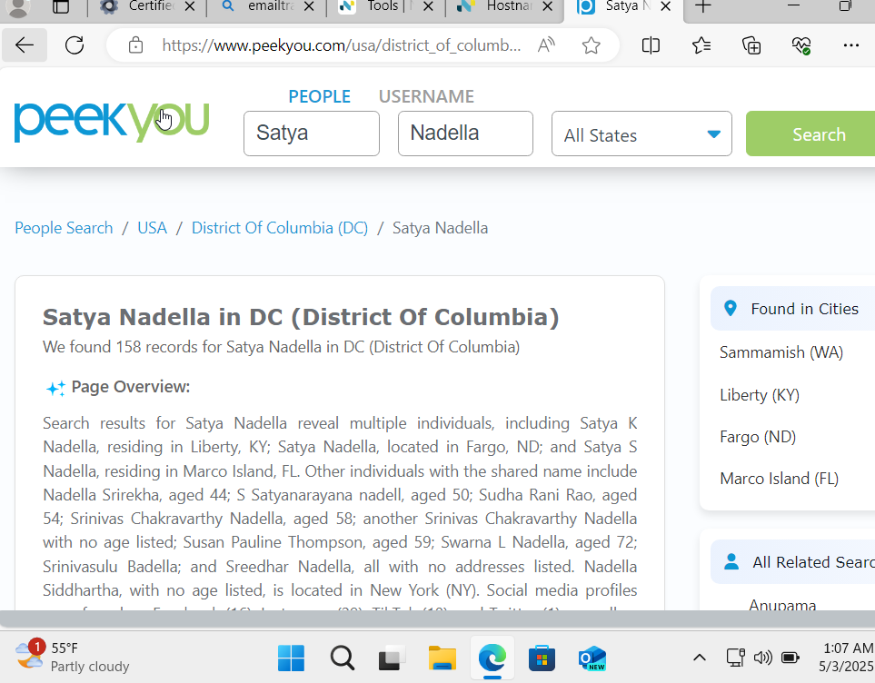

#### 

#### Task 3 – Gather an Email List Using theHarvester

1. Launch ParrotOS and open terminal.
2. Run: theHarvester -d example.com -b google (replace with your domain).
3. Observe and note down collected email addresses.
4. Save or screenshot the results.

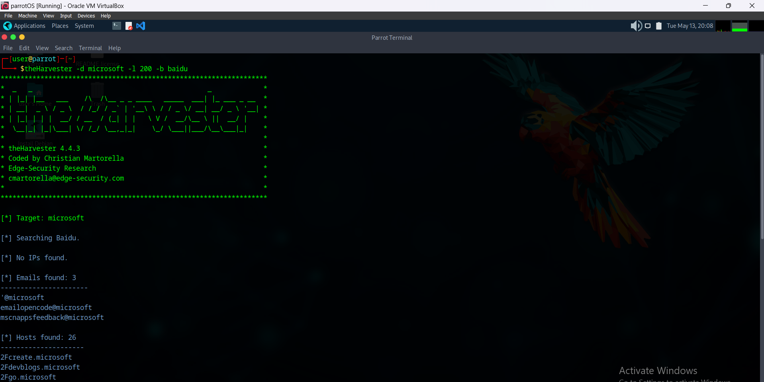

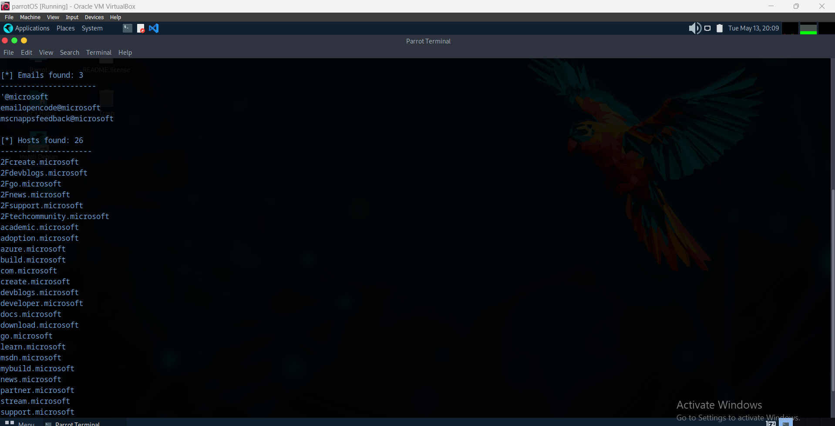

**Task 5 – Determine Target OS Through Passive Footprinting**

1. Use Netcraft or Shodan.io or search.censys.io to search for the domain/IP.
2. Identify OS info based on banners or fingerprints.
3. 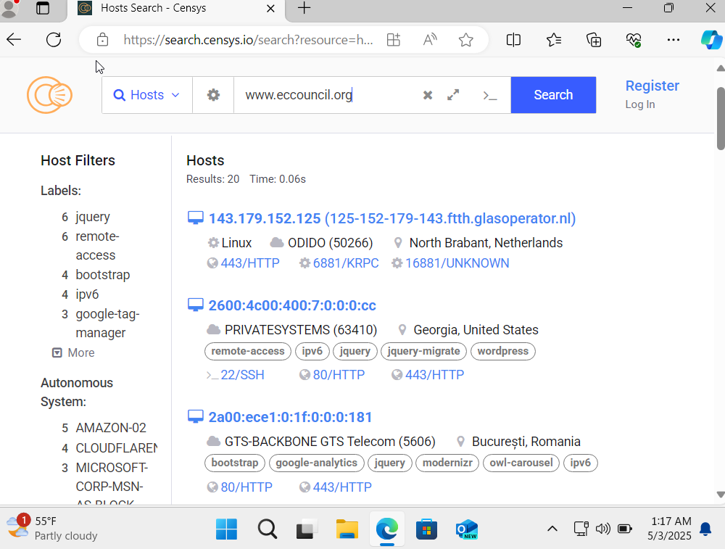Cross-check with network tools or headers for verification.

**Task 4 – Gather Information Using Deep and Dark Web Searching**

1. Use a dark web search engine like [ahmia.fi](https://ahmia.fi) or access via Tor browser.
2. Search for organization or person-specific keywords.
3. Document anything sensitive or revealing.
4. Be cautious and only use ethical/legal sources.

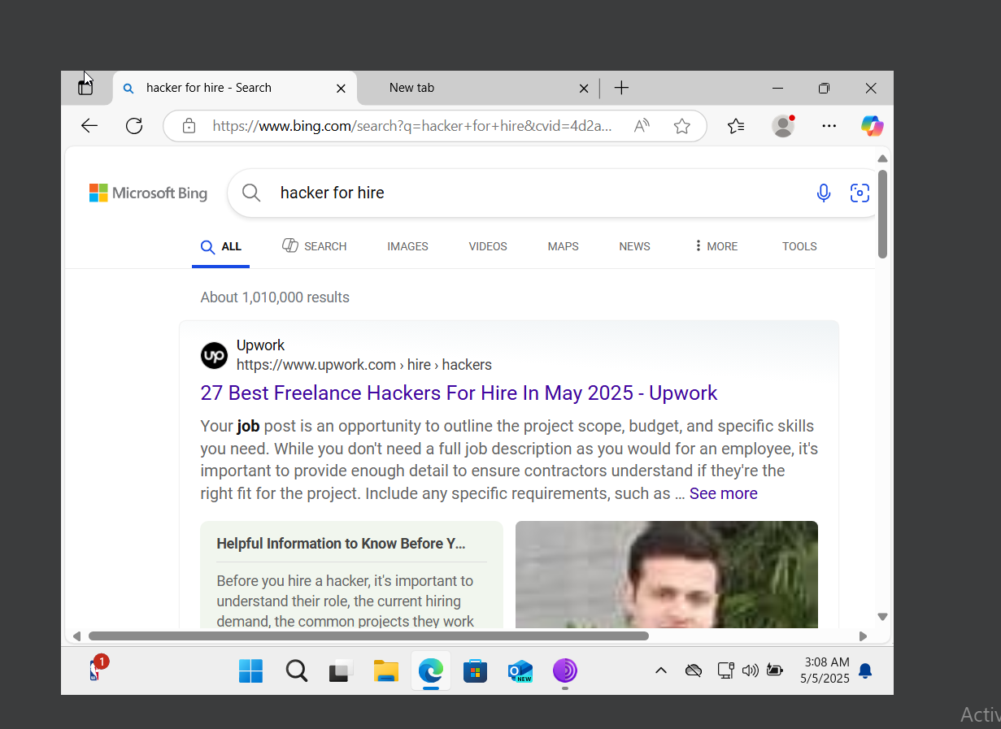

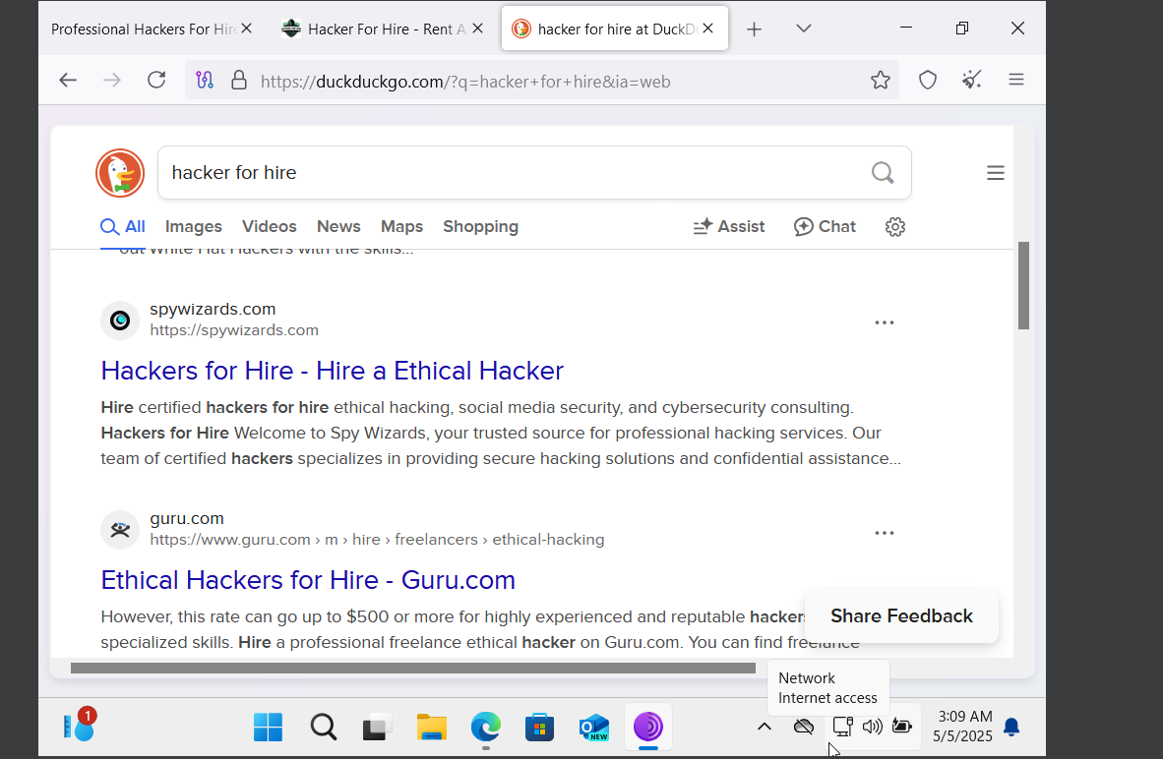

**MODULE 2: LAB 5- Perform Email Footprinting**

1. Open Windows11 VM and launch the EmailTrackerPro (or any email tracking tool).
2. Analyze email headers by copying and pasting them.
3. Click on 3 dots on right side of email to see original route of email
4. Identify sender IP, mail server, and possible spoofing.
5. Check for vulnerabilities or leaks associated with email servers.
6. Document findings with screenshots.

**• Objective of Task:**  
To trace the source and analyze header information of an email.

**• Command or Procedure Used:**

1. Opened **EmailTrackerPro** via browser.
2. Pasted full email header text into the tool.
3. Clicked "Trace Email" to analyze origin.

**• Result or Output:**  
The tool extracted the **sender’s IP address**, geolocation, and mail server routing info.

**• Interpretation:**  
From the IP and mail flow, we can verify if an email is legitimate or spoofed. This can help detect **phishing attempts or business email compromise**.

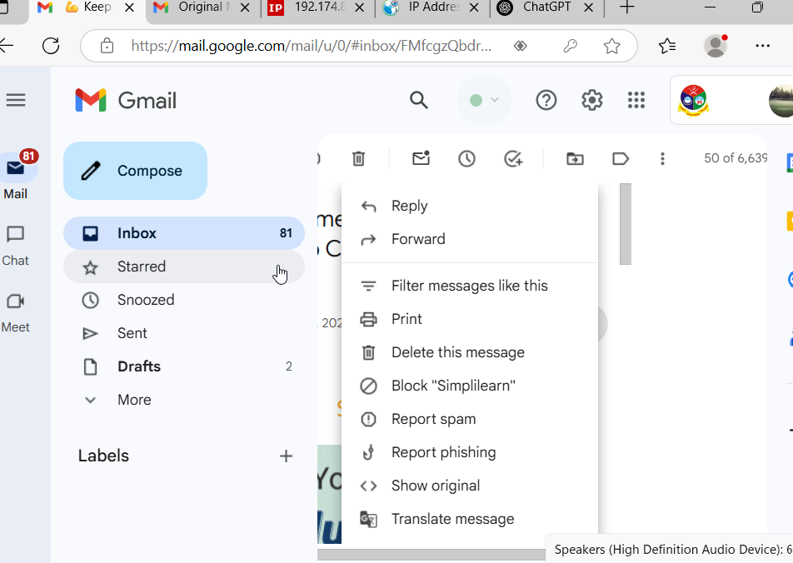

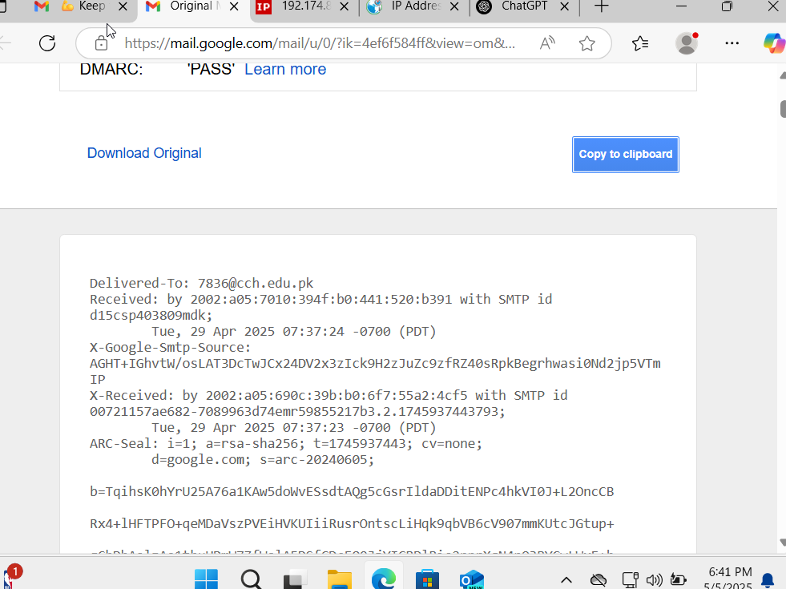

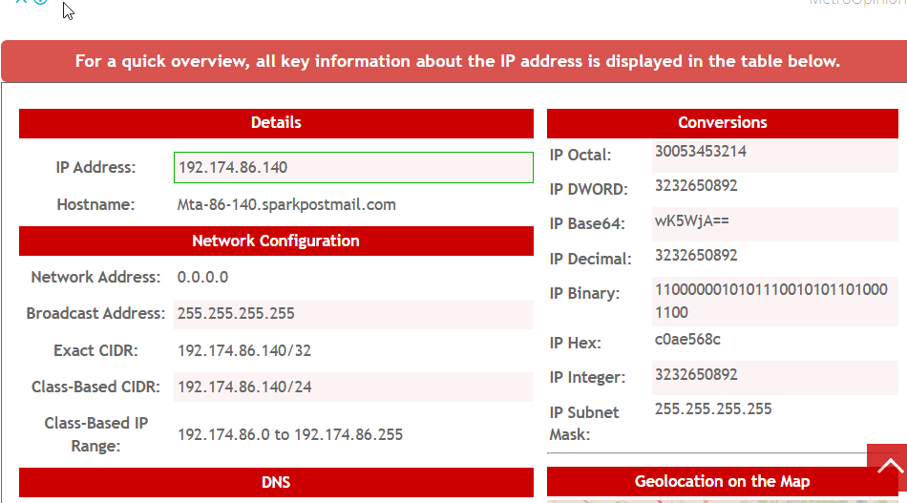

**MODULE 3: Perform Host Discovery**

**LAB 1 Task 1 – Using Nmap**

1. Make sure both VMs are on same network
2. Open command terminal of both vms and enter command ‘ipconfig’
3. Note down IP address of target VM
4. Run command ‘nmap –sn –PE [target VM IP]
5. Check and analyse results

**• Objective of Task:**  
To identify live hosts in a given network range.

**• Command or Procedure Used:**

* On ParrotOS: sudo nmap –sn –pe 192.168.56.102
* On Windows VM: Opened Angry IP Scanner → Set range → Clicked “Start”.

**• Result or Output:**  
Both tools identified several live hosts with their IP addresses, MAC, and status (up/down).

**• Interpretation:**  
This confirms which systems are online and could be potential targets. It's the **first step in network scanning.**

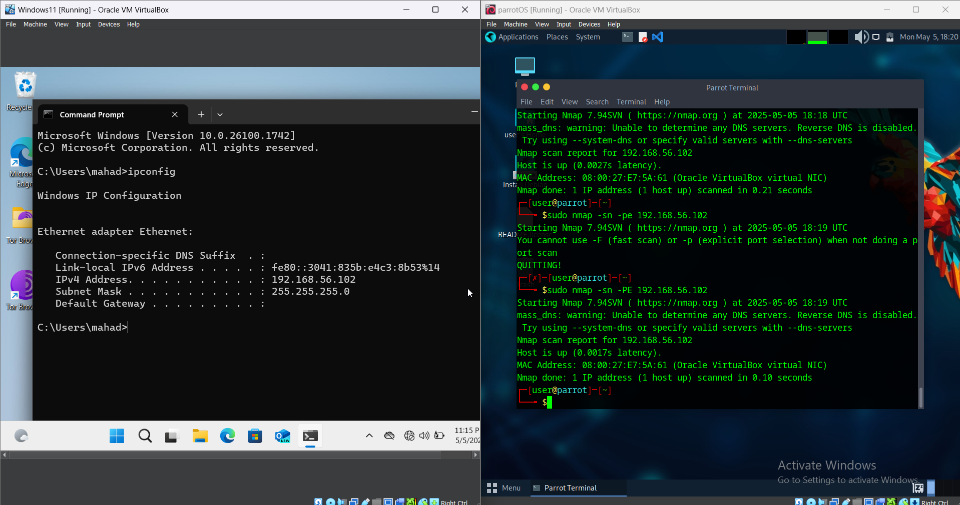

Task 2- Using AngryIP scanner

1. Open Angry IP Scanner.
2. Set the IP range and start scanning.
3. View hosts, status, and hostname details.
4. Export the results as a CSV or screenshot them.

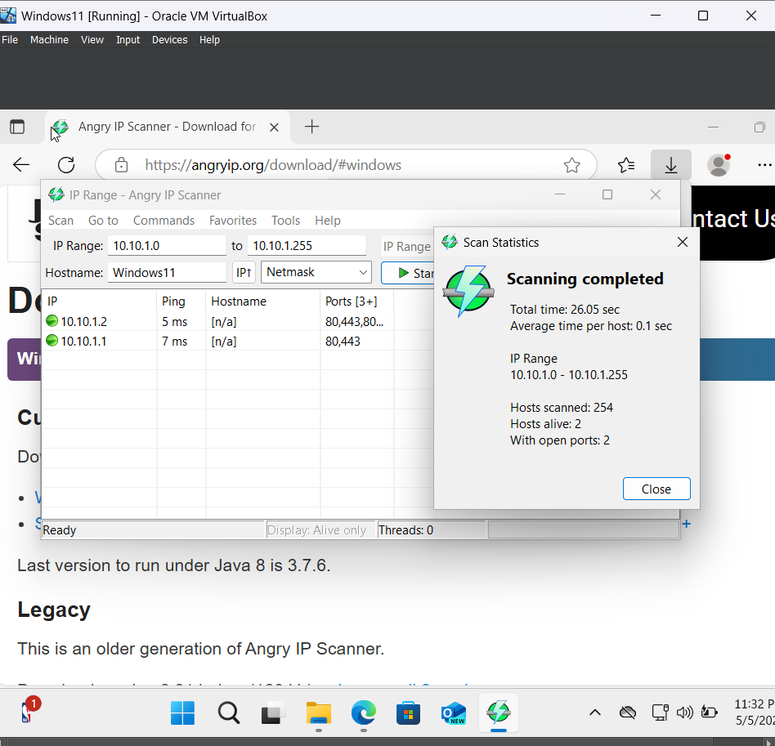

## Errors Faced and How They Were Solved

During the course of performing the labs from **Module 2 and 3**, I encountered several issues related to **virtual machine setup, tool compatibility, and network configuration**. These challenges were expected, and resolving them enhanced my hands-on learning experience.

### 🔹 1. Virtual Machine Installation & Setup Issues

**Issue:**  
Initially, I faced difficulties setting up **ParrotOS on VirtualBox** — the installation ISO wasn't booting properly, and the default display resolution was off.

**How I Solved It:**  
I watched multiple YouTube tutorials and followed the official ParrotSec OS documentation step-by-step. I re-downloaded the latest ISO file and allocated the correct RAM and storage settings. I also enabled virtualization from the BIOS settings of my host machine.

### 🔹 2. Network Configuration Problems Inside Windows 11 VM

**Issue:**  
After installing Windows, it wasn’t connecting to the internet. This created issues with running tools like Netcraft (browser-based).

**How I Solved It:**  
I checked VirtualBox **network settings** and changed the adapter from **NAT** to **Bridged Adapter**, which allowed Kali to use the host system's internet directly.

### 🔹 3. Outdated or Broken Tool Links

**Issue:**  
Some tools like **email tracking utilities** had broken download links or outdated repositories on GitHub.

**How I Solved It:**  
I searched for updated forks or alternatives on GitHub and used community forums (like Stack Overflow and Reddit) to find working versions.

### 🔹 4. Permission & Execution Errors

**Issue:**  
When using tools like theHarvester or Nmap, I sometimes received permission errors (e.g., “cannot access network interface”).

**How I Solved It:**  
I prefixed the commands with sudo to ensure they had administrative privileges:

sudo theHarvester -d example.com -b google

### 🔹 5. Tool Not Running in Windows VM

**Issue:**  
Tools like **Angry IP Scanner** didn't run initially due to missing Java runtime on my Windows 11 VM.

**How I Solved It:**  
I installed the latest version of Java from the official Oracle site, and the tool launched successfully afterward.

Being able to solve these issues gave me **confidence in configuring environments**, using the command line, and troubleshooting Linux and Windows systems — which are essential skills for cybersecurity.

**Total 2 labs performed by Muhammad Daniyal 2023406**

* + - 1. Module 2 : lab 7
      2. Module 2 : lab 8

## 

### Environment Setup

* **Virtual Machines**: Parrot Security OS and Windows VM.
* **Operating Systems**: Parrot Security (Linux-based, version not specified), Windows (version not specified).
* **IP Configuration**: Network adapter configured to use Google DNS (8.8.8.8) for DNS requests to resolve connectivity issues.

## Tools Used

* The following table lists the tools used across both Lab 7 (DNS Footprinting) and Lab 8 (Network Footprinting), including their versions (where available) and purpose.

|  |  |  |
| --- | --- | --- |
| **Tool** | **Version** | **Purpose** |
| nslookup | Not specified | Command-line tool to query DNS records, retrieve IPs, and identify name servers. |
| NSLOOKUP Online Tool | Not specified | Web-based tool to gather DNS information (IPv4, IPv6, CNAME, NS, etc.). |
| Reverse IP Domain Check | Not specified | Online tool for reverse DNS lookup to identify domains on the same server. |
| DNSRecon | Not specified | Enumerates DNS records from an IP range on Parrot Security. |
| SecurityTrails | Not specified | Online tool to gather subdomain and DNS records (IPv4, IPv6, MX, NS, SOA, TXT, CNAME). |
| DNSchecker | Not specified | Alternative online tool for DNS footprinting. |
| DNSdumpster | Not specified | Alternative online tool for DNS footprinting. |
| ARIN WHOIS Database Search | Not specified | Online tool to locate the target’s network range. |
| tracert | Not specified | Windows command-line tool to trace the network path to a target domain. |
| traceroute | Not specified | Linux command-line tool to view packet hops on Parrot Security. |
| VisualRoute | Not specified | Online tool for network hop information. |
| Traceroute NG | Not specified | Online tool for network hop information. |
| Path Analyzer Pro | Not specified | Intended for advanced network route tracing (not functional on VM). |

### Lab 7 : DNS Footprinting

### Lab Tasks

#### Task 1: Gathering DNS Information Using nslookup Command Line and Online Tool

**Objective of Task**: The task aimed to collect DNS-related information about the target domain [www.certifiedhacker.com](http://www.certifiedhacker.com), including IP addresses, authoritative name servers, and mail server details, to build a footprint for reconnaissance.

**How to Perform This Task**:

1. Open the Windows Command Prompt.
2. Type nslookup and press Enter to start the tool.
3. Type set type=a and press Enter to set the query type to A records.
4. Type www.certifiedhacker.com and press Enter to retrieve the IP address.
5. Type set type=cname and press Enter to query CNAME records.
6. Type set type=a again and press Enter to revert to A records for further IP details.
7. For the online tool, navigate to a web browser, visit an NSLOOKUP online service (e.g., mxtoolbox.com), enter [www.certifiedhacker.com](http://www.certifiedhacker.com), and click "Look it up."

**Command or Procedure Used**: Executed the following commands in the Windows command prompt:  
 text  
Copy  
nslookup

set type=a

www.certifiedhacker.com

set type=cname

set type=a  
 Additionally, the online NSLOOKUP tool was used by entering the domain [www.certifiedhacker.com](http://www.certifiedhacker.com) and clicking "Look it up."

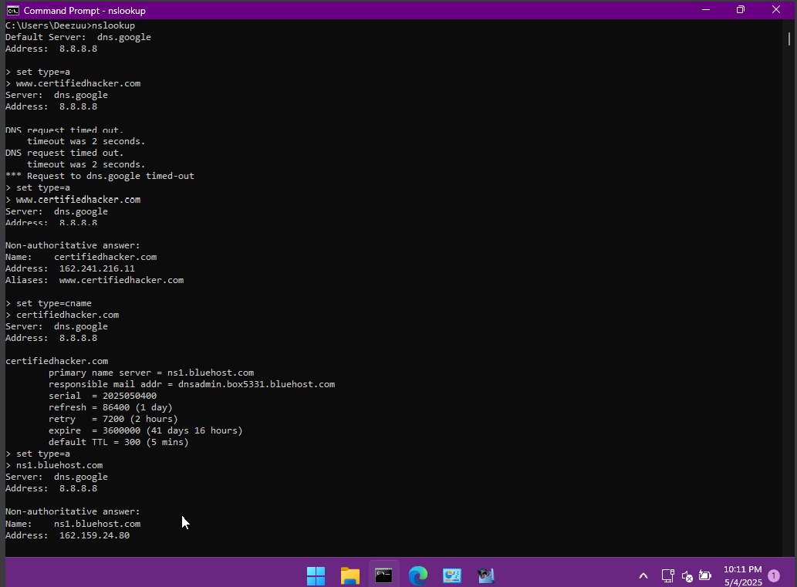

Now we use the online tool

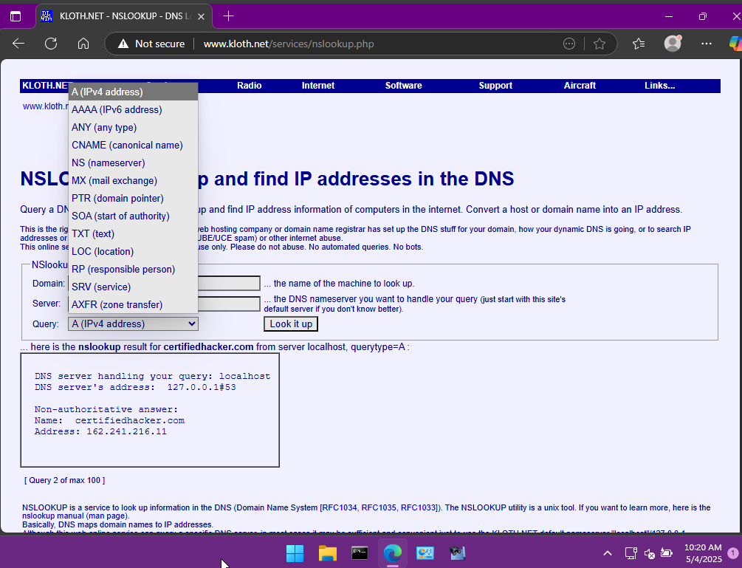

**Result or Output**: The nslookup command displayed the default DNS server of the VM. Using set type=a, it retrieved the IP address of [www.certifiedhacker.com](http://www.certifiedhacker.com). Switching to set type=cname provided the authoritative name server and mail server details. Repeating set type=a confirmed the IP address. The online NSLOOKUP tool returned similar DNS records, including IPv4, IPv6, CNAME, and NS details.

**Interpretation**: The results confirmed the target’s IP infrastructure and authoritative servers, offering potential entry points for attacks like DoS or URL redirection. The consistency between command-line and online tool outputs validated the reliability of the gathered data for further reconnaissance.

#### Task 2: Performing Reverse DNS Lookup Using Reverse IP Domain Check and DNSRecon

**Objective of Task**: Identify domains on the same server as [www.certifiedhacker.com](http://www.certifiedhacker.com) and enumerate DNS records.

**How to Perform This Task**:

1. Open browser, go to yougetsignal.com.
2. Enter [www.certifiedhacker.com](http://www.certifiedhacker.com), click search.
3. On Parrot Security, open terminal.
4. Install DNSRecon: sudo apt-get install dnsrecon.
5. Run dnsrecon -r <IP_range> -d certifiedhacker.com.

**Command or Procedure Used**:  
 text  
Copy  
dnsrecon -r <IP_range> -d certifiedhacker.com  
 Online: Entered domain in Reverse IP Domain Check tool.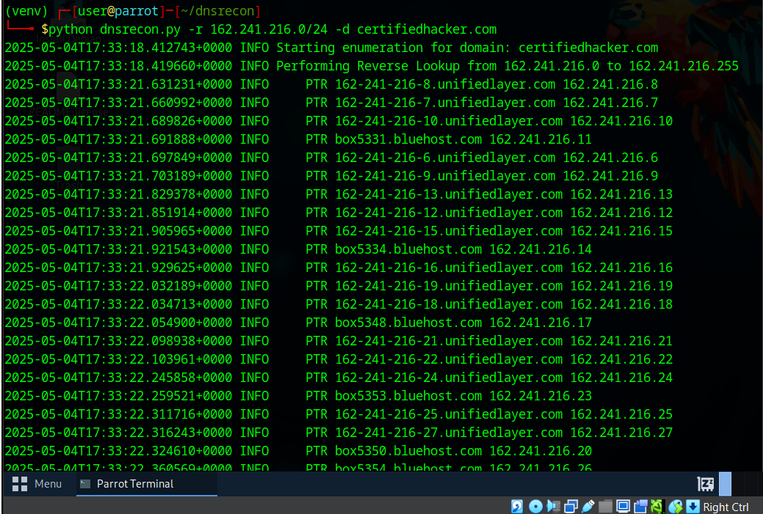

Here we used an online tool to find the other domains who are hosted on the same server as certifiedhacker.com

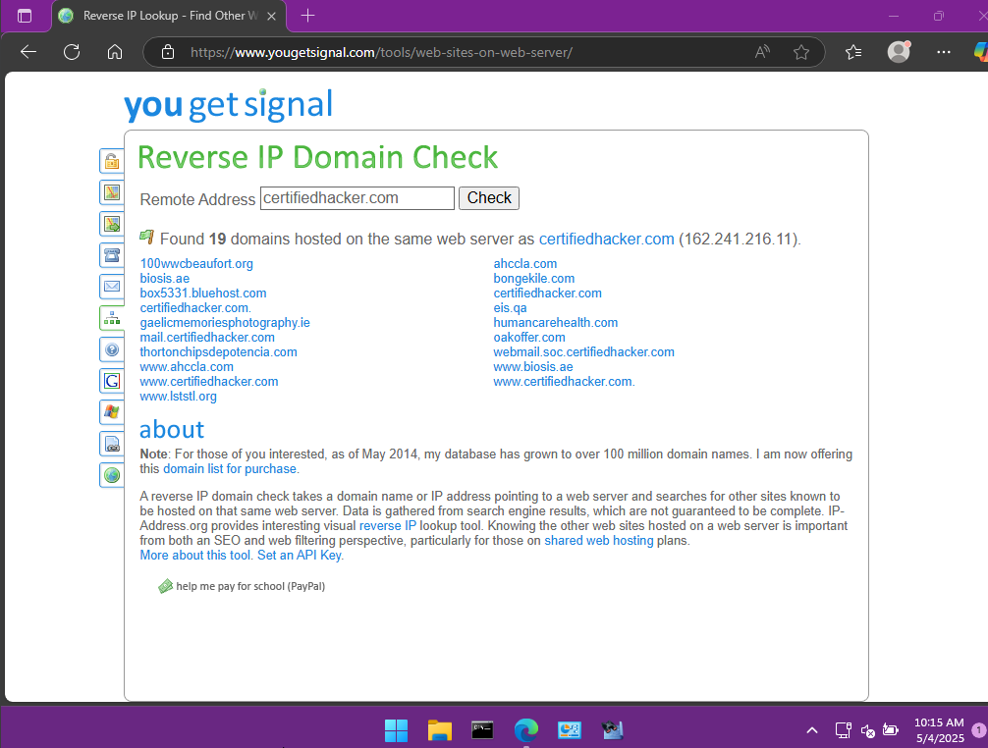

**Result or Output**: Reverse IP tool listed domains on the same server. DNSRecon provided DNS records for the IP range.

**Interpretation**: Found related domains and DNS records, expanding the attack surface for further analysis.

#### Task 3: Gather Information of Subdomain and DNS Records Using SecurityTrails

**Objective of Task**: Collect subdomains and DNS records for [www.certifiedhacker.com](http://www.certifiedhacker.com).

**How to Perform This Task**:

1. Open browser, go to securitytrails.com.
2. Enter [www.certifiedhacker.com](http://www.certifiedhacker.com) in the search bar, press Enter.
3. Navigate to DNS and subdomain sections.

**Command or Procedure Used**: Entered [www.certifiedhacker.com](http://www.certifiedhacker.com) in SecurityTrails interface.

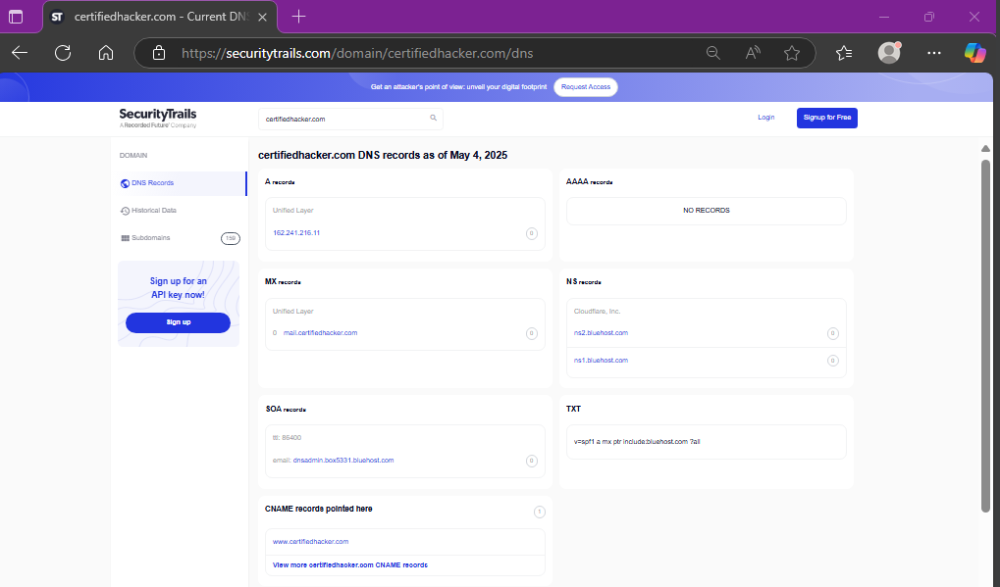

**Result or Output**: Got DNS records (IPv4, IPv6, MX, NS, SOA, TXT, CNAME) and subdomains.

**Interpretation**: Exposed potential vulnerabilities in DNS setup, useful for targeted attacks or security fixes.

## Lab 8: Network Footprinting

### Lab Tasks

#### Task 1: Locate Network Range

**Objective of Task**: Identify the network range for [www.certifiedhacker.com](http://www.certifiedhacker.com).

**How to Perform This Task**:

1. Open browser, go to whois.arin.net.
2. Enter [www.certifiedhacker.com](http://www.certifiedhacker.com), click search.

**Command or Procedure Used**: Entered [www.certifiedhacker.com](http://www.certifiedhacker.com) in ARIN WHOIS Database Search tool.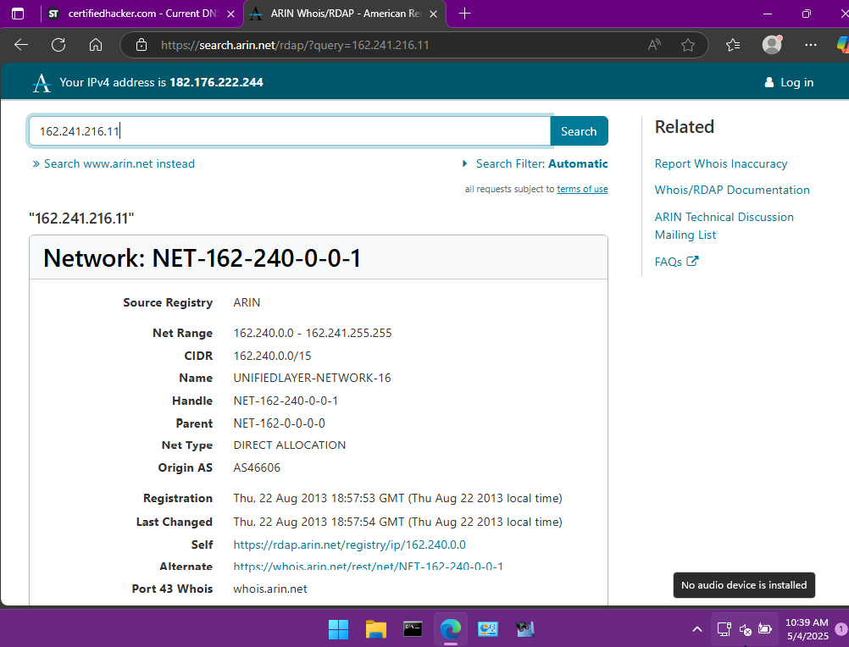

**Result or Output**: Returned network range with IP allocation details.

**Interpretation**: Defined the target’s IP space for network mapping.

#### Task 2: Perform Network Tracerouting in Windows and Linux Machines

**Objective of Task**: Trace the network path to [www.certifiedhacker.com](http://www.certifiedhacker.com) to map hops.

**How to Perform This Task**:

1. On Windows, open Command Prompt.
2. Type tracert www.certifiedhacker.com, press Enter.
3. Type tracert -h 5 www.certifiedhacker.com, press Enter.
4. On Parrot Security, open terminal.
5. Type traceroute www.certifiedhacker.com, press Enter.

**Command or Procedure Used**:  
   
tracert www.certifiedhacker.com

tracert -h 5 www.certifiedhacker.com

traceroute www.certifiedhacker.com

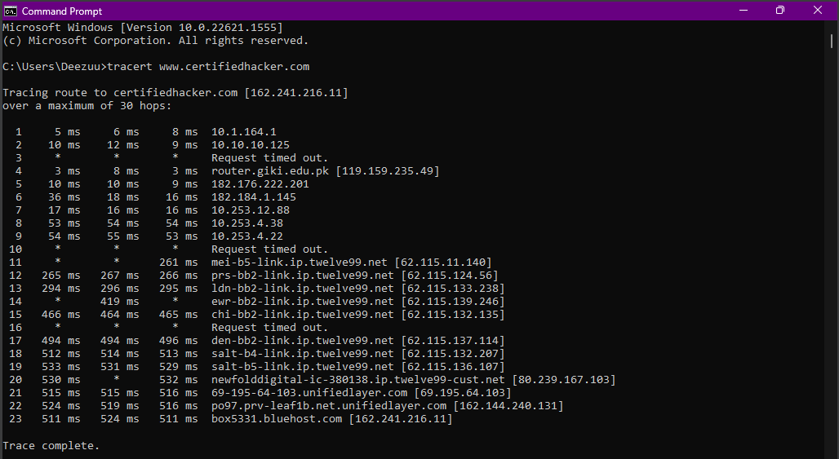

tracert -h 5 [www.certifiedhacker.com](http://www.certifiedhacker.com) for max 5 hops

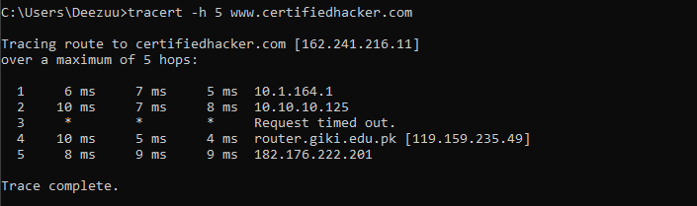

**Command on parrot security:**

traceroute [www.certifiedhacker.com](http://www.certifiedhacker.com)

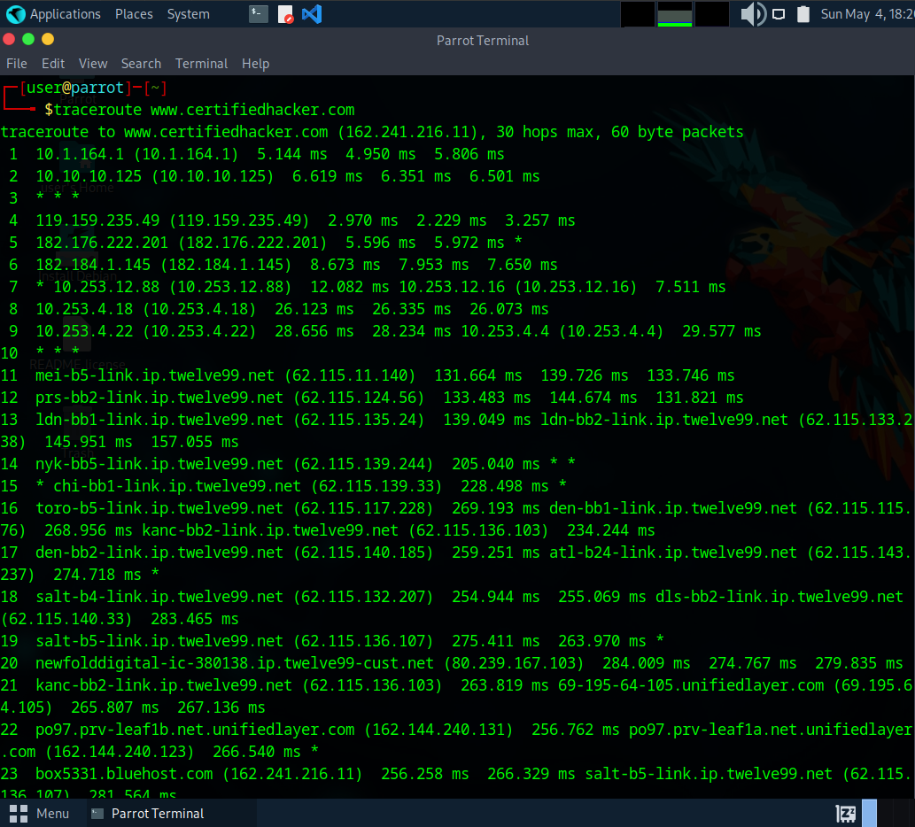

**Result or Output**: Windows tracert listed hops, -h 5 limited to 5 hops. Linux traceroute showed similar hops.

**Interpretation**: Revealed network path and potential choke points for targeting or securing.

**Task 3: Perform Advanced Network Route Tracing Using Path Analyzer Pro**

**Objective of Task**: Conduct advanced route tracing to [www.google.com](http://www.google.com) for detailed path analysis.

**How to Perform This Task**:

1. Open Path Analyzer Pro on Windows VM.
2. Set target to [www.google.com](http://www.google.com).
3. Select "ICMP" protocol, set "Port" to "Smart."
4. Adjust settings: Initial TTL to 1, Probes per TTL to 2-10.
5. Click "Run."
6. Check DNS, Routing, Geo, Stats, and Log tabs.

**Command or Procedure Used**: Configured Path Analyzer Pro with ICMP, set target to [www.google.com](http://www.google.com), adjusted settings, and clicked "Run."

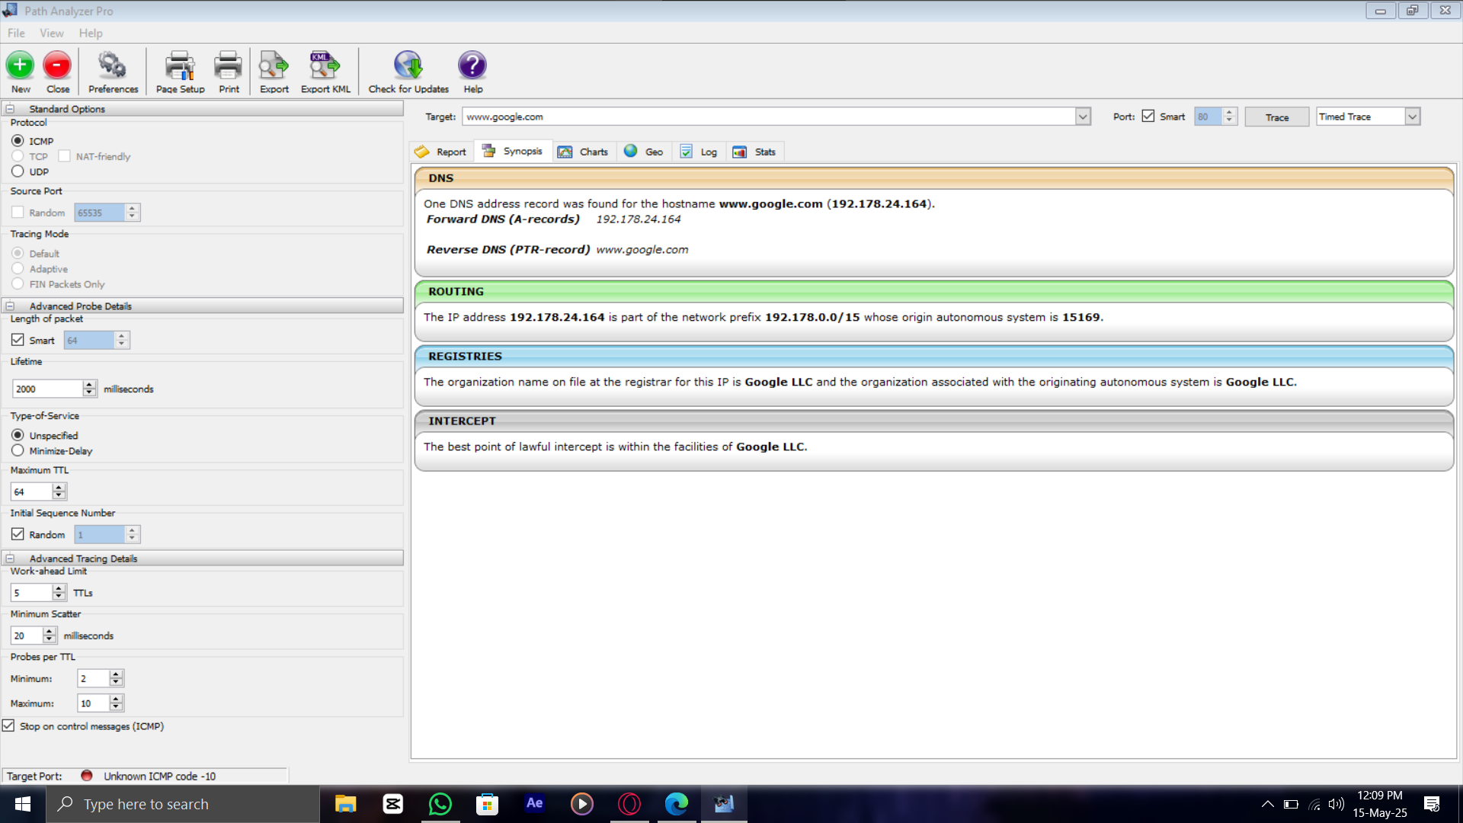

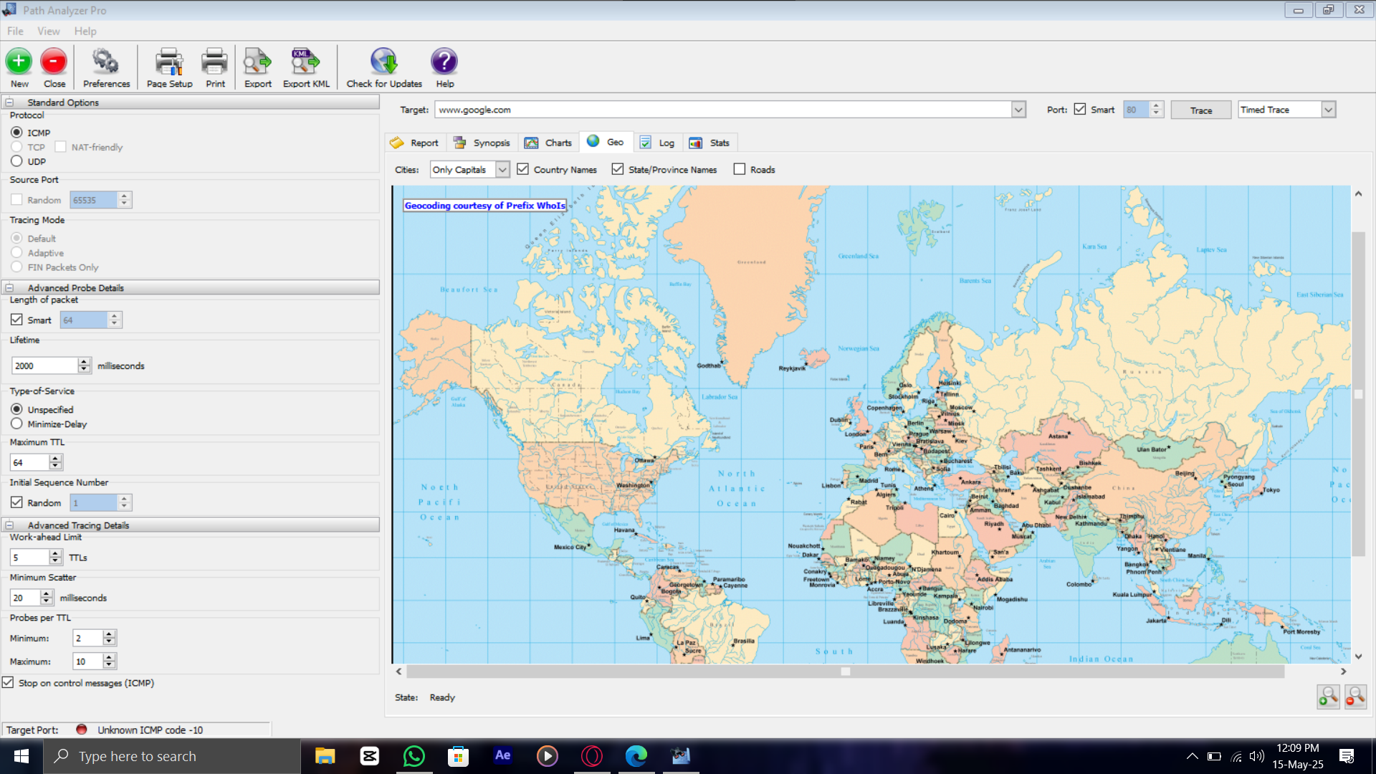

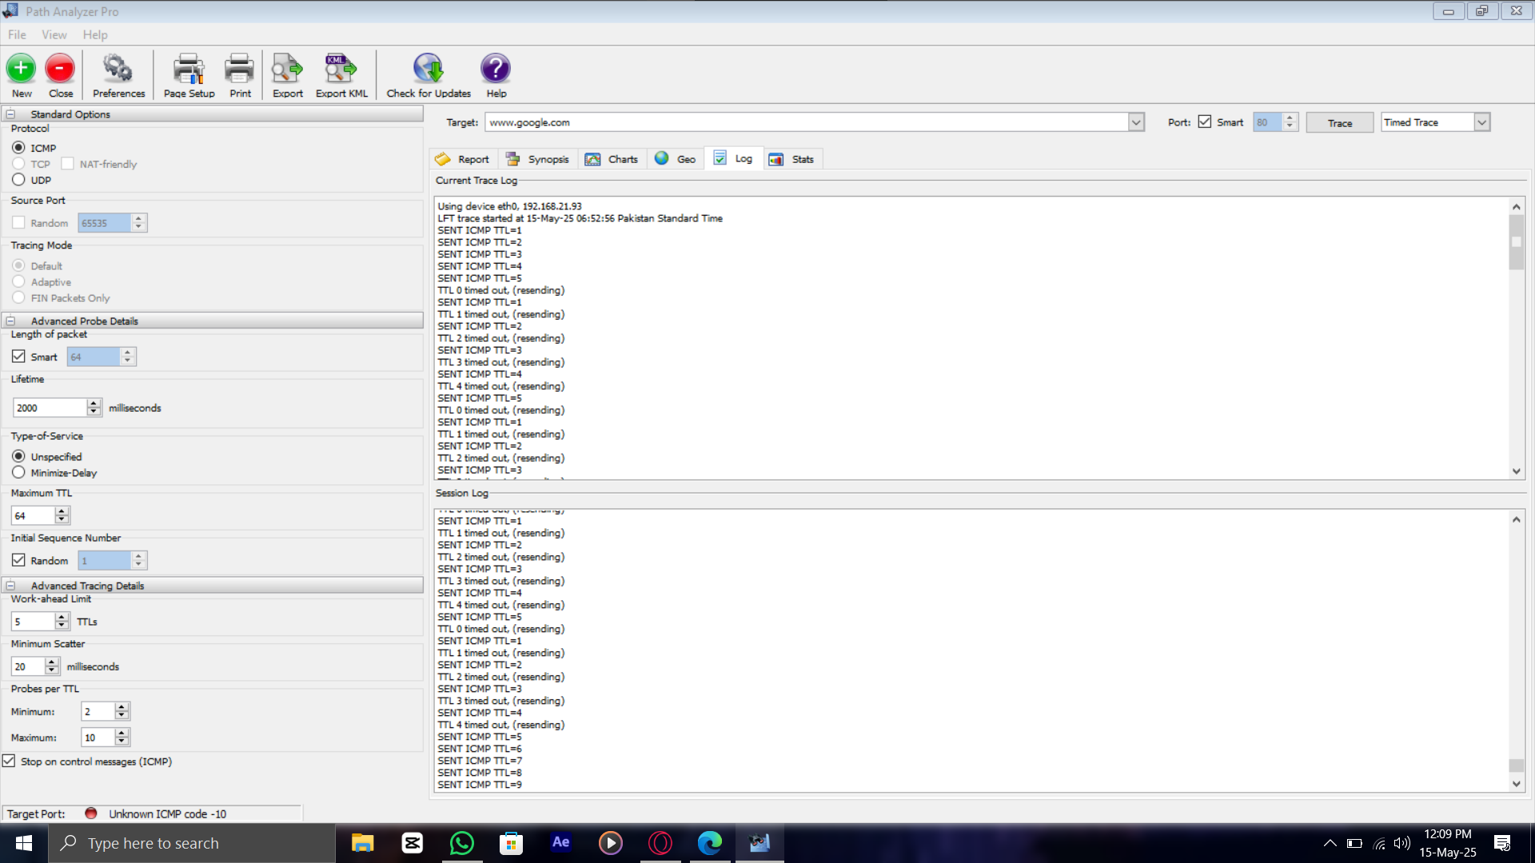

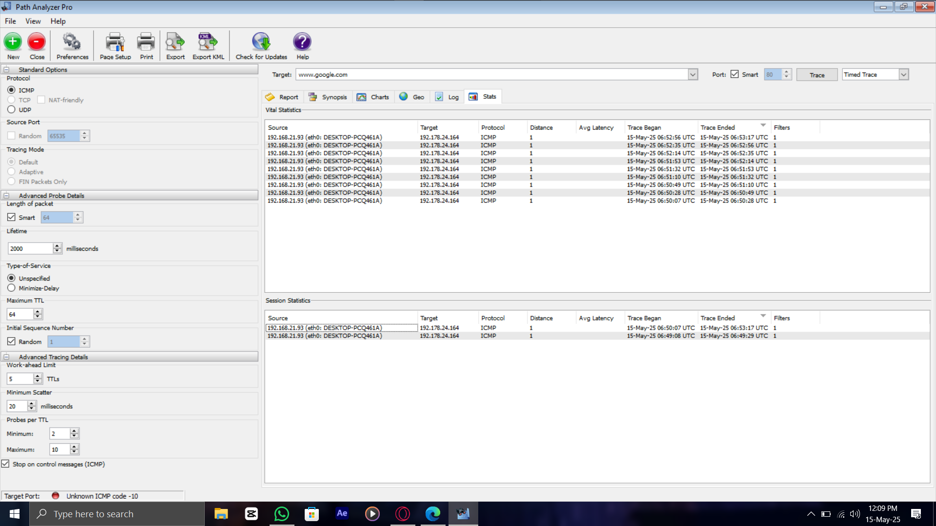

**Result or Output**: DNS tab showed IP (192.178.24.164). Routing tab gave prefix (192.178.0.0/15), AS15169 (Google LLC). Geo tab mapped hops. Stats tab listed 1 hop, 1 ms latency. Log tab confirmed ICMP probes.

**Interpretation**: Successfully traced the path, latency, and ownership, enhancing network topology understanding.

**Errors and handlings :**

* **Network Adapter Configuration:** DNS queries and tracerouting failed in both labs due to incorrect network settings. Resolved by configuring DNS to Google DNS (8.8.8.8) for reliable connectivity.
* **DNSRecon Installation:** Installing DNSRecon in Lab 7 was challenging due to missing dependencies. Resolved by manually installing required dependencies on Parrot Security.
* **Command Syntax Issues:** Parrot Security’s module version in both labs used different syntax for dnsrecon and traceroute. Resolved by researching and applying the correct syntax.
* **VM Performance Issues:** Both labs experienced VM slowdowns and crashes. Resolved by reinstalling the VMs, restoring performance.
* **Path Analyzer Pro Errors:** In Lab 8, Path Analyzer Pro encountered raw socket issues, TTL problems, timeouts, and UDP/TCP blockages. Resolved by adjusting network configurations, enabling raw socket permissions, correcting TTL settings, and unblocking UDP/TCP ports in the VM environment.
* Final Learning

Our group’s work in Modules 2 and 3 equipped us with critical technical skills, such as identifying open ports, fingerprinting services, and collecting emails, domains, and subdomains using tools like Nmap, theHarvester, and Photon, while also mastering social media footprinting with Sherlock and analyzing real-time network communication through Wireshark. These activities closely resemble real-world penetration testing, where attackers leverage reconnaissance and scanning to uncover vulnerabilities, revealing how seemingly harmless public data can lead to significant security risks. We were surprised when Shodan exposed open services on public IPs we assumed were secure, and our initial belief that ping scans would always succeed was challenged when firewalls blocked ICMP traffic, forcing us to adopt alternative methods. This taught us the importance of using diverse tools and staying adaptable. As a team, we collaborated effectively by dividing tasks like passive footprinting, active scanning, and result analysis, with regular communication ensuring we verified findings and deepened our understanding. Through this process, we honed our documentation skills and learned to interpret results more accurately, gaining hands-on insight into both attacker strategies and defensive countermeasures.